Salesforce Commerce Cloud e-Commerce Design
Storefront Reference Architecture (SFRA) Modifications for

add Customer Logo Here

Functional Specification Document (FSD)
Date goes here
Version goes here

Introduction
Overview
Project Stakeholders
Related Documents
Internationalization and Locales
Browser Compatibility
Browser Window Scaling
Accessibility
iFrames
Search Engine Optimization (SEO) and Site URLs
1.0 Header | Global Navigation | Footer | Tracking Consent | Cookie Notification
1.1 Header
1.2 Global Navigation
1.3 Footer
1.4 Tracking Consent
1.5 Cookie Notification
2.0 Homepage | Search Suggestions | Search Results | Article Detail | Search Refinements
2.1 Homepage
2.2 Search Suggestions
2.3 Search Results with No Products
2.4 Search Results with Products
2.5 Search Results with Articles
2.6 Article Detail Page
2.7 Search Refinements
2.7.1 Search Refinement Selection
3.0 Category Landing | Category Grid | Product Tile
3.1 Category Landing
3.2 Category Grid
3.3 Product Tile
3.3.1 Product Tile - Pricing
4.0 Compare Products
4.1 Compare Bucket
4.2 Compare Products
5.0 Product Detail
5.1 Standard Product Detail
5.2 Product Option Detail
5.3 Variation Product Detail
5.3.1 Product Detail - Limited Inventory Message
5.3.2 Product Detail - Price Display & Promotion Callout Message
5.3.3 Product Detail - Choice of Bonus Product
5.4 Product Set Detail
5.5 Product Bundle Detail
6.0 Quickview
6.1 Standard Product Quickview
6.2 Product with Option Quickview
6.3 Variation Product Quickview
6.4 Product Set Quickview
6.5 Product Bundle Quickview
7.0 In-Store Pickup (ISPU)
7.1 ISPU - Product Detail Page (No Saved Store)
7.1.1 ISPU - Enter Zip Code / Select Store
7.2 ISPU - Product Detail Page (Saved Store)
7.3 ISPU - Cart
7.4 ISPU - Shipping Address | Shipping Method (No Saved Store)
7.5 ISPU - Shipping Address | Shipping Method (Saved Store)
7.6 ISPU - Billing Address | Payment Method
7.7 ISPU - Place Order
7.8 ISPU - Order Receipt
7.9 ISPU - Order History
7.10 ISPU - Order Detail
8.0 Mini-Cart | Cart
8.1 Mini-Cart
8.2 Cart - Empty Cart
8.3 Cart - Coupon & Promotion Messaging
8.5 Cart - Choice of Bonus Product
9.0 Checkout (Registered & Guest)
9.1 Checkout - Login
9.2 Registered Checkout
9.2.1 Checkout - Shipping Address | Shipping Method (Registered)
9.2.2 Checkout - Billing Address | Payment Method (Registered)
9.2.3 Checkout - Place Order (Registered)
9.2.4 Checkout - Order Receipt (Registered)
9.3 Guest Checkout
9.3.1 Checkout - Shipping Address | Shipping Method (Guest)
9.3.2 Checkout - Billing Address | Payment Method (Guest)
9.3.3 Checkout - Place Order (Guest)
9.3.4 Checkout - Order Receipt (Guest)
9.4 Checkout - Update | Add New Shipping Address
9.5 Checkout - Update | Add New Billing Address
9.6 Checkout - Add Payment Method
10.0 Multi-Ship Checkout
10.1 Multi-Ship Checkout (Registered)
10.1.1 Multi-Ship - Shipping Address / Shipping Method (Registered)
10.1.2 Multi-Ship - Edit Shipping Address | Shipping Method (Registered)
10.1.3 Multi-Ship - Billing Address | Payment Method (Registered)
10.1.4 Multi-Ship - Place Order (Registered)
10.1.5 Multi-Ship - Order Receipt (Registered)
10.2 Multi-Ship Checkout (Guest)
10.2.1 Multi-Ship - Shipping Address | Shipping Method (Guest)
10.2.2 Multi-Ship - Billing Address | Payment Method (Guest)
10.2.3 Multi-Ship - Place Order (Guest)
10.2.4 Multi-Ship - Order Receipt (Guest)
11.0 My Account
11.1 My Account - Login
11.2 My Account Dashboard
11.3 My Account - Edit Profile
11.4 My Account - Edit Password
11.5 My Account - Address Book
11.5.1 My Account - Add | Edit Address
11.6 My Account - Payment Method
11.6.1 My Account - Add Payment Method
11.7 My Account - Create an Account
11.8 My Account - Forget Password
11.9 My Account - Reset Password
11.10 My Account - Order History Landing
11.11 My Account - Order History Detail
12.0 Wishlist
12.1 Wishlist - Guest View (Temporary Wishlist)
12.2 Wishlist - Registered View
12.2.1 Edit Wishlist
12.3 Wishlist - Search
12.4 Wishlist - Search Results
12.5 Wishlist - Public View
13.0 Store Locator
13.1 Store Locator - Search
13.2 Store Locator - Search Results
14.0 Gift Registry
14.1 Gift Registry – Footer
14.2 Gift Registry – My Account Dashboard
14.3 Create Registry - Event Information
14.4 Create Registry - Address Information
14.5 Create Registry – Review Registry Information
14.6 Gift Registry – Add Item to Registry
14.7 Gift Registry – Registered View
14.7.1 Gift Registry – Edit Registry Product
14.8 Gift Registry Landing - Search
14.8.1 Gift Registry – Manage Gift Registries
14.9 Gift Registry – Search Results
14.10 Gift Registry – Public View
15.0 Error Pages | Example Error States
15.1 General (500) Error
15.2 Missing Page (404) Error
15.3 Client Side Validation Error
15.4 Server Side Validation Error
15.5 Cart - Coupon Error
15.6 Checkout - Login Error
15.7 Checkout - Credit Card Error
15.8 My Account – Order Tracking Error
15.9 My Account - Confirm Email Error
Appendix
Glossary

Introduction

This document and the information herein is conﬁdential and proprietary information of salesforce, Inc. (“Salesforce”). This document and information cannot be used for any purpose without the express written permission of Salesforce or pursuant to a valid Salesforce Commerce Cloud Master Subscription and Services Agreement. “Digital” refers to Salesforce Commerce Cloud Digital.

Overview
The scope of this document is to describe the functional requirements for the [customer] commerce website using the Salesforce Commerce Cloud Storefront Reference Architecture (SFRA). Each section will specify the functional requirements for the [customer] commerce website.

It is assumed that all functionality not included in this document will mimic that of SFRA.

Project Stakeholders
Name | Role | Company | Email
 | Business Sponsor | [Customer]
 | Project Manager | [Customer/Partner]
 | Business Analyst | [Systems Integrator/Partner]
 | Tech Lead | [Systems Integrator/Partner]
 | QA Lead | [Systems Integrator/Partner]

Related Documents
[Customer] has provided/will provide a style guide. If differences exist between the annotated design provided in this document and the style guide, the style guide will be the point of reference.

Document | Company
Style Guide | [customer]
UI Guidelines | [customer]
Technical Specification Document (TSD) | [Systems Integrator/Partner]
Data Mapping Documentation | [Systems Integrator/Partner]

Internationalization and Locales
List all locales that are in scope for this release.
Locale ID | Locale Name
 | E.g., See locale list below for examples.
en | English
en_CA | English (Canada)
fr_FR | French (France)
ja | Japanese
ja_JP | Japanese (Japan)

Browser Compatibility
List all browser versions in each format that will be tested for compatibility.
Desktop | Tablet | Mobile

Browser Window Scaling
The site will scale to fit the pixel width of the browser window of each device type as follows.
Desktop | Tablet | Mobile

Accessibility
List all accessibility requirements
(For more information, https://www.w3.org/standards/webdesign/accessibility)
Requirement | Description

iFrames
List all iFrames with the location in the storefront (minimize the use where possible)
Name | Location

Search Engine Optimization (SEO) and Site URLs
List all Search Engine Optimization requirements.
Requirement | Description | Owner
301 Redirects |  | [Systems Integrator/Agency/Customer]
Heading Tags |  | [Systems Integrator/Agency/Customer]
Page Meta Tags (title, description, etc) |  | [Systems Integrator/Agency/Customer]
Canonicalization |  | [Systems Integrator/Agency/Customer]
Heading Tags |  | [Systems Integrator/Agency/Customer]
Sitemaps |  | [Systems Integrator/Agency/Customer]
Robots.txt |  | [Systems Integrator/Agency/Customer]

1.0 Header | Global Navigation | Footer | Tracking Consent | Cookie Notification

1.1 Header  Mobile:  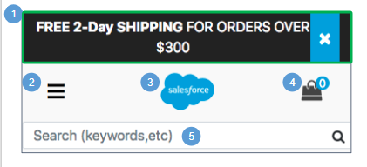  Desktop:  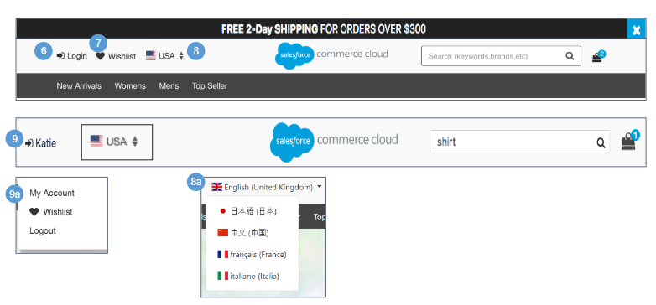 | Header  Mobile:  1. Shows the global content slot ‘header-banner-m,’ which is maintained in Business Manager. Clicking 'X’ closes the promotional banner.  2. Clicking the navigation icon opens a hamburger menu showing the top level category navigation, user state (logged in or not logged in), and a country selector when applicable (see Global Navigation for details).  3. Clicking the company logo opens the homepage.  4. The item number increases as the shopper adds items to the cart.  5. When a shopper places the cursor in the search field, the default search text remains intact until at least one character is entered.  - When a shopper enters a search term into the search field and clicks the Search icon or presses Enter, the shopper is taken to the search results page, and the original text is shown in the search field.  - By default, the search field has Search Suggestions enabled (see Search Suggestions for details).  Desktop:  6. For a guest shopper, clicking Login opens the My Account Login page (see My Account Login for details).  7. For a guest shopper, clicking Wishlist opens the Temporary Wishlist page (see Wishlist - Guest View (Temporary Wishlist) for details).  8. Shows the default country (if a localized version of the store is available).  - The shopper can select a different country, which changes the locale that is shown. The locales and countries must be enabled in Business Manager.  9. Shows the registered shopper’s first name. On hover, a drawer opens showing links for My Account, Wishlist, and Logout.  - Clicking My Account opens the My Account Dashboard page (see My Account Dashboard for details). Clicking Wishlist opens the shopper’s Wishlist page (see Wishlist - Registered View for details). Clicking Logout logs the shopper out of their account, clears their cart, and returns the shopper to the homepage.

1.2 Global Navigation  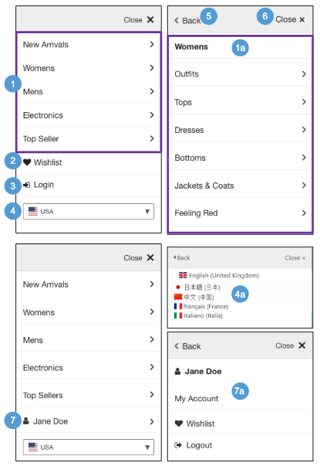  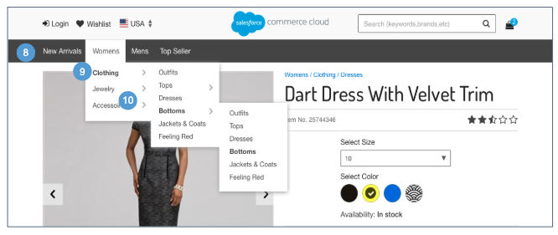 | Global Navigation  Mobile  1. The tabular navigation is built using the child categories of the root category. Child categories are shown if they are online and have the category attribute ‘‘showInMenu’ checked. A category that is offline, regardless of sort order, is not shown. When a shopper clicks a category, they are shown that category.  - Clicking a top-level category shows its subcategories.  - Clicking a sub-category arrow (>) shows its sub-categories.  - When the shopper clicks a sub-category, the menu closes, and the shopper is shown the sub-category landing page they selected.  2. For guest shoppers, clicking Wishlist opens the Temporary Wishlist page (see Wishlist - Guest View (Temporary Wishlist) for details).  3. For guest shoppers, clicking Login opens the My Account login page (see My Account - Login for details). On this page, the shopper can log in, create an account, or check an order.  - Clicking Logout logs the shopper out of their account, clears their cart, and returns them to the homepage.  4. Shows the default country (if a localized version of the store is available).  - The shopper can select a different country, which changes the locale that is shown. The locales and countries must be enabled in Business Manager.  5. Clicking Back returns the shopper to the previous page.  6. Clicking Close X closes the navigation menu.  7. After logging in, the shopper’s first name is shown. Clicking their name opens a page with links for My Account, Wishlist, and Logout.Update  - Clicking My Account opens the My Account Dashboard page. Clicking Wishlist opens the shopper’s Wishlist page (see Wishlist Registered View for details). Clicking Logout logs the shopper out of their account, clears their cart, and returns them to the homepage.  Desktop  8. The tabular navigation is built using the child categories of the root category. Child categories are shown if they are online and have the category attribute ‘‘showInMenu’ checked. A category that is offline, regardless of sort order, is not shown. When a shopper clicks a category, they are shown that category.  9. When a shopper mouses over a top-level category, a mega-menu opens. The menu shows the sub-categories of the top-level category.  When the shopper clicks a sub-category, the menu closes and the selected sub-category page opens.  10. Sub-categories with child sub-categories have an arrow that enables an additional menu flyout. When the shopper clicks a child sub-category, the menu closes and the selected sub-category page opens.

1.3 Footer  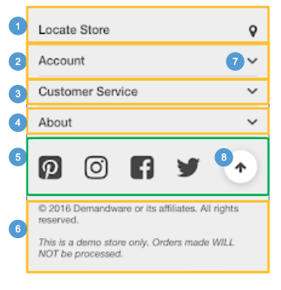  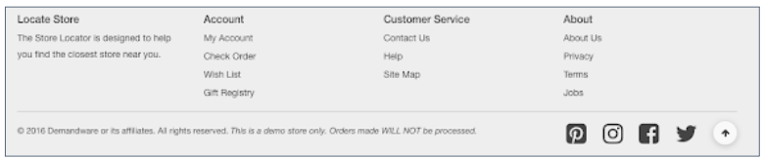 | Footer  Shown globally on every storefront page, the persistent footer contains a content slot and five content assets. The slot configuration and the assets are maintained in Business Manager.  Mobile | Desktop:  1. Shows the content asset: ‘footer-locate-store’ which is maintained in Business Manager. Clicking Locate Store opens the Store Locator page (see Store Locator for details).  2. Shows the content asset ‘footer-account.’  3. Shows the content asset ‘footer-support.’  4. Shows the content asset ‘footer-about.’  5. Shows the content slot ‘footer-column-m.’  6. Shows the content asset ‘footer-copy.’  7. Clicking the arrow expands the content asset drawer.  8. Clicking the arrow returns the shopper back to the top of the page.

1.4 Tracking Consent  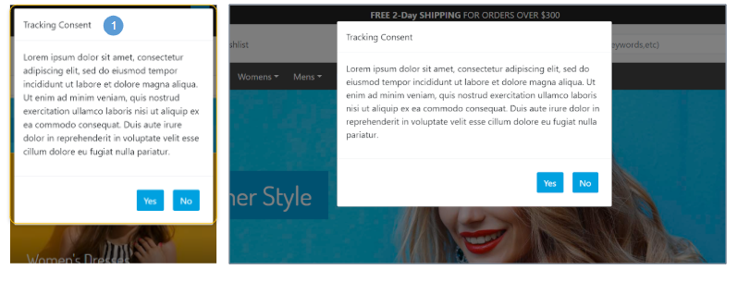 | Tracking Consent  In Commerce Cloud, merchants can track personal information about their shoppers to improve the shopping experience. As a merchant, you can collect and honor your shoppers’ consent preferences when they are using your site.  The implementation uses:  - A content asset to show a consent request message to the shopper.  - The site-specific preference to disable tracking by default.  - A session-specific flag to allow tracking if the shopper grants consent.  The Tracking site preference determines the default tracking behavior. When this preference is set to Opt-in, personal information is not tracked by default for all shoppers visiting the site; otherwise, personal information is tracked. To set this preference, select Merchant Tools > site > Site Preferences > Privacy.  Mobile | Desktop:  1. Shows the session-based content asset ‘tracking_hint,’ which is maintained in Business Manager. The modal window is sticky to the page as the shopper scrolls up and down. If the shopper allows tracking, tracking is enabled during the shopper’s session.

1.5 Cookie Notification  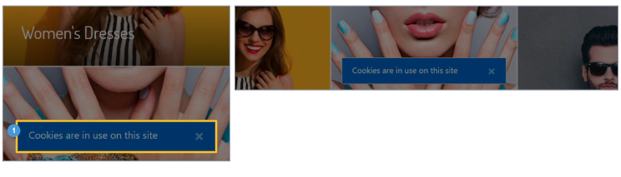 | Cookie Notification  The European Cookie Law requires websites to notify shoppers that cookies are being used and how they are being used.  Mobile | Desktop:  1. Shows the content asset ‘cookie_hint,’ which is maintained in Business Manager. The modal window is sticky to the page as the shopper scrolls up and down.  If this asset does not exist in Business Manager, or if the asset is set to ‘offline,’ no notice is given. The cookies are set as they always have been. This behavior is used in the USA, for example.  If this asset exists and is set to ‘online,’ the content asset ‘cookie_hint’ is shown. Clicking ‘I ACCEPT’ sets the cookies and causes the popup to be hidden.  Note: Customers can also add a Close button to implement a more relaxed interpretation of the Cookie Law.

2.0 Homepage | Search Suggestions | Search Results | Article Detail | Search Refinements

2.1 Homepage  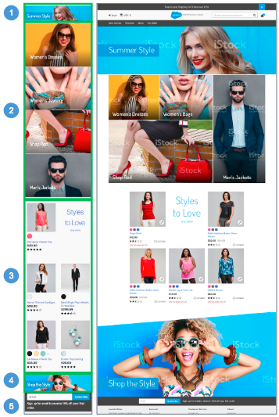  M | Homepage  The homepage shows multiple content slots, which are maintained in Business Manager.  Mobile | Desktop:  1. Shows the global content slot 'home-main-m'  2. Shows the global content slot 'home-categories-m'  3. Shows the global content slot ‘home-products-m'  4. Shows the global content slot 'home-product-set-m'  5. The shopper can enter an email address to opt-in to a newsletter or other email notification sent by the Email Service Provider (ESP). This behavior requires a 3rd-party integration.

2.2 Search Suggestions  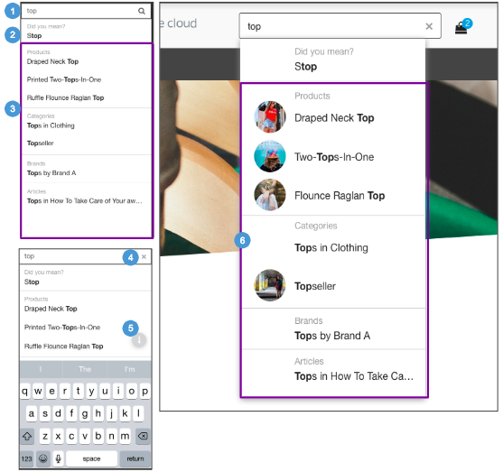 | Search Suggestions  Search Suggestions are a dynamic search list that is shown automatically when the shopper enters a search term into the search field.  Mobile:  1. The default help text ‘Search (keywords, etc)’ is shown until the shopper enters at least one character.  Clicking the Search icon or pressing Enter opens the applicable page (i.e., Search Results, No Search Results).  Suggestions are shown after the shopper enters 3 characters. This number is controlled in Business Manager via the Search Suggestion - Settings preference ‘Minimum Length.’  2. The system uses the spelling index to find a suggested spelling for the misspelled word. Only one suggested word is shown. Clicking this word causes the search results for the word selected to be refreshed.  3. For enhanced search suggest, information is shown based on product, category, brand, and content data configured in Business Manager. The number of suggestions shown is configurable via APIs. The default is 3.  Clicking a link opens the corresponding suggestion page (i.e., search results, product detail, category, content).  4. Clicking ‘X’ removes the search keyword from the search input field.  5. Clicking the arrow collapses the keyboard.  Desktop:  6. Product and Category Search Suggestions are shown with a thumbnail image. For Products, this thumbnail image is derived from the main image. For Categories, this thumbnail image is pulled from the standard image category attribute.

2.3 Search Results with No Products  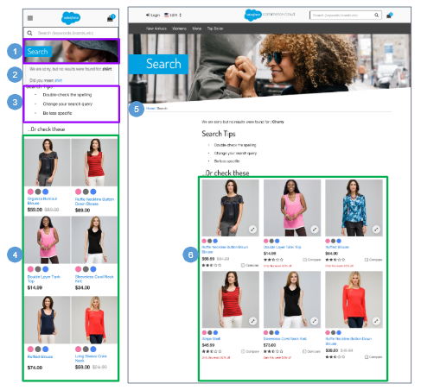  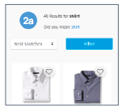 | Search Results with No Products  Mobile:  1. The search banner text is not stored in a properties file. The slot search-result-banner-m is used to render the search banner with a fallback background image set in search.scss.  2. The system uses the spelling index to find a suggested spelling for the misspelled word. Only one suggested word is shown.  “We are sorry, but no results were found for: shiirt  Did you mean: shirt”  Clicking this word causes the system to refresh the search results for the selected word.  - When the Search Site Preference ‘Search Autocorrection’ is enabled, the system uses the spelling index to find a suggested spelling for the misspelled word and to present search results for the suggested word.  “X results for: shiirt  Did you mean: shirt”  Clicking this word causes the system to refresh the search results for the selected word.  3. Text is stored in the content asset “noresults-help”  4. This is a global content slot (‘noresult-recommendations’) that is shown beneath the search tips content. The product grid defaults to 6 items (2 X 3). The ‘noresult-recommendations’ content slot is maintained in Business Manager.  - If Content Type ’Product’ is selected, the slot rendering template shows products that are configured in the slot configuration (product id) and defined by the isml template.  - If Content Type ’Category’’ is selected, the slot rendering template shows category content that is configured by the slot configuration (category id) and defined by the isml template.  - If Content Type ‘Content Asset’ is selected, the slot rendering template shows content that is configured in the slot configuration (content asset id) and defined by the isml template.  - If Content Type ‘HTML’ is selected, the slot rendering template shows content that is configured in the slot configuration (html body) and defined by the isml template.  - If Content Type ‘Recommendation’ is selected, the slot rendering template shows products that are generated by the recommendation rule configured in the slot configuration (i.e., recently-viewed) and defined by the isml template.  Desktop:  5. The breadcrumbs do not exist on this template  6. This is a global content slot (‘noresult-recommendations’) shown beneath the search tips content. The product grid defaults to 6 items (3 X 2). The ‘noresult-recommendations’ content slot is maintained in Business Manager.

2.4 Search Results with Products  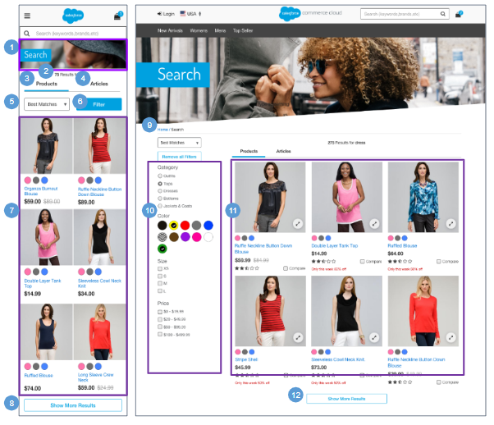 | Search Results with Products  Mobile:  1. The search banner text is not stored in a properties file. The slot search-result-banner-m is used to render the search banner with a fallback background image set in search.scss.  2. Shows a count of the results based on the keyword input “# Results for <keyword>.”  3. When a shopper executes a search query, the Products tab opens by default (assuming no search driven redirects are in place). If no products are found, the system opens the No Search Results page (see Search Results with No Products for details).  4. When a shopper executes a search query, the Articles tab is hidden by default (assuming no search driven redirects are in place). Clicking Articles opens the Article Listing page (see Search Results with Articles for details).  5. Storefront Sorting Options are configured in Business Manager. Selecting a sort option from the dropdown list refreshes the product grid based on the selection (for example, ‘Product Name [A-Z]’ sorts products in ascending order by product name within the grid). This sort is persistent as the shopper pages through the results or selects more search refinements; however, the sort returns to the default if a new search occurs.  Changing the sort order causes the first results page to open.  6. The search refinement navigation affects the product grid. The default refinements shown on the Search Results page are set at the root level of the storefront catalog (in this example Category, Color, Size and Price).  7. The product grid defaults to 12 items, not 6 and is 2x6, not 2x3.  8. A More button is shown when there are 13 or more product results. Clicking More loads 6 more products. The sort order depends on the category sorting rule configured in Business Manager.  Desktop:  9. There are no breadcrumbs on this template  10. The search refinement navigation affects the product grid. All search refinements are open by default.  11. Assumes products are online and searchable. The product grid defaults to 12 items (3 X 4).  12. A More button is shown when there are 13 or more product results Clicking More loads 12 more products. The sort order depends on the category sorting rule configured in Business Manager.

2.5 Search Results with Articles  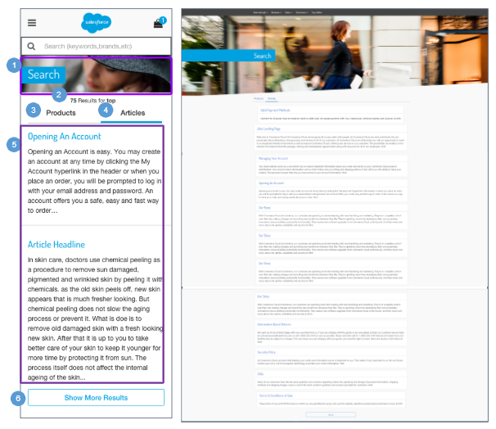 | Search Results with Articles  Mobile | Desktop:  1. The search banner text is not stored in a properties file. The slot search-result-banner-m is used to render the search banner with a fallback background image set in search.scss.  2. Shows a count of the results based on the keyword input “# Results for <keyword>”.  3. Clicking the Products tab opens the Search Results with Products page (see Search Results with Products for details).  4. When a shopper executes a search query, the Articles tab is hidden by default (assuming no redirects are in place). Clicking the Articles tab opens this page.  5. Shows articles associated with the keyword entered by the shopper. The articles are shown in one column and are sorted in descending order of the most recent best match.  Each article name is shown in bold font and is linked to the article; the article ‘description’ attribute text is shown underneath the name.  6. A Show More Results button is shown when there are 13 or more article results. Clicking More loads 12 more articles onto the page.

2.6 Article Detail Page  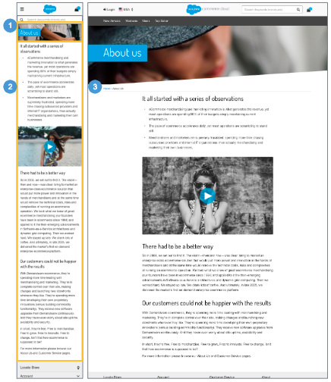 | Article Detail Page  Articles are content assets.  Mobile:  1. Shows the content asset ‘about-us,’ which is maintained in Business Manager.  2. Shows the content asset name and body. Styling can be done within the HTML editor in the Business Manager.  Desktop:  3. Shows the article name (as defined in Business Manager) in the breadcrumb.

2.7 Search Refinements  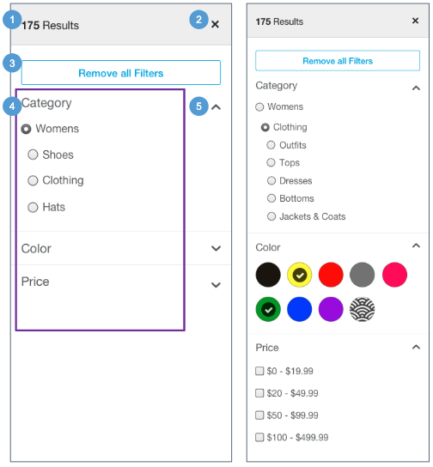  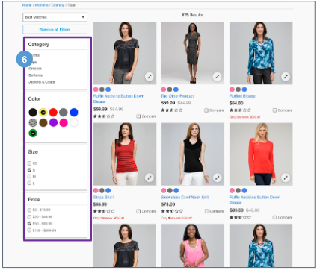 | Search Refinements  The Filter button is shown after the Search page loads with product results. Selecting ‘Filter’ opens the Search Refinement selector.  Mobile:  1. Shows the number of products on the grid page that match the selected refinement value.  2. Clicking Close (X) returns the shopper to the category grid page with the product results matching the selected refinement values.  3. Clicking Reset deselects all refinement values that have been selected and refreshes the result set.  4. Search Refinements are configured on the Storefront Catalog in Business Manager.  The category refinement should be shown as the first refinement. Only categories based on the current (possibly refined) search result are shown. Available categories are sorted according to the sort order configured in the Business Manager. Other categories with no resulting products in the search result are not shown.  5. Each refinement is expandable and collapsible, causing only the refinement option to be shown or hidden. By default, all refinements are collapsed.  - Clicking the down arrow expands the refinement area.  - Clicking the up arrow closes the refinement area.  Desktop:  6. Search refinements are expanded by default.

2.7.1 Search Refinement Selection  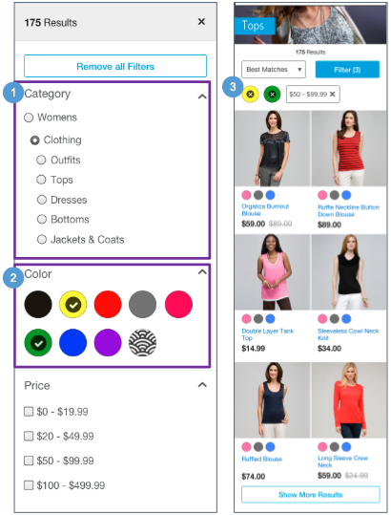  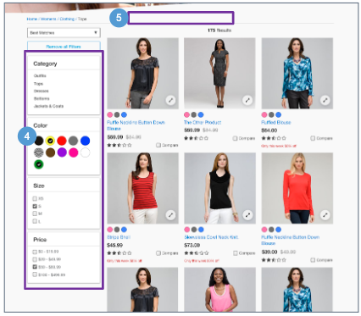 | Search Refinement Selection  By default, all refinements are shown as simple value lists. All attribute refinements, except category and price, support multi-selections.  Refinement appearance is controlled by appending CSS styles to the containing div.  Mobile:  1. Single Select Refinements let the shopper select only one value of the result set (i.e., Category, Price). These refinements have two possible states: ‘Selectable’ and ‘Selected.’  - Selectable - shown as unchecked. The product grid refreshes on select.  - Selected - shown as checked. The product grid refreshes on deselect.  2. Multi-Select Refinements let the shopper select multiple values of the result set (i.e., Size, Color). These refinements have three possible states: ‘Selectable,’ ‘Selected,’ and ‘Not Available.’  - Selectable - shown as unchecked. The product grid refreshes on select.  - Selected - shown as checked. The product grid refreshes on deselect. When the shopper selects multiple values, only those products having one of those values are shown in the product grid. For example, if the shopper selects size 10, 11, 12.5 and 15, all blouses with sizes 10, 11, 12.5 OR 15 are shown in the product grid when the page is refreshed.  - Not Available - shown as unchecked and unclickable.  3. Selected values are visible (Mobile & Tablet). Selecting ‘X’ deselects an individual value.  Desktop:  4. A tooltip does not show on hover of refinement value  5. Selected values are not visible.

3.0 Category Landing | Category Grid | Product Tile

3.1 Category Landing  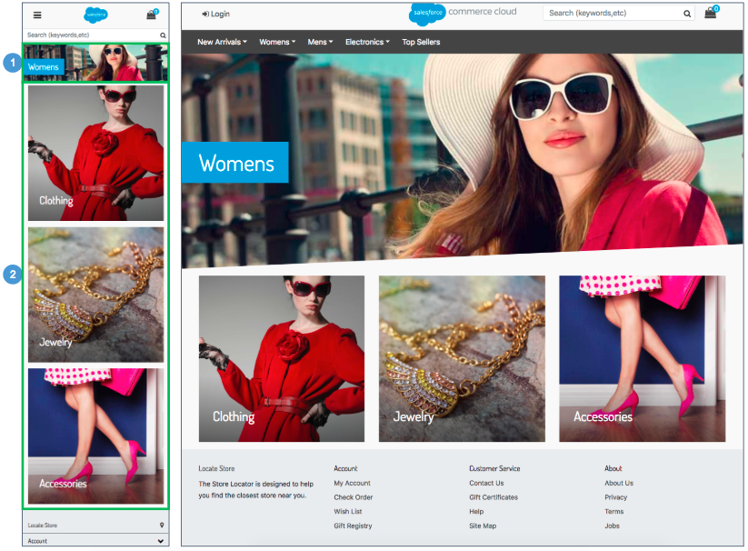 | Category Landing  The Category Landing template can be configured in Business Manager when the category attribute ‘rendering template’ is set to ‘‘rendering/category/catLanding.’’  1.Shows a category-specific content slot (‘cat-landing-slotbanner-m’) at the top of the Category Landing page. The content slot is maintained in Business Manager.  - If Content Type ’Product’ is selected, the slot rendering template shows products that are configured in the slot configuration (product id) and defined by the isml template.  - If Content Type ’Category’’ is selected, the slot rendering template shows category content that is configured by the slot configuration (category id) and defined by the isml template.  - If Content Type ‘Content Asset’ is selected, the slot rendering template shows content that is configured in the slot configuration (content asset id) and defined by the isml template.  - If Content Type ‘HTML’ is selected, the slot rendering template shows content that is configured in the slot configuration (html body) and defined by the isml template.  - If Content Type ‘Recommendation’ is selected, the slot rendering template shows products that are generated by the recommendation rule configured in the slot configuration (i.e., recently-viewed) and defined by the isml template.  2. Shows the category-specific content slot (‘cat-landing-slotbottom-m’) beneath the first slot on the Category Landing page. The content slot is maintained in Business Manager.  - If Content Type ’Product’ is selected, the slot rendering template shows products that are configured in the slot configuration (product id) and defined by the isml template.  - If Content Type ’Category’’ is selected, the slot rendering template shows category content that is configured by the slot configuration (category id) and defined by the isml template.  - If Content Type ‘Content Asset’ is selected, the slot rendering template shows content that is configured in the slot configuration (content asset id) and defined by the isml template.  - If Content Type ‘HTML’ is selected, the slot rendering template shows content that is configured in the slot configuration (html body) and defined by the isml template.  - If Content Type ‘Recommendation’ is selected, the slot rendering template shows products that are generated by the recommendation rule configured in the slot configuration (i.e., recently-viewed) and defined by the isml template.

3.2 Category Grid  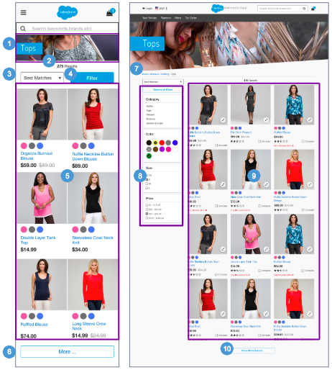 | Category Grid  Mobile:  1. Shows category-specific content at the top of the Category Grid page. The category attribute is ‘Standard Image’ and is maintained in Business Manager.  2. Shows a count of the results based on the Category selected.  3. Storefront Sorting Options are configured in Business Manager. Selecting a sort option from the dropdown list refreshes the product grid based on the selection (for example, Product Name [A-Z] sorts products in ascending order by product name within the grid).This sort is persistent as the shopper pages through the results or selects more search refinements; however, the sort returns to the default if a new search occurs.  Changing the sort order causes the first results page to open.  4. Search refinements are defined at the category level within the Business Manager (see Search Refinements for details), and are visible upon clicking the Filter button.  5. The product grid defaults to 12 items (2x6)  6. A More button is shown when there are 13 or more product results. On click of More, the system loads 6 more products.  The sort order depends on the category sorting rule configured in Business Manager.  Desktop:  7. There are no breadcrumbs on this template  8. Search refinements are defined at the category level within the Business Manager. Search refinements are expanded by default (see Search Refinements for details).  9. The product grid defaults to 12 items (3 X 4). See Product Details for details.  10. A More button is shown when there are 13 or more product results. Clicking More loads 12 more products.  The sort order depends on the category sorting rule configured in Business Manager.

3.3 Product Tile  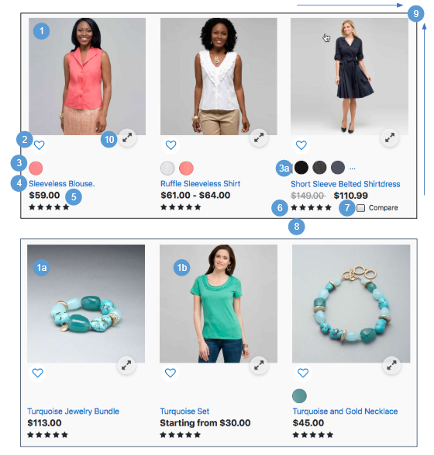  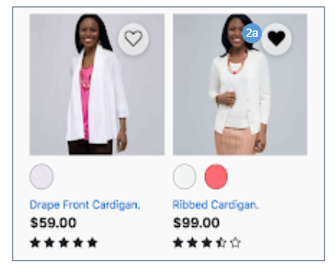 | Product Tile  Product tiles are shown on Search Result pages and Category Grid pages.  Mobile:  1. Shows the master product thumbnail image by default. For products having a color variation, the image of the first color variation configured in Business Manager is shown. Clicking the thumbnail image opens the Product Detail page with the color pre-selected.  a. The product bundle image is the standard image shown for the product bundle.  b. The product set image on the Grid page is the standard image that is loaded for the product set.  This behaviour assumes products are online, searchable, and at least one product is in stock.  2. An empty heart indicates that the product hasn’t yet been added to the shopper’s wishlist.  - Clicking the heart icon adds the product to the shopper’s wishlist (see Wishlist - Registered View for details). A message is shown indicating that the product was added to the wishlist.  3. Shows the product’s color swatches. Clicking a color swatch opens the Product Detail page with the color pre-selected.  - If a product has more than 3 colors associated with it, the additional swatches are replaced with an ellipsis icon. Clicking the ellipsis shows the Product Detail page. Only color variations based on the actual product are shown, with the first swatch pre-selected.  4. Shows the product name. Clicking the name opens the product details page (see Standard Product Detail Page for details).  5. Shows the product price (see Product Tiles - Pricing for details).  6. Shows the average Star Rating for a product. This requires a 3rd-party integration.  7. Clicking Compare or checking the checkbox adds the product to the compare bucket. Deselecting the checkbox removes the product from the compare bucket (see Compare for details).  8. Shows promotional messaging for applicable products (as configured in Business Manager via the promotion attribute ‘callout message’). If multiple promotions are active, promotions are shown based on exclusivity, rank and other promotion related attributes.  9.The width and height for the product container is fixed, and the overflow is hidden with the style sheet to ensure that the grid is rendered properly.  Desktop:  10. Clicking the Quickview icon opens the Quickview modal window (see Quickview for details).

3.3.1 Product Tile - Pricing  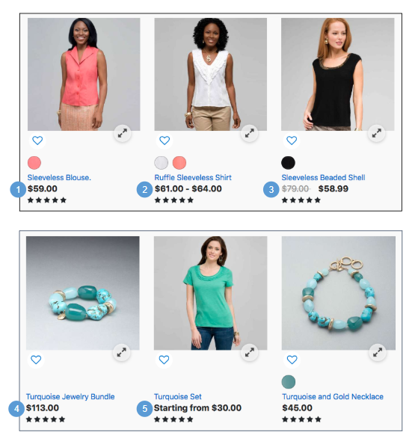 | Product Tile - Pricing  Mobile | Desktop:  1. Shows the list price.  2. For a variation master, shows a ‘From - To price’ range. The price range reflects only the variations that match the search criteria. If all matching variations have the same price, only one price is shown. Variation promotions are not accounted for.  3. Shows the list price and the promotion price side by side. The list price has a strike through.  4. Product bundles and standard products are presented in the same way.  5. Prices are not shown for product sets. Instead, the following text is shown:  ‘Starting from $XX.XX’  where [XX.XX] is the lowest priced variation associated to the product set.

4.0 Compare Products

4.1 Compare Bucket  Mobile:  Compare functionality is not supported in mobile design.  Desktop:  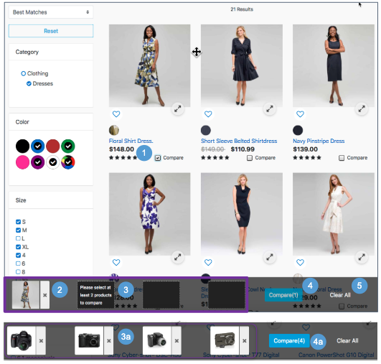 | Compare Bucket  Shoppers can add items to the compare bucket for side-by-side product attribute comparison. This behavior applies to Category Grid pages, but not to Search pages. Product sets and bundles are not comparable.  Configurations:  - Install the cartridge ‘plugin_productcompare.’  - Enable the category attribute ’enableCompare.’  Desktop:  1. Clicking Compare or checking the checkbox adds the product to the compare bucket, increasing the item count on the Compare button.  Deselecting the checkbox removes the product from the compare bucket, decreasing the item count on the Compare button. If there are no products in the compare bucket, the bucket is not shown.  2. Shows the thumbnail image of the items that have been selected for comparison. As the shopper scrolls up and down the page, the compare bucket remains sticky to the bottom of the page.  Shoppers can remove a product from the compare bucket by clicking the X to the right of the thumbnail.  3. When a product is selected for comparison, the compare bucket shows the selected item and shows blank squares to indicate how many more items can be compared (maximum of four items). For example, if only one product was added, three blank squares are shown. The second square is shown with the text: ‘Please select at least 2 products to compare.’  a. If the compare bucket already has four items, the shopper must remove one item to add another.  4. Shows the Compare [#] button after the shopper selects at least one item for comparison. The count [#] increases and decreases as the shopper selects and deselects items for comparison. The button is disabled until two or more products are added.  a. Clicking the Compare [#] button opens the Product Compare page, showing all the products selected (see Product Compare for details).  5. Clicking Clear All removes all items from the compare bucket.

4.2 Compare Products  Mobile:  Compare functionality is not supported in mobile design.  Desktop:  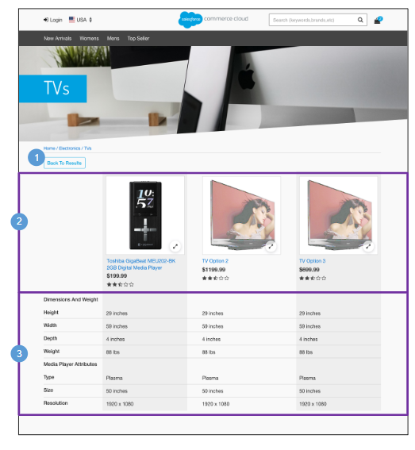 | Compare Products  Comparing items in the product grid is responsive to the number of items selected. Only the items being compared are shown, and they span the width of the window. A shopper can select up to four products to compare. When fewer than four are selected, the width of each item expands.  Configurations:  - Install the cartridge ‘plugin_productcompare.’  - Enable the category attribute ’enableCompare.’  - Set the product attribute object definition to ‘Visible’. This allows the attribute to be viewable on the storefront.  - If attribute groupings are required, configure product attribute definitions on the appropriate catalog (i.e master).  Desktop:  1. Clicking Back to Results opens the previously viewed category page.  2. Shows products selected for comparison by using the following attributes:  - Thumbnail Image - clicking opens the Product Detail page.  - Name - clicking opens the Product Detail page.  - Color Swatch - clicking opens the product page with the color selected.  - Price  - Product Star Rating - requires 3rd-party integration.  - Quickview - clicking opens the product Quickview window.  3. Shows the product attributes of the product that are to be compared. If the attribute does not apply for the product, a hyphen (“-”) is shown.

5.0 Product Detail

5.1 Standard Product Detail  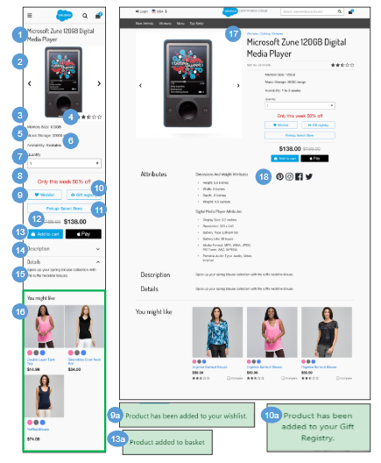 | Standard Product Detail  The Standard Product Detail page has similar functionality to the Variation Product Detail page, except that with a standard product there is not a variation attribute (color, size, etc) to select.  Mobile:.  1. Shows the product attribute ‘name.’  2. If a product has more than a single image associated with it, the shopper can scroll through to see the other images with the arrows to the right and left of the main image.  3. Shows the product attribute ‘ID.’  4. Shows the product average star rating. This requires a 3rd-party integration.  5. Product attribute groups are derived from the product’s classification category and inherited from the product’s parent category(s) product attribute definitions.  6. If a product is available (ATS < 0), availability is ‘In-Stock.’ Otherwise, availability is ‘Out of Stock.’  7. Quantity is a drop-down with a forced maximum (e.g., 9). By default, a quantity of 1 is selected. When a shopper selects a different quantity from the dropdown, the system checks the availability of that product. If the product has less ATS than the quantity selected, the system shows a limited availability message (see Product Detail - Limited Inventory for details).  8. Shows the promotion attribute ‘calloutMsg.’ when 'without qualifying product' type promotion has been configured in Business Manager.  9. Clicking Wishlist adds the item (master or variation product) to the shopper’s wishlist. If the shopper is not signed in, the item is added to a temporary wishlist that is only available on the device and expires at the end of the shopper’s session (see Wishlist - Guest View (Temporary Wishlist) for details).  - After the shopper adds the product to a wishlist, the message ‘Product has been added to your Wishlist’ is shown.  10. The Gift Registry button is disabled until required variations (size, color) are selected. For guest shoppers, clicking Gift Registry opens the Create an Account page (see My Account - Create an Account for details). For registered shoppers, clicking Gift Registry adds the item to their gift registry (see Gift Registry - Add Item To Registry for details).  - After the shopper adds the product to a gift registry, the message ‘Product has been added to your Gift Registry’ is shown.  11. Clicking Store Pickup: Select Store opens the In-Store Pickup Store Locator panel (see ISPU - Enter Zip Code / Select Store for details).  12. Shows the product list price and sale price when applicable (see Product Detail - Pricing and Promotions).  13. Add to Cart button is enabled if the selected product is available. The Apple Pay button is also enabled if the selected product is available (requires a 3rd-party integration).  - After the shopper adds the product to the cart, the message ‘Product added to basket’ is shown.  13. Shows the product attribute ‘shortDescription.’  14. Shows the product attribute ‘longDescription.’  15. Shows product reviews. This requires a 3rd-party integration.  16. Shows the content slot ‘product-recommendations-m,’ which is maintained via Business Manager.  Desktop:.  17. Breadcrumbs are derived from the product’s primary category configured in Business Manager.  18. Requires an integration with various social media applications (i.e. plugins for Facebook, Twitter, Pinterest)

5.2 Product Option Detail  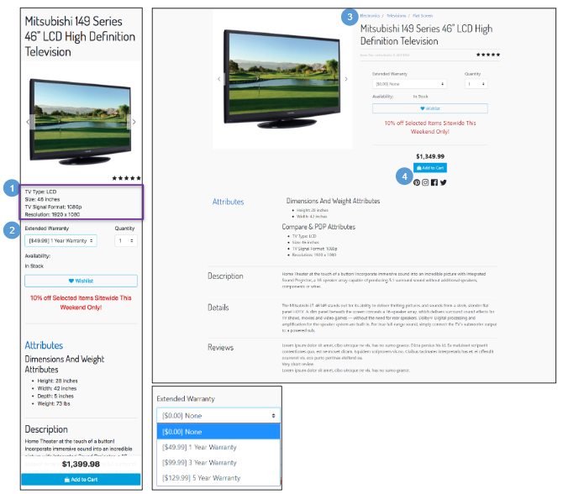 | Product Option Detail  The Product Option Detail page has the same functionality as the Standard or Variation Product Detail page with the following exceptions.  Options are:  - Purchased with a product and can’t be purchased separately.  - Have their own price and display name but do not have a thumbnail images.  - Can’t be searched by the shopper but are usually visible on the Product Detail page.  Each option value defines a price that can be added to the product’s price when the option is selected. You can include a certain option in the price by making it the default option in Business Manager.  Mobile:  1. Shows the product’s main attributes configured in Business Manager.  2. Shows options in a dropdown menu. Selecting an option updates the price without a full page refresh. When the page opens, the default/first option is preselected.  After the customer clicks Add to Cart, the product with its selected option is added to the cart and the mini-cart.  Desktop:  3. Breadcrumbs are derived from the product’s primary classification, configured in Business Manager.  4. Requires an integration with various social media applications.

5.3 Variation Product Detail  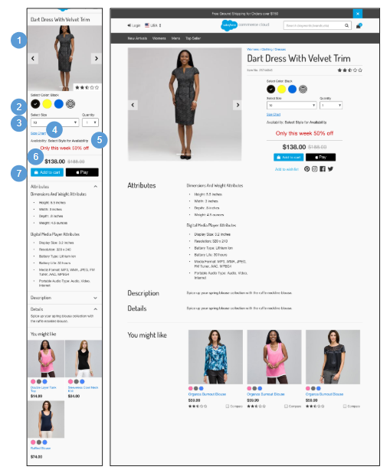 | Variation Product Detail  The Variation Product Detail page has the same functionality as the Standard Product Detail page, with the following exceptions.  Mobile | Desktop:  1. If the product is a master product, shows the image defined as the master product image. If a variation product has images associated with it, when the variation product is selected, the master product image is replaced by the variation product image.  2. Shows available colors. CSS controls which colors and selections are shown.  If the shopper selects the product thumbnail image on the Product Grid page (or follows a direct url to a master product), the shopper is shown the Product Detail page with no variation product pre-selected. Clicking a color swatch selects it. Clicking the selected swatch again deselects it.  Selecting a color swatch on the Product Grid page shows the Product Detail page with the color pre-selected.  3. Shows available sizes. Visual indications of size and width availability change to match the inventory of the selected color swatch. CSS controls which variations are shown.  Selecting the product thumbnail image on the Product Grid page (or following a direct url to a master product) shows the Product Detail page with no variation product pre-selected.  4. Clicking Size Chart opens the size chart panel. The size chart is stored as a content asset. The content asset’s ID is retrieved from a product’s primary category attribute ‘sizeChart.’  5. If the product is a master product, shows the availability message ‘Select Styles for Availability’ and updates based on inventory status of the variation product selected (size, color).  6. If the product is a master product and the variation products have different prices, shows a range [lowest variation price to highest variation price]. If the product is a variation product, shows the product list price and applicable sale price (see Product Detail - Pricing | Promotions for details).  7. When the shopper selects the required product variation, the Add to Cart button is enabled, but only if the selected product is available. An alternative payment method (like Apple Pay) button may also be enabled if a 3rd-party integration is in place.

5.3.1 Product Detail - Limited Inventory Message  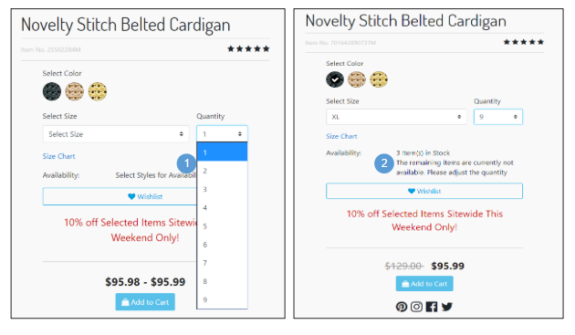 | Product Detail - Limited Inventory Message  Mobile | Desktop:  1. Quantity is a drop-down with a forced maximum (e.g., 9). By default, a quantity of 1 is selected. When a shopper selects a different quantity from the dropdown, the system checks the availability to sell (ATS) of that product.  2. If a product has less availability to sell (ATS) than the quantity selected in the dropdown, shows a limited availability message without refreshing the page. The shopper must adjust the quantity before adding the product to the cart.

5.3.2 Product Detail - Price Display & Promotion Callout Message  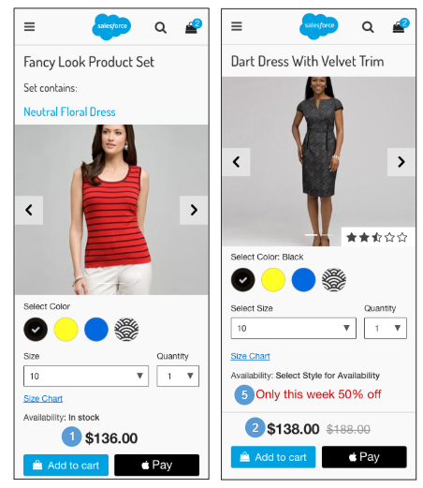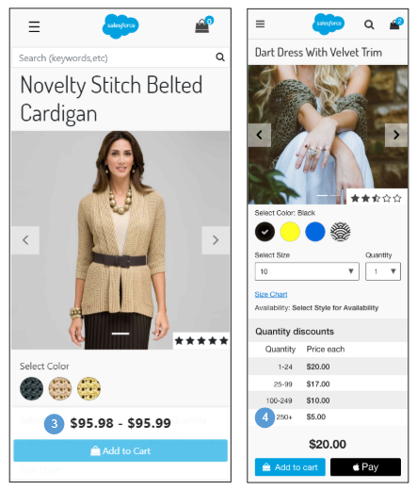 | Product Detail - Price Display & Promotion Callout Message  Mobile:  1. If a product has no sale price, shows the price as a single value. Styling is handled within the CSS (i.e., black text).  2. If a product has a sale price or a promotion price, shows the original price (with a line through it) and shows the sale or promotion price next to the original price. Styling is handled within the CSS (i.e., black text with strikethrough).  3. If the product is a master product, and if the variation products have different prices, shows a price range (lowest variation product price to highest variation product price).  4. Shows quantity discounts as a table if configured in Business Manager via the product pricebook.  5. Shows the promotion attribute ‘calloutMsg.’ Promotion ranking and compatibility rules managed in Business Manager determine which promotions are shown.  Desktop:  If configured in Business Manager, shows the promotion attribute ‘details’ in a tooltip. The tooltip isn’t shown, but rather promotion details show in an accordion format.

5.3.3 Product Detail - Choice of Bonus Product  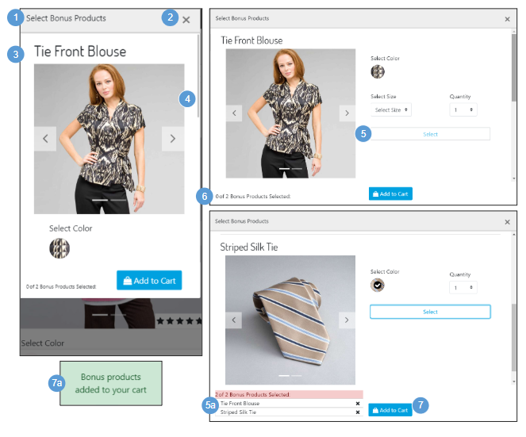 | Product Detail - Choice of Bonus Product  If a shopper adds a product to cart that makes the shopper eligible for a Choice of Bonus Product discount, the Choice of Bonus Product selection window opens.  Mobile | Desktop:  1. Shows UI text stored in a resource bundle.  2. Clicking X closes the Choice of Bonus Product window. The shopper can still select the Bonus Product for which they are eligible from the cart page (see Cart - Choice of Bonus Product for details).  3. Shows the following product attributes:  - Name  - Thumbnail Image(s)  - Variations (color, size)  - Quantity  4. The shopper can scroll through all products in the Choice of Bonus Product window. The scrolling behavior is set via CSS.  5. The shopper must select the required variations (size, color).  - After the shopper selects the required variations, the product is listed at the bottom of the window. Clicking X removes the product from the list.  6. Shows UI text that is stored in a resource bundle where [x] = number of products the shopper has selected and [y] = number of products available for selection. This UI text is configured on the promotion in Business Manager.  7. Clicking Add to Cart adds the Bonus Product to the shopper’s cart (see Cart - Choice of Bonus Product for details).  - After a product is added to the cart, the message “Bonus products added to your cart” is shown.

5.4 Product Set Detail  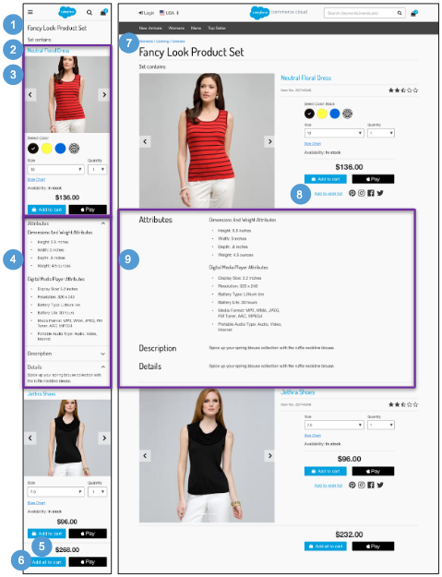 | Product Set Detail  Product Sets:  - Have unique Product IDs.  - Use the inventory and price of their component products.  - Are affected by the quantity selected for their component products.  - Cannot be added to a wishlist or gift registry.  Mobile:  1. Shows the product set attribute ‘name.’ CSS makes the name fit within the available area.  2. Shows UI text (‘Set contains’) that is stored in a resource bundle.  3. By default, shows the master product for each component product with no variations pre-selected. Shows the following product attributes for each product:  - Name - clicking opens the Product Detail page  - Thumbnail Image(s)  - Product ID  - Average Star Rating - requires a 3rd-party integration  - Product variations (color, size)  - Quantity  - Size Chart, if applicable  - Availability  - Price  - Add to Cart button  - Apple Pay button - requires a 3rd-party integration  4. By default, product attributes are collapsed. Shoppers can expand and collapse the area by using the arrows.  - Product attribute groups are derived from the product’s classification category. They are inherited from product attribute definitions of the product’s parent category.  - Shows the product attribute ‘shortDescription.’  - Shows the product attribute ‘longDescription.’  - Shows product reviews. This requires a 3rd-party integration.  5. Shows product set price UI text (‘Starting from [$x.xx]’) that is stored in a resource bundle. In the UI text, [x] equals the lowest-priced component product.  6. Clicking Add All to Cart purchases the entire product set in one operation. The Add All to Cart button is not enabled until the shopper selects the required component product variations (size, color). The Apple Pay button requires a 3rd-party integration.  Desktop:  7 .Breadcrumbs are derived from the product set primary classification configured in Business Manager.  8. Requires an integration with various social media applications.  9. By default, product attributes are expanded.  - Product attribute groups are derived from the product’s classification category. They are  - inherited from product attribute definitions of the product’s parent category.  - Shows the product attribute ‘shortDescription.'  - Shows the product attribute ‘longDescription.'  - Shows product reviews. (Requires a 3rd-party integration.)

5.5 Product Bundle Detail  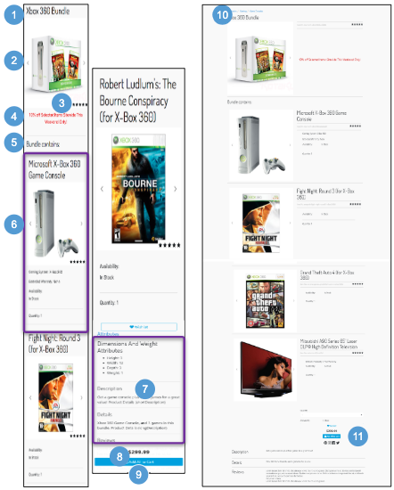 | Product Bundle Detail  Product Bundles:  - Have unique product IDs (SKUs).  - Use their own inventory and price.  - Are unaffected by the price of their component products.  - Contain specified product variations in specified quantities.  - Can be added to wishlists or gift registries.  Mobile:  1. Shows the product bundle attribute ‘name.’ CSS makes the name fit within the available area.  2. Shows the image configured on the product bundle (large view) above the individual items in the bundle.  3. Shows the product bundle’s average star rating (requires a 3rd-party integration).  4. Promotions may apply to a product bundle. The promotion applied to the product bundle doesn’t apply to the individual products when they are sold separately.  5. Shows UI text stored in a resource bundle.  6. Shows the following product attributes:  - Product Name - not clickable  - Thumbnail Image(s)  - Product ID  - Average Star Ratings - requires a 3rd-party integration.  - Product Main Attributes - configured in Business Manager.  - Specified product variation(s) (color, size)  - Product Option, if applicable  - Specified Quantity  - Availability  7. By default, product attributes are expanded.  - Product attribute groups are derived from the product’s classification category and inherited from the product’s parent category(s) product attribute definitions.  - Shows the product attribute ‘shortDescription.’  - Shows the product attribute ‘longDescription.’  - Shows product reviews. Requires a 3rd-party integration.  8. Shows the price for the entire product bundle, using standard pricing and promotional display (see Product Detail - Pricing Display & Promotion Callout Message for details).  9. Add to Cart is enabled for the entire product bundle. After the shopper adds the product bundle to the cart, the system adds the component products to the cart and the mini-cart.  Desktop:  10. Breadcrumbs are derived from the product bundle primary classification configured in Business Manager.  11. Requires an integration with various social media applications.

6.0 Quickview

6.1 Standard Product Quickview  Mobile:  Quickview is not supported in mobile design.  Desktop:  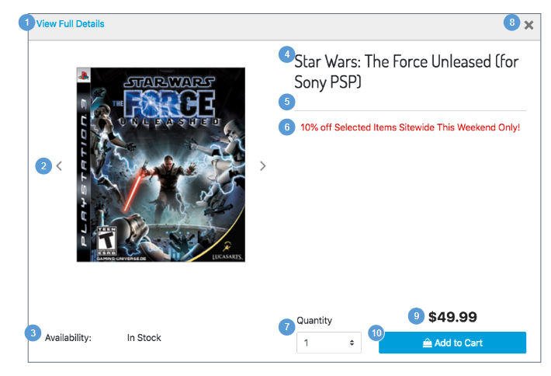 | Standard Product Quickview  This shows the module window created when a shopper clicks the Quickview icon within a product grid.  The Quickview for a standard product has similar functionality as the Quickview for a variation product, except that with a standard product there is not a variation attribute (color, size, etc) to select.  Desktop:  1. Clicking View Full Details closes the Quickview and returns the shopper to the Product Detail page (see Standard Product Detail Page for details).  2. If a product has multiple associated images associated, the shopper can use the arrows to scroll through the images.  3. If a product is available, it’s listed as ‘In-Stock.’ Out-of-stock products are not shown.  4. Shows the product attribute ‘name.’ CSS makes the name fit within the available area.  5. The product ID is derived from the ‘ID’ product attribute.  6. Shows any promotion applicable to the product. Shows the Promotional Call Out message. If multiple promotions are available, the standard Business Manager ranking is applied. The promotion is reflected in the discount pricing.  7. Quantity is a drop-down with a forced maximum (e.g., 9). By default, a quantity of 1 is selected. When a shopper selects a different quantity, the system checks the availability of that product. If the product has less ATS than the selected quantity, the system shows a limited availability message (see Limited Inventory for details).  8. Clicking X closes the Quickview panel, and the shopper is returned to the parent page.  9. The product list price and applicable sale price are shown (see Pricing and Promotions for details).  10. The Add to Cart button is enabled if the selected product is available. After the shopper adds a product to the cart, the Quickview panel closes, and the shopper is returned to the parent page. The message ‘Product added to basket’ is shown at the top of the page.  - The Apple Pay button is enabled if the selected product is available. Requires a 3rd-party integration.

6.2 Product with Option Quickview  Mobile:  Quickview is not supported in mobile design.  Desktop:  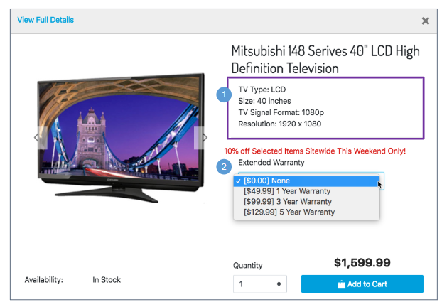 | Product with Option Quickview  The Quickview for a product with an option has the same functionality as the Quickview for a standard product (or a variation product), with the following exceptions.  Desktop:  1. Shows the product’s main attributes configured in Business Manager.  2. Shows options in a dropdown menu. Selecting an option updates the price without a full-page refresh. When the page opens, the default (first) option is preselected.  After the shopper adds the product to the cart, the Quickview panel is closed and the shopper is returned to the parent page. The message ‘Product added to basket’ is shown at the top of the page.

6.3 Variation Product Quickview  Mobile:  Quickview is not supported in mobile design.  Desktop:  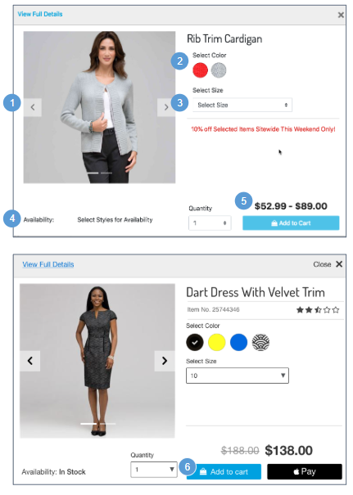 | Variation Product Quickview  The Quickview for a variation product has the same functionality as the Quickview for a standard product, with the following exceptions.  Desktop:  1. If the product is a master, shows the image defined as the master image.  If a variation product has images associated with it, when the variation product is selected, the master product images are replaced by the variation product images. (See Color and Size Selection for details.)  2. If applicable, the color variation area is populated with available colors, with the selected color indicated. If the product is a master, no variation attributes are pre-selected. (See Color and Size Selection for details.)  3. Sizes display in a dropdown, populated with available sizes.  If the product is a master product, variation attributes are not pre-selected. (See Color and Size Selection for details.)  4. If the product is a master product, the message ‘Select Styles for Availability’ is shown. This message changes based on the inventory status of products matching the selected attributes. If a product is available, the message ‘In-Stock’ is shown. If a product is on pre-order, backorder, or is out of stock, an alternative message is shown that indicates the product’s availability status (depending on the configuration and implementation).  5. If a master product has a different price than its variation products, shows a price range (lowest to highest price of the variation products).  For variation products, shows, the product list price and applicable sale price. (See Pricing and Promotions for details.)  6. The Add to Cart button is enabled if the selected product is available. If the shopper adds the product to the cart, the Quickview panel is closed, and the shopper is returned to the parent page. The message ‘Product added to basket’ is shown at the top of the page.  - An alternative payment button (like Apple Pay) may be enabled if the selected product is available (requires a 3rd-party integration).

6.4 Product Set Quickview  Mobile:  Quickview is not supported in mobile design.  Desktop:  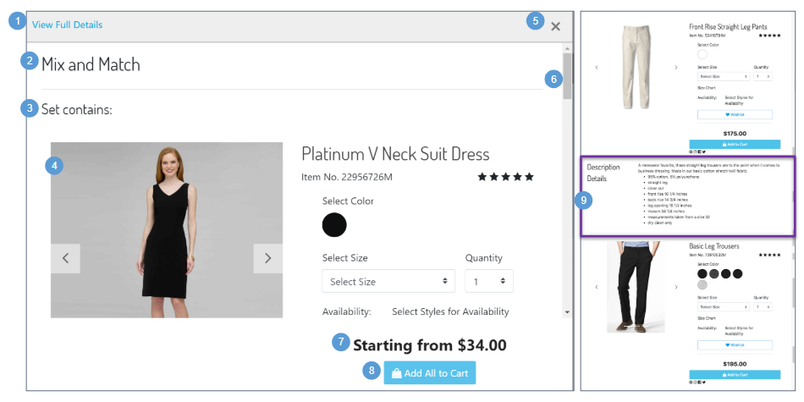 | Product Set Quickview  Desktop:  1. Clicking View Full Details closes the Quickview and returns the shopper to the product set details page.  2. The product set name is derived from the ‘name’ attribute and is controlled via CSS to ensure the length and height fit within the area.  3. Shows UI text (‘Set contains’) that is stored in a resource bundle.  4. By default, shows the master product for all individual products, with no variations pre-selected. Shows the following product attributes, as applicable:  - Product Name - clickable and navigates the shopper to that product’s detail page.  - Thumbnail Image  - Alternate Image(s)  - Product ID  - Average Star Rating - requires a 3rd-party integration  - Product variations (color, size, etc)  - Quantity  - Size Chart  - Availability  - Add to Wishlist  - Add to Gift Registry  - Price  - Add to Cart button  - Alternative Payment button (i.e., Apple Pay) - requires 3rd-party integration  - Social icons - requires 3rd-party integration(s)  5. Clicking Close (X) closes the Quickview and returns the shopper to the parent page.  6. This scrollbar enables the shopper to scroll through all items of the product set. It is set via CSS.  7. Shows UI text (‘Starting from [x]’) that is stored in a resource bundle, where [x] equals the lowest priced individual product.  8. Clicking Add All to Cart adds the entire product set to the cart. This capability is enabled if the shopper selects the appropriate product variations (i.e., size, color). After the shopper adds the product set to the cart, the Quickview panel is closed, and the shopper is returned to the parent page. The message ‘Product added to basket’ is shown at the top of the page.  - An alternative payment button (e.g., Apple Pay) might be shown, enabling the shopper to purchase the product set. (Requires a 3rd-party integration.)  9. Product content attributes are opened by default.  - Product attribute groups are derived from the product’s classification category. They are inherited from product attribute definitions of the product’s parent category.  - The product description is derived from the ‘shortDescription’ product attribute.  - ‘Product details’ is derived from the ‘longDescription’ HTML system product attribute.  - Shows product reviews. (Requires a 3rd-party integration.)

6.5 Product Bundle Quickview  Mobile:  Quickview is not supported in mobile design.  Desktop:  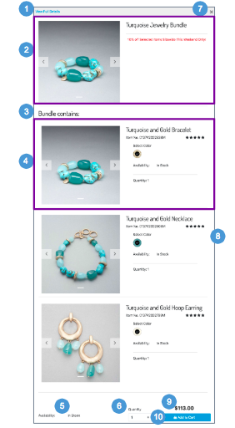 | Product Bundle Quickview  Desktop:  1. Clicking View Full Details closes the Quickview panel and returns the shopper to the product bundle details page.  2. Shows applicable product bundle attributes:  - The image configured on the product bundle master (large view) is shown above the individual items within the product bundle.  - The product bundle name is derived from the ‘name’ product attribute and controlled via CSS to ensure the length and height fit within the area.  - Promotions may apply to a product bundle. The promotion applied to the bundle doesn’t apply to the individual products when they are sold separately.  3. Shows UI text (‘Bundle contains’) that is stored in a resource bundle.  4. Shows applicable individual product attributes:  - Product Name - not clickable  - Average Sar Rating - requires a 3rd-party integration  - Product ID  - Thumbnail Image  - Alternate Image(s)  - Product Main Attributes - configured in Business Manager.  - Specified product variation(s) (i.e., color, size)  - Availability  - Product Options  - Specified Quantity  5. If a product bundle is available, it is shown as ‘In-Stock.’ Otherwise, the product bundle is not shown.  6. Quantity is a drop-down with a forced maximum (e.g., 9). By default, a quantity of 1 is selected. When a shopper selects a different quantity from the dropdown, the system checks the availability of that product. If the product has less ATS than the quantity selected, the system shows a limited availability message (see Limited Inventory for details).  7. Clicking Close (X) closes the Quickview window and returns the shopper to the parent page.  8. A scroll bar (set via CSS) enables the shopper to scroll through all items of the bundle.  9. Shows the price for the entire bundle. It uses standard pricing and promotional display (see Pricing and Promotions for details). The pricing updates if product options are present and the shopper selects an option (such as a Warranty) that has a price associated.  10. Clicking Add to Cart adds all product in the bundle to the cart and mini-cart, closes the Quickview panel, and returns the shopper to the parent page. The message ‘Product added to basket’ is shown at the top of the page..

7.0 In-Store Pickup (ISPU)

7.1 ISPU - Product Detail Page (No Saved Store)  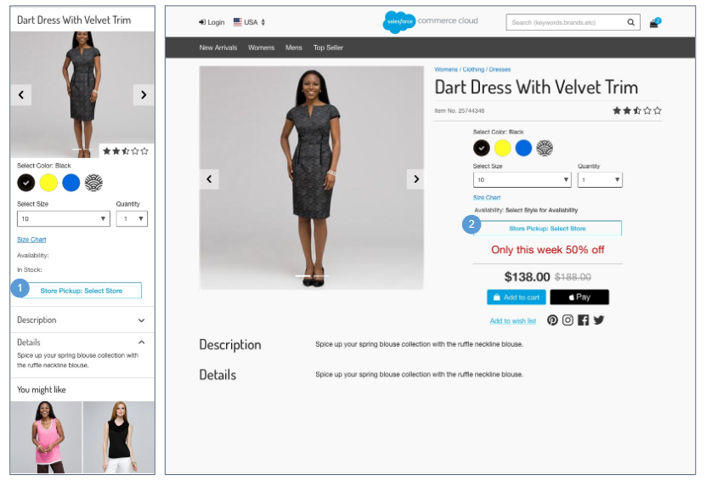 | ISPU - Product Detail Page (No Saved Store)  The Product Detail page for a product with in-store pickup has the same functionality as the Product Detail page for a standard product or a variation product, with the following exceptions  Configurations:  - Install the ‘plugin_instorepickup’ cartridge.  - Assign an active inventory book to the store record.  - Enable the product attribute ‘availableForInStorePickup.'  Mobile:  1. Clicking Store Pickup: Select Store opens the Store Selector panel (See ISPU - Enter Zip Code / Select Store for details).  Desktop:  2. Clicking Store Pickup: Select Store opens the Store Selector page in a modal window (See ISPU - Enter Zip Code / Select Store for details).

7.1.1 ISPU - Enter Zip Code / Select Store  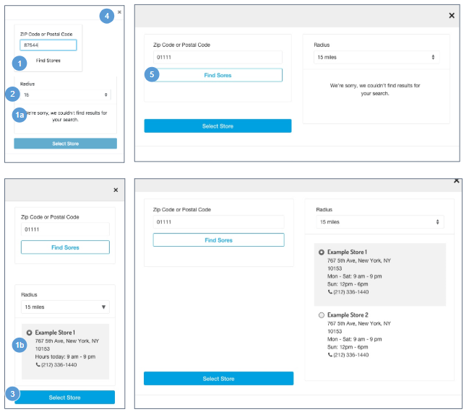  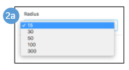 | ISPU - Enter Zip Code / Select Store  Configurations:  - Install the ‘plugin_instorepickup’ cartridge.  - Assign an active inventory book to the store record.  - Enable the product attribute ‘availableForInStorePickup.’  Mobile:  - The shopper can enter a zip code or a postal code. Clicking Find Stores searches the geographical area specified.  - Shows an error message if an incorrect postal code or zip code is entered, or if there are no matching stores for the entered code.  - The system returns all valid store locations in list view based on the zip code / postal code and radius. The following store attributes are shown:  - Store Name  - Address - Clicking opens Google Maps in a browser window with the store location pinned on the map. Store attributes for latitude and longitude must be configured in Business Manager.  - Store Hours  - Phone Number - Clicking opens a prompt to dial the store's number.  2. Radius dropdown values are stored in the plugin code (15-300 miles), the default is 15 miles. Selecting a radius value refines the search results.  Miles can be converted to kilometers via the script method ‘dw.catalog.StoreMgr.searchStoresBy.'  3. Clicking Select Store sets the store as the preferred store for the remainder of the session. The Store Selector panel closes, and the shopper is returned to the prior page showing the store information (see ISPU - Product Detail Page (Saved Store) for details).  4. Clicking Close (X) closes the panel and returns the shopper to the Product Detail page, which shows no store information (see ISPU - Product Detail Page (No Saved Store) for details).  Desktop:  5. Clicking Find Stores opens the Store Selector in a modal window (with or without results).

7.2 ISPU - Product Detail Page (Saved Store)  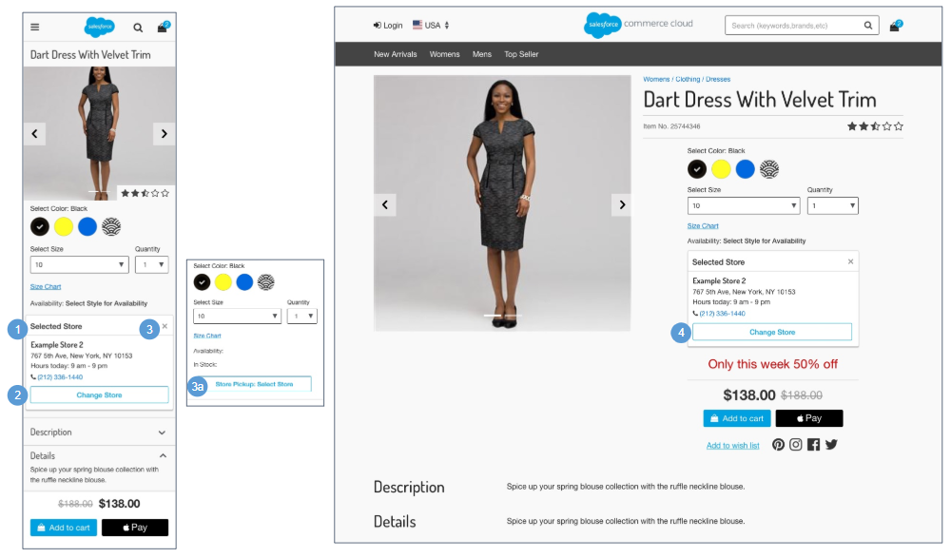 | ISPU - Product Detail Page (Saved Store)  The Product Detail page for a product with in-store pickup has the same functionality as the Product Detail page for a standard product or a variation product with the following exceptions  Configurations:  - Install the ‘plugin_instorepickup’ cartridge.  - Assign an active inventory book to the store record.  - Enable the product attribute ‘availableForInStorePickup.’  Mobile:  1. Shows the following store attributes:  - Store Name  - Store Address - Clicking opens Google Maps in a browser window with the store location pinned on the map. Store attributes for latitude and longitude must be configured in Business Manager.  - Store Hours  - Phone Number - Clicking opens the a prompt to dial the store's number.  2. Clicking Change Store opens the Store Selector panel (see ISPU - Enter Zip Code / Select Store for details).  3. Clicking X removes the saved store. The Change Store button is replaced with Store Pick-up: Select Store.  - Clicking Store Pickup: Select Stores opens the Store Selector panel (see ISPU - Enter Zip Code / Select Store for details).  Desktop:  4. Clicking Change Store opens the Store Selector page in a modal window (see ISPU - Enter Zip Code / Select Store for details).

7.3 ISPU - Cart  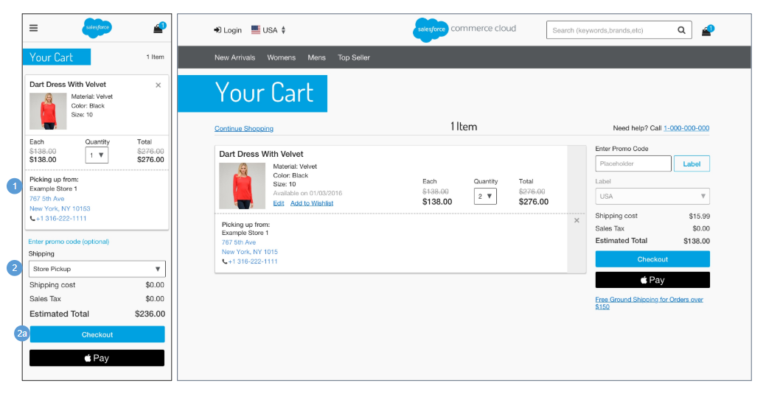 | ISPU - Cart  The cart page for a product with in-store pickup has the same functionality as the cart page for a standard product or a variation product with the following exceptions.  Configurations:  - Install the ‘plugin_instorepickup’ cartridge.  - Assign an active inventory book to the store record.  - Enable the product attribute ‘availableForInStorePickup.’  Mobile | Desktop:  1. If the shopper has a store saved in their session, shows the text ‘Picking up From’ and the following store attributes:  - Store Name  - Store Address - Clicking opens Google Maps in a browser window with the store location pinned on the map. Store attributes for latitude and longitude must be configured in Business Manager.  - Phone Number - Clicking opens the phones prompt to dial the store's number.  2. If the shopper does not have a store saved in their session, they can select Store Pickup in the Shipping Method dropdown.  - For guest shoppers, clicking Checkout opens the Checkout Login page (see Checkout - Login for details). For registered shoppers, clicking Checkout opens the Shipping Address | Shipping Method page with the Store Selector panel blank (see ISPU - Shipping Address | Shipping Method (No Saved Store) for details).

7.4 ISPU - Shipping Address | Shipping Method (No Saved Store)  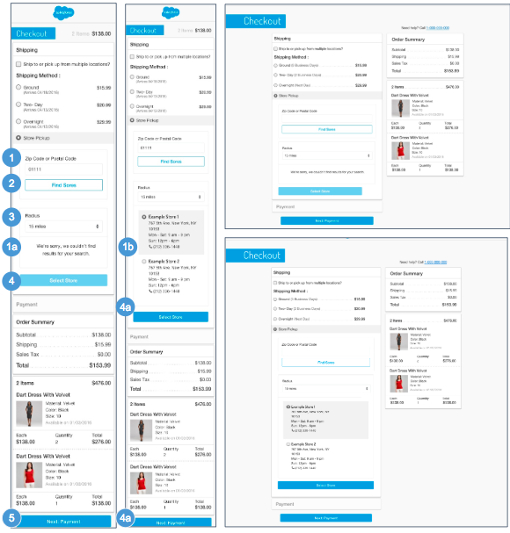  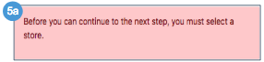 | ISPU - Shipping Address | Shipping Method (No Saved Store)  The shopper is presented this page if they do not have a saved store in their session. The shopper can select Store Pickup from the Shipping Method panel.  The Shipping Address | Shipping Method page for a product with in-store pickup has the same functionality as the Shipping Address | Shipping Method page for a standard product or a variation product with the following exceptions.  Configurations:  - Install the ‘plugin_instorepickup’ cartridge.  - Assign an active inventory book to the store record.  - Enable the product attribute ‘availableForInStorePickup.’  Mobile| Desktop:  1. The shopper can enter a zip code or a postal code.  - Shows an error if an incorrect postal code or zip code is entered, or if there are no matching stores.  - Shows all valid store locations in list view based on the zip code / postal code and radius. The following store attributes are shown:  - Store Name  - Store Address - Clicking opens Google Maps in a browser window with the store location pinned on the map. Store attributes for latitude and longitude must be configured in Business Manager.  - Store Hours  - Phone Number - Clicking opens a prompt to dial the store's number.  2. Clicking Find Stores searches the geographical area specified.  3. Radius dropdown values are stored in a .properties file (15-300 miles), the default is 15 miles. Selecting a radius value refines the search results.  Miles can be converted to kilometers via the script method ‘dw.catalog.StoreMgr.searchStoresBy.'  4. The Select Store button is inactive until at least 1 store is returned in the result set.  - Clicking Select Store sets the store as the preferred store for the remainder of the session.  5. This button is active even if all required fields are not filled in. Clicking Next: Payment opens the Billing & Payment Method page (see ISPU - Billing & Payment Method for details).  - An error message is shown if the shopper clicks Next: Payment without first selecting a store by clicking Select Store.
7.5 ISPU - Shipping Address | Shipping Method (Saved Store)  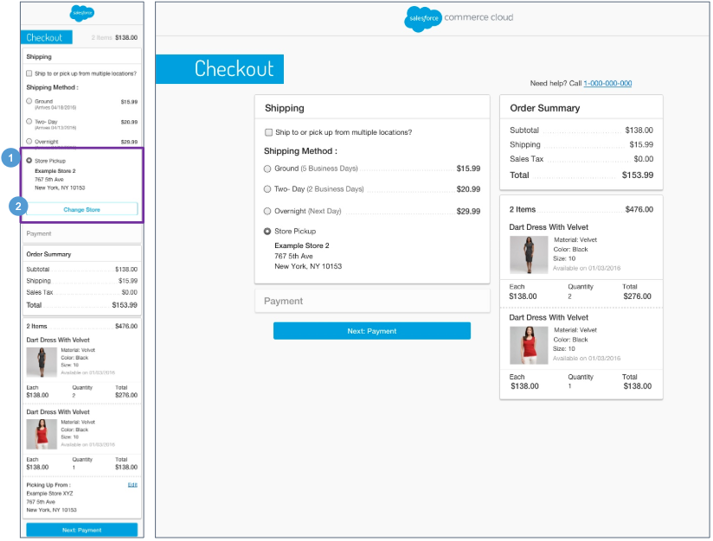 | ISPU - Shipping Address | Shipping Method (Saved Store)  The shopper is presented this page if they have a saved store in their session.  The Shipping Address | Shipping Method page for a product with in-store pickup has the same functionality as the Shipping Address | Shipping Method page for a standard product or a variation product with the following exceptions.  Configurations:  - Install the ‘plugin_instorepickup’ cartridge.  - Assign an active inventory book to the store record.  - Enable the product attribute ‘availableForInStorePickup.’  Mobile | Desktop:  1. The selected store is shown under Shipping Method: Store Pickup. The following store attributes are shown:  - Store Name  - Store Address - Clicking opens Google Maps in a browser window with the store location pinned on the map. Store attributes for latitude and longitude must be configured in Business Manager.  - Store Hours  - Phone Number - Clicking opens a prompt to dial the store's number.  2. Clicking Change Store removes the saved store details. The Store Locator panel opens and shows the previous search (see ISPU - Shipping Address (No Saved Store) for details).

7.6 ISPU - Billing Address | Payment Method  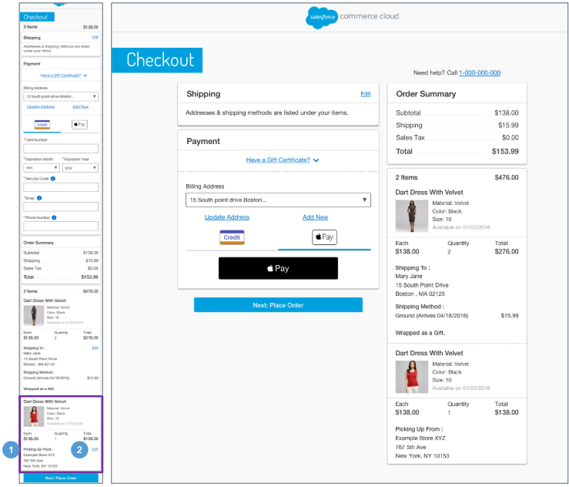 | ISPU - Billing Address | Payment Method  The Billing Address | Payment Method page for a product with in-store pickup has the same functionality as the Billing Address | Payment Method for a standard product or a variation product with the following exceptions.  Configurations:  - Install the ‘plugin_instorepickup’ cartridge.  - Assign an active inventory book to the store record.  - Enable the product attribute ‘availableForInStorePickup.’  Mobile | Desktop:  1. Shows store attributes:  - Store Name  - Store Address  - Phone Number  2. Clicking Edit opens the Store Locator page, enabling the shopper to perform a new store search.

7.7 ISPU - Place Order  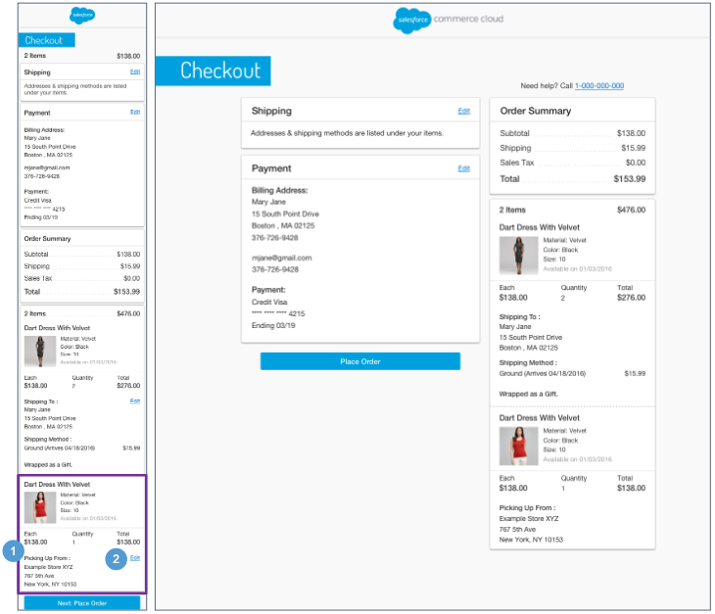 | ISPU - Place Order  The Place Order page for a product with in-store pickup has the same functionality as the Place Order page for a standard product or a variation product with the following exceptions.  Configurations:  - Install the ‘plugin_instorepickup’ cartridge.  - Assign an active inventory book to the store record.  - Enable the product attribute ‘availableForInStorePickup.’  Mobile | Desktop:  1. Shows store attributes:  - Store Name  - Store Address  - Phone Number  2. Clicking Edit opens the Store Locator page, enabling the shopper to perform a new store search.

7.8 ISPU - Order Receipt  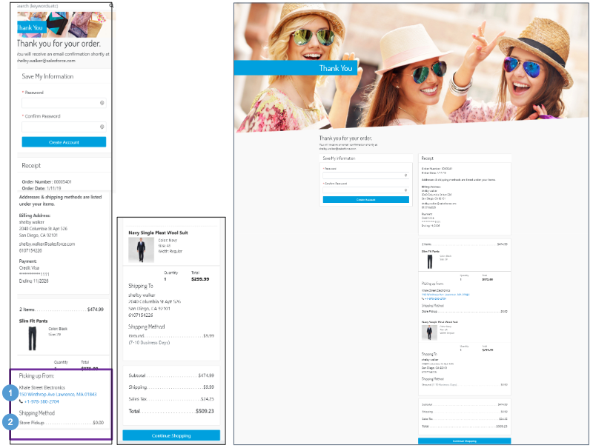 | ISPU - Order Receipt  The Order Receipt page for a product with in-store pickup has the same functionality as the Order Receipt page for a standard product or a variation product with the following exceptions.  Configurations:  - Install the ‘plugin_instorepickup’ cartridge.  - Assign an active inventory book to the store record.  - Enable the product attribute ‘availableForInStorePickup.’  Mobile | Desktop:  - Shows store attributes:  - Store Name  - Store Address - Clicking opens Google Maps in a browser window with the store location pinned on the map. Store attributes for latitude and longitude must be configured in Business Manager.  - Phone Number - Clicking opens a prompt to dial the store's number.  2. Shipping Method is shown as Store Pickup with a $0.00 shipping charge.

7.9 ISPU - Order History  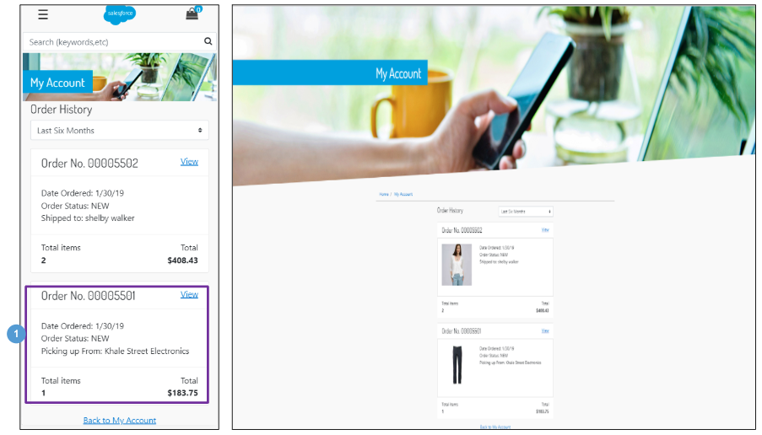 | ISPU - Order History  The Order History page for a product with in-store pickup has the same functionality as the Order History page for a standard product or a variation product with the following exceptions.  Mobile | Desktop:  1. Shows a compact view of the store details ‘Picking up from: [store name].’

7.10 ISPU - Order Detail  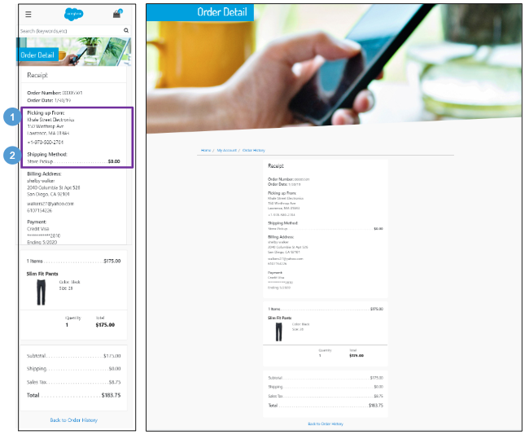 | ISPU - Order Detail  The Order Detail page for a product with in-store pickup has the same functionality as the Order Detail page for a standard product or a variation product with the following exceptions.  Configurations:  - Install the ‘plugin_instorepickup’ cartridge.  - Assign an active inventory book to the store record.  - Enable the product attribute ‘availableForInStorePickup.’  Mobile | Desktop:  1. Shows store attributes:  - Store Name  - Store Address.  - Phone Number  2. Shipping Method is shown as Store Pickup with a $0.00 shipping charge.

8.0 Mini-Cart | Cart

8.1 Mini-Cart  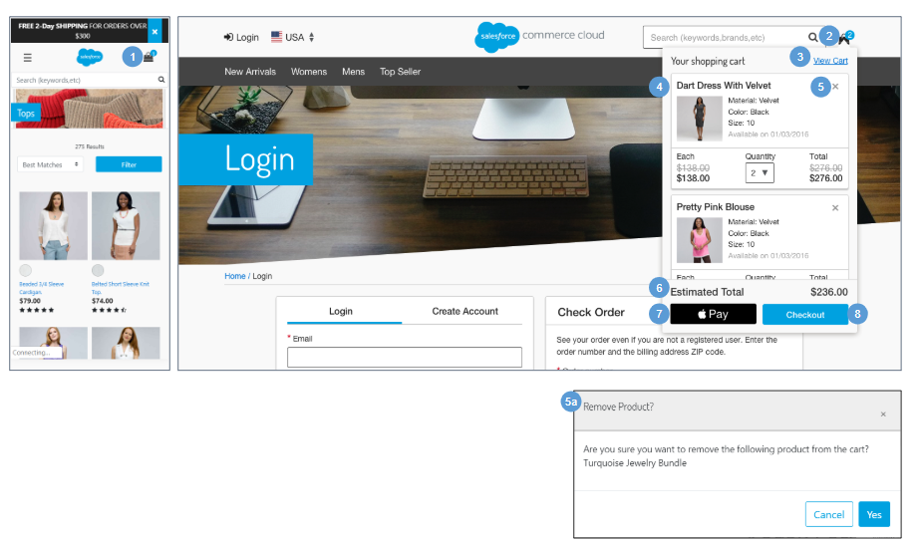 | Mini-Cart  Mobile:  1. The mini-cart is not shown on mobile. Clicking the Shopping Bag opens the cart page (see Cart for details).  Desktop:  2. Hovering over the Shopping Bag opens the mini-cart. If there are no items in the cart, the mouseover state is disabled.  3. Clicking View Cart or the Shopping Bag icon opens the cart page. If the cart is empty, the empty cart page opens (see Cart- Empty Cart for details).  4. Shows a scroll bar in the product area if more than 2 products are listed in the cart. The number of products shown in the mini-cart is defined in the code.  Shows a newly added product on the bottom of the cart. The following product attributes are shown:  - Name  - Variations (i.e., color, size, width)  - Availability Message  - Quantity  - Price - individual price, total product price, applicable discounted price.  Product attributes such as color and size are not editable. The shopper can update the product quantity, which updates the price total.  5. Clicking (X) opens the remove product confirmation modal window.  - Selecting Cancel closes the modal window, and the product remains in the cart. Selecting Yes removes the product from the cart.  6. Shows estimated total price of the line items in the mini-cart. Shipping cost and tax are not included in the total.  7. The shopper can checkout using Apple Pay. Requires a 3rd-party integration.  8. For guest shoppers, clicking Checkout opens the Checkout Login page (see Checkout - Login for details).  For registered shoppers, clicking Checkout opens the Shipping Address page (See Checkout - Shipping Address (Registered) for details).

8.2 Cart - Empty Cart  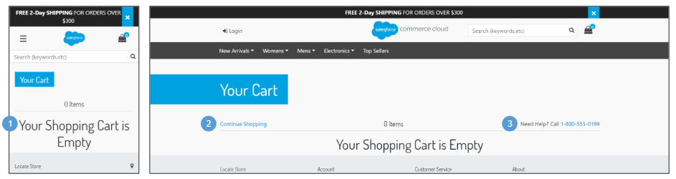 | Cart - Empty Cart  The Empty Shopping Cart page is shown when a shopper attempts to navigate to the cart page without any products previously added to cart.  Mobile:  1. When no products are in the cart, the message ‘Your Shopping Cart is Empty’ is shown. UI text for this message is stored in the ‘cart.properties’ file (in the ‘info.cart.empty.msg’ property).  Desktop:  2. Clicking Continue Shopping opens the homepage.  3. UI text is stored in the ‘checkout.properties’ file (in the ‘msg.Guest.checkout1’ property and the ‘msg.Guest.checkout2’ property). Clicking the phone number opens the a prompt to dial the store's number.

8.3 Cart - Cart with Products  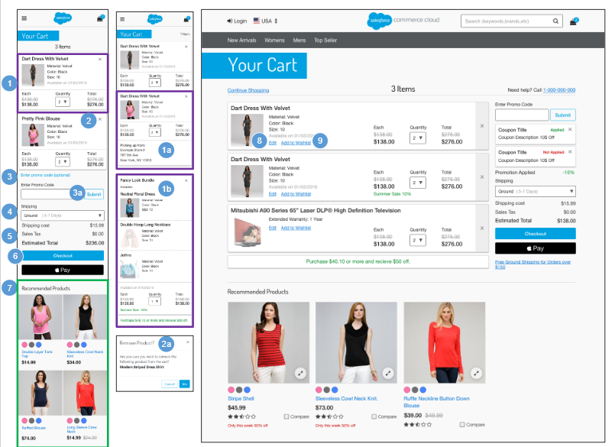 | Cart - Cart with Products  Mobile | Desktop:  - Shows the following product attributes:  - Product Name  - Thumbnail Image  - Selected Variations (i.e., size, color, and width)  - Availability Message  - Individual Price  - Quantity  - Total Product Price  - Example In-Store Pickup (ISPU)  - Example Bundle  2. Clicking (X) opens the Remove Product Confirmation modal window.  - Selecting Cancel closes the modal window, and the product remains in the cart. Selecting Yes removes the product from the cart.  3. Shoppers can enter coupon codes only on the Cart page. Clicking Enter promo code opens the Promo Code Entry box.  - Clicking Submit applies the promo code to the order.  4. Shows valid shipping methods based on the rules configured in Business Manager. The default method configured is pre-selected.  5. Order Summary information displays:  - Shipping Cost - based on shipping method selected.  - Sales Tax - sales tax calculation is done using the standard B2C Commerce tax functionality, unless a 3rd-party integration is used.  - Order Subtotal - total of all line items in the cart after product promotions are applied. This subtotal is the merchandise total price without order-level discounts. The sum of all order-level discounts is shown below “Order Discount.”  6. For guest shoppers, clicking Checkout opens the Checkout - Login page (see Checkout - Login for details). For registered shoppers, clicking Checkout opens the Shipping Address | Shipping Method page (see Shipping Address | Shipping Method (Registered) for details).  - An alternative payment method (like Apple Pay) button may also be enabled, if a 3rd-party integration is in place.  7. Shows the content slot ‘m-cart-footer.’  Desktop:  8. Clicking Edit opens the product Quickview, enabling the shopper to make last-minute changes to product attributes (size color).  9. For guest shoppers, Clicking Add to Wishlist adds the product to the shopper’s temporary wishlist (see Wishlist - Guest View (Temporary Wishlist) for details). For registered shoppers, Clicking Add to Wishlist adds the product to the shoppers wishlist (see Wishlist - Registered View for details).

8.4 Cart - Coupon & Promotions  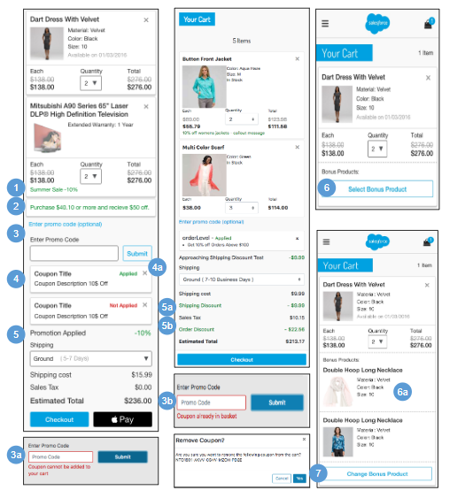 | Cart - Coupon & Promotions  Mobile | Desktop:  1. If the Cart qualifies for a product-level discount, the promotion attribute ‘calloutMsg’ is shown, and the list price has a strikethrough with the promotion price shown underneath.  2. Shows the additional amount a shopper must purchase to receive a promotional discount, as configured in Business Manager (‘Alert on Approaching Discount’). This feature is applicable for the following types of promotions:  - Order promotion with amount of order merchandise total.  - Shipping promotion with amount of shipment merchandize total.  3. Shoppers can enter coupon codes only on the Cart page. Clicking Enter promo code opens the promo code entry box.  - If the shopper enters an invalid coupon code, the message ‘Coupon cannot be added to your Cart’ is shown.  - If the shopper enters the same code that has already been applied, the message ‘Coupon is already in basket’ is shown  4. After a shopper submits a valid promo code, the code is applied to the order. The promotion attribute ‘calloutMsg’ displays under the text “Applied.”  - Clicking (X) opens the remove coupon confirmation modal window. Clicking Cancel closes the modal window, and the coupon remains in the cart. Clicking Yes removes the coupon from cart.  5. If the cart qualifies for an order level discount, the promotion attribute ‘calloutMsg’ displays next to the discount value. If the cart qualifies for a free shipping discount, the promotion attribute ‘name’ displays next to the method and discount value.  - The order level discount value is shown as “Order Discount” in the order summary.  - The shipping discount value is shown as “Shipping Discount” in the order summary.  6. If a shopper is eligible for a choice of bonus product promotion, the shopper can select the bonus product on the cart page. Clicking Select Bonus Product opens the the choice of bonus product window (see Product Detail - Choice of Bonus Product for details).  - On successful section, the bonus product displays. The shopper must remove the qualifying product to remove the bonus product from cart.  7. The shopper can change the selected bonus product on the cart page. Clicking Change Bonus Product opens the the choice of bonus product window (see Product Detail - Choice of Bonus Product for details).

9.0 Checkout (Registered & Guest)

9.1 Checkout - Login  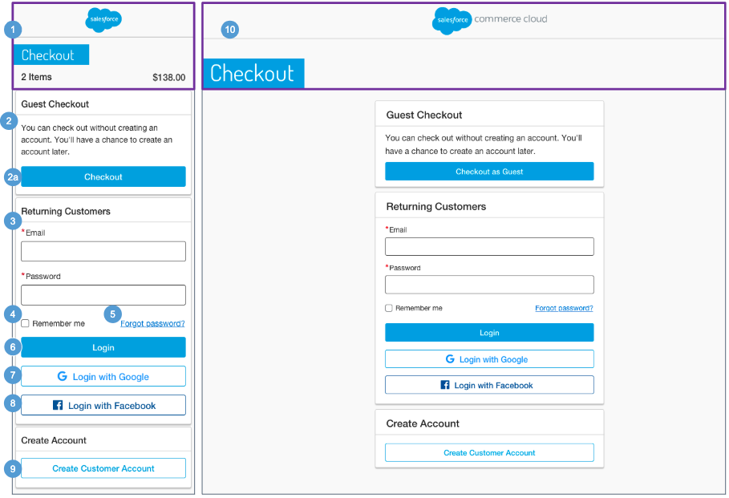 | Checkout - Login  The shopper has the option to checkout as a guest or as a registered user.  Mobile:  1. Shows a modified header. The total number of items in the cart and the total price are shown. Clicking the company logo opens the homepage.  2. Shows UI text is stored in the ‘checkout.properties’ file (in the ‘msg.Guest.checkout1’ and the ‘msg.Guest.checkout2’ properties).  - Clicking Checkout as Guest opens the guest shopper Shipping Address | Shipping Method page (see Checkout - Shipping Address | Shipping Method (Guest) for details).  3. The shopper must enter their login credentials. Mandatory fields are a valid email address and password.  4. Clicking Remember Me saves the shopper’s email and password information for future sessions.  5. Clicking Forgot Password opens the password recovery window (see My Account - Forget Password for details).  6. Clicking Login opens the registered shopper’s Shipping Address | Shipping Method page (see Checkout - Shipping Address | Shipping Method (Registered) for details).  If the shopper enters invalid login information, an invalid login error message is shown.  7. The shopper can Login via Google. Requires a 3rd-party integration.  8. The shopper can Login via Facebook. Requires a 3rd-party integration.  9. Clicking Create Customer Account opens the Create Account page (see My Account - Create an Account for details).  Desktop:  10. Shows a modified header. Clicking the company logo opens the homepage.

9.2 Registered Checkout
9.2.1 Checkout - Shipping Address | Shipping Method (Registered)  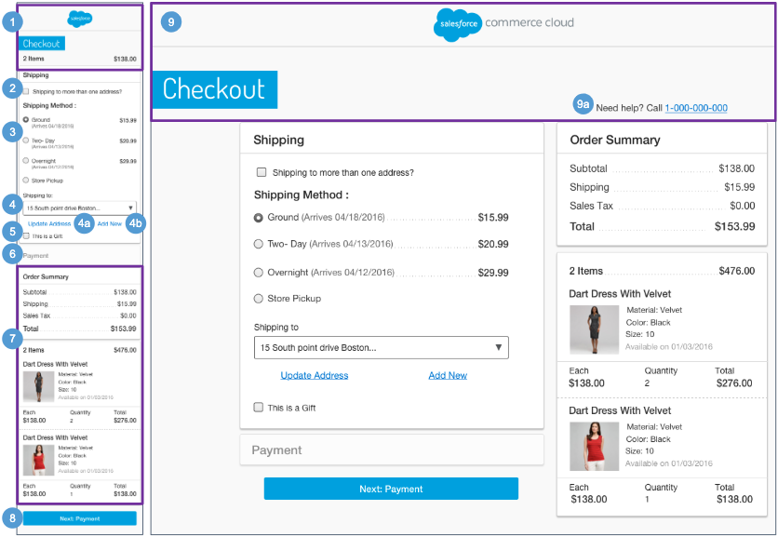 | Checkout - Shipping Address | Shipping Method (Registered)  Mobile:  1. Shows a modified header throughout the checkout experience. The total number of items in the cart and the total price are shown. Clicking the company logo opens the homepage.  2. If the shopper has multiple SKUs in their cart, they are given the option to ship the products to multiple addresses (See Multi-Ship Checkout for details).  3. Shows valid shipping methods that are based on the rules configured in Business Manager. The default method is selected. This list of Shipping Method options is dynamically updated based on the address selected / entered (state, country, PO Box, etc).  4. Registered shoppers can select a saved address from the dropdown list (if they have at least one saved address in their address book). The address set as the default address is shown first.  - Clicking Update Address opens the Shipping Address form with the corresponding fields auto-filled. Shoppers can edit the auto-filled fields, but this does not modify the saved address.  - Clicking Add Address opens the Shipping Address form with no fields pre-filled.  5. The ‘This is a gift’ checkbox is unchecked by default. Clicking the checkbox opens a message field. The field is limited to 250 characters and renders using the available width. The message is sent in the order export to the Order Management System.  6. The Payment section is blank until a payment method has been added.  7. The Order Summary section is persistent throughout the checkout experience.  - Order Subtotal - total of all line items in the cart after product promotions have been applied. It is the merchandize total price without order level discount. The sum of all order level discounts are shown below as ‘Order Discount.’  - Shipping / Tax - total shipping and total sales tax. Sales tax calculation is done using the standard Commerce Cloud tax functionality unless a 3rd-party integration is used.  - Total Price - total of the all the lines added or subtracted from the Order Subtotal.  - Total Products - total number of products in the order.  - Shows the following product attributes:  - Product Name  - Thumbnail Image  - Selected Variations (i.e., size, color, width)  - Availability Message  - Individual Price  - Quantity  - Total Product Price  8. Clicking Next: Payment opens the registered shopper’s Billing Address | Payment Method page after all fields are validated without error. This button is active even if all required fields are not filled in. If the form is not valid, the appropriate error messages are shown.  Desktop:  9. Shows a modified header throughout the checkout experience. Clicking the company logo opens the homepage.  - UI text is stored in the ‘cart.properties’ file (in the ‘info.need.help’ property) and in the ‘common.properties’ file (in the ‘info.phone.number’ property).  Clicking the number opens a prompt to dial the phone number.

9.2.2 Checkout - Billing Address | Payment Method (Registered)  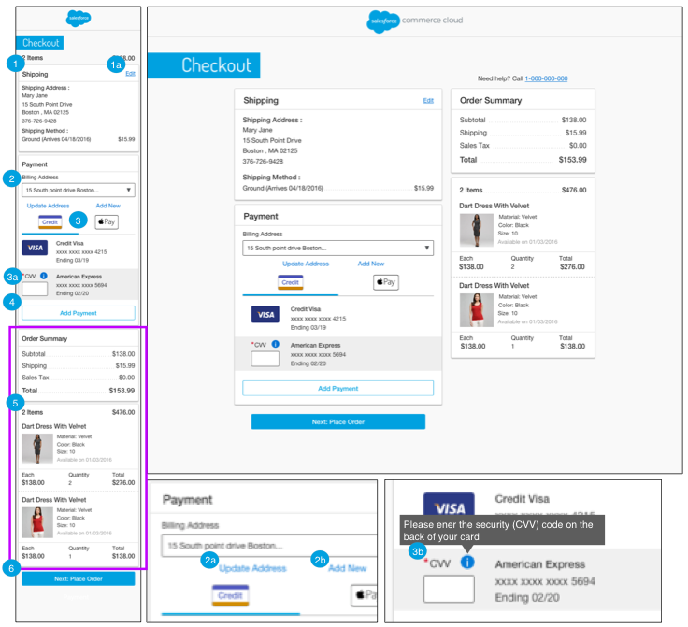 | Checkout - Billing Address | Payment Method (Registered)  Mobile | Desktop::  - Shows the selected Shipping Address, Shipping Method, and shipping cost.  - Shows the shipping address attributes:  - First Name  - Last Name  - Address  - City, State, Zip Code  - Phone Number  - Shows the shipping method attributes:  - Shipping Method  - Shipping Cost  - Clicking Edit opens the registered shopper’s Shipping Address | Shipping Method page. The updated Shipping Address and Shipping Method data are carried forward throughout the checkout process.  2. The shopper can select a saved address from the dropdown list (if they have at least one saved address in their my account address book). See Checkout - Update | Add New Shipping Address for details.  - Clicking Update Address opens the address form with the corresponding fields auto-filled. The shopper can edit the auto-filled fields but this does not modify the saved address.  - Clicking Add Address opens the address form with the fields blank.  3. The shopper can select a saved payment method from the list (if they have at least one saved payment method in their my account payment method book). The shopper can select Apply Pay as a payment method. The plugin_apple_pay to be installed properly.  - When applicable, the shopper must enter the security (CVV) code on the back of the selected credit card.  - Clicking the CVV help icon opens a tooltip. Text is stored in the ‘creditCard.properties’ file (in the ‘tooltip.security.code’ property).  4. Clicking Add Payment Method opens the Payment Method form with the fields blank (see Checkout - Add New Payment Method for details).  5. The Order Summary section is persistent throughout the checkout experience. Shows Order Subtotal, Shipping Cost, Sales Tax, and Product information (see Checkout - Shipping Address | Shipping Method (Registered) for details).  6. After the shopper submits a valid form, the Place Order page opens. If the form is not valid, the Billing Address | Payment Method page remains open with appropriate error messaging.  .

9.2.3 Checkout - Place Order (Registered)  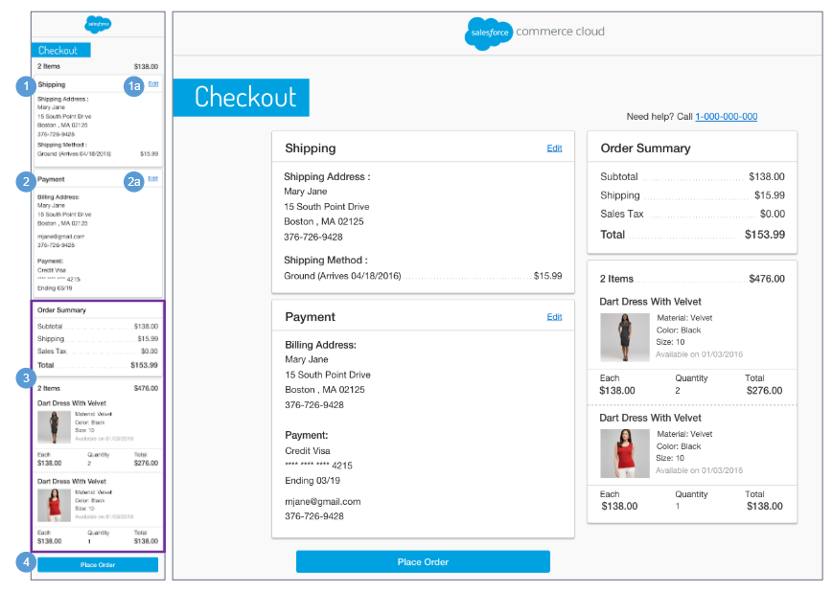 | Checkout - Place Order (Registered)  The Place Order page represents the final page on which the registered shopper can make changes to their order.  Mobile | Desktop:  1. Shows the selected Shipping Address, Shipping Method, and shipping cost.  - Shows shipping address attributes:  - First Name  - Last Name  - Address  - City, State, Zip Code  - Phone Number  - Shows shipping method attributes:  - Shipping Method  - Shipping Cost  - Clicking Edit opens the registered shopper’s Shipping Address | Shipping Method page. The updated Shipping Address and Shipping Method data are carried forward throughout the checkout process.  2. Shows the selected Billing Address and payment method.  - Shows billing address attributes:  - First Name  - Last Name  - Address  - City, State, Zip Code  - Email Address  - Phone Number  - Shows payment method attributes:  - Credit Card Type  - Credit Card Number - masked except last 4 digits  - Expiration Date  - Clicking Edit opens the registered shopper’s Billing Address | Payment Method page. The updated Billing Address and / or Payment Method data is carried forward throughout the checkout process.  3. The Order Summary section is persistent throughout the checkout experience. Shows Order Subtotal, Shipping Cost, Sales Tax, and Product information (see Checkout - Shipping Address | Shipping Method (Registered) for details).  4. Clicking Place Order initiates payment authorization. After authorizing the shopper, the system opens the Order Receipt page, allocates inventory to the order, and creates an order with status ‘New.’ If the system cannot authorize the shopper, an appropriate message is shown to the shopper.

9.2.4 Checkout - Order Receipt (Registered)  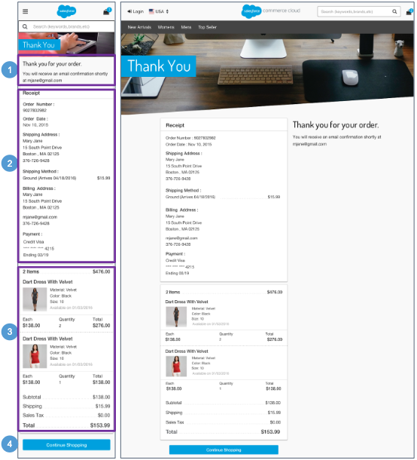 | Checkout - Order Receipt (Registered)  Mobile | Desktop:  1. Text is stored in the scss.  2. The Order Receipt contains order related information:  - Order Number  - Creation Date  - Shipping Address  - First Name  - Last Name  - Address  - City, State, Zip Code  - Phone Number  - Shipping Method  - Shipping Method  - Shipping Cost  - Billing Address  - First Name  - Last Name  - Address  - City, State, Zip Code  - Email Address  - Phone Number  - Payment Information  - Credit Card Type  - Credit Card Number - masked except last 4 digits  - Expiration Date  3. The Order Summary section is persistent throughout the checkout experience. Shows Order Subtotal, Shipping Cost, Sales Tax, and Product information (see Checkout - Shipping Address | Shipping Method (Registered) for details).  4. Clicking Continue Shopping opens the homepage.

9.3 Guest Checkout
9.3.1 Checkout - Shipping Address | Shipping Method (Guest)  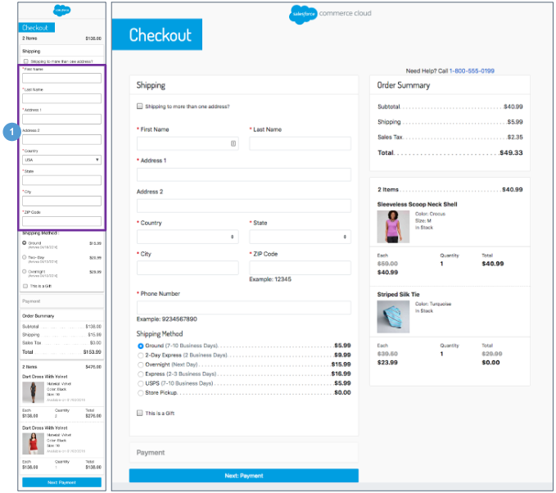 | Checkout - Shipping Address | Shipping Method (Guest)  The Shipping Address | Shipping Method page for a guest shopper has the same functionality as the Shipping Address | Shipping Method page for a registered shopper with the following exceptions (see Checkout - Shipping Address | Shipping Method (Registered) for details).  Mobile | Desktop:  1. The default for a guest shopper is that no shipping information is pre-filled in the Shipping Address form fields. The shopper must add a Shipping Address. All fields are required except for Address:  - First Name  - Last Name  - Address 1  - Address 2  - Country  - State  - City  - Zip Code  - Phone Number

9.3.2 Checkout - Billing Address | Payment Method (Guest)  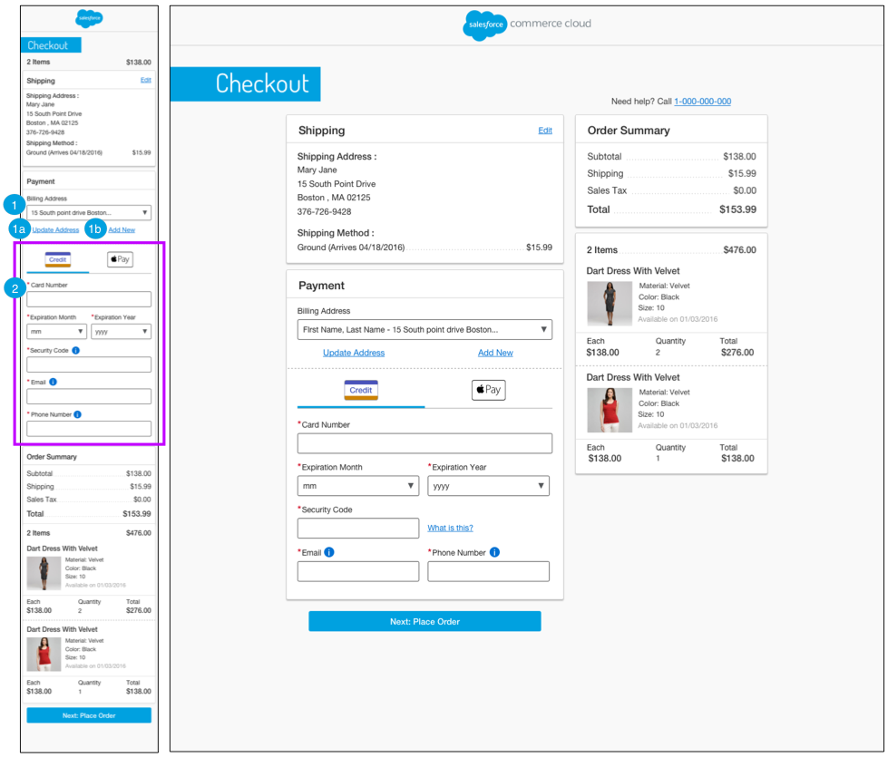 | Checkout - Billing Address | Payment Method (Guest)  The Billing Address | Payment Method page for a guest shopper has the same functionality as the Billing Address | Payment Method page for a registered shopper, with the following exceptions (see Checkout - Billing Address | Payment Method (Registered) for details).  Mobile | Desktop:  1. The default for a guest shopper is that the Shipping Address entered on the previous page is carried over and provided as the Billing Address, so the shopper does not have to enter it again. The shopper can select a different saved address from the dropdown menu.  - Clicking Update Address opens the Billing Address form with the corresponding fields auto-filled. The shopper can edit the auto-filled fields but this does not modify the saved address.  - Clicking Add New opens the Billing Address form with the fields blank.  2. The default for a guest shopper is that no payment information is pre-filled in the Payment Method form fields. The shopper must add a payment method. All fields are required.  - Card Number  - Expiration Month  - Expiration Year  - Security Code  - Email Address  - Phone Number  When the shopper enters the credit card number, the form dynamically updates to show the fields associated with the type of credit card.

9.3.3 Checkout - Place Order (Guest)  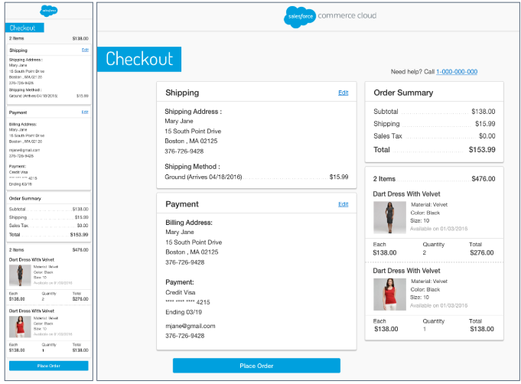 | Checkout - Place Order (Guest)  Mobile | Desktop:  The Place Order page for a guest shopper has the same functionality as the Place Order page for a registered shopper (see Checkout - Place Order (Registered) for details).

9.3.4 Checkout - Order Receipt (Guest)  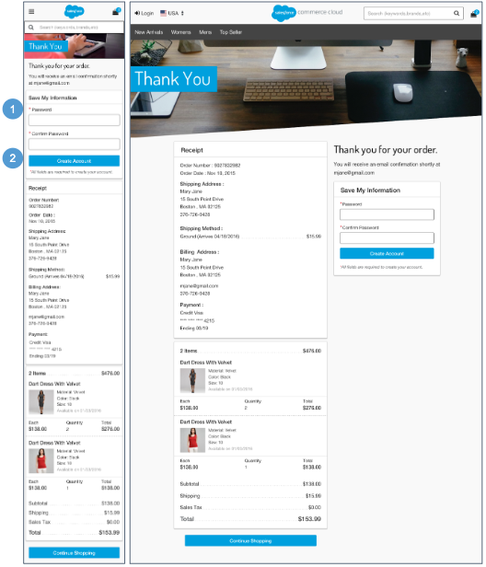 | Checkout - Order Receipt (Guest)  The Order Receipt page for a guest shopper has the same functionality as the Order Receipt page for a registered shopper, with the following exceptions (see Checkout - Order Receipt (Registered) for details).  Mobile | Desktop:  1. If shoppers are unauthenticated at the time of checkout, they are given the ability to save their information and create an account by entering a password and confirming the password.  2. Clicking Create Account opens the shopper’s My Account Dashboard page (see My Account Dashboard for details).

9.4 Checkout - Update | Add New Shipping Address  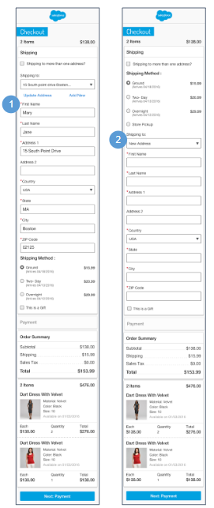 | Checkout - Update | Add New Shipping Address  Mobile | Desktop:  - Clicking Update Address opens the Shipping Address form with the corresponding fields auto-filled. The shopper can edit the auto-filled fields but this does not modify the saved address.  - Clicking Add New opens the Shipping Address form with the fields blank.

9.5 Checkout - Update | Add New Billing Address  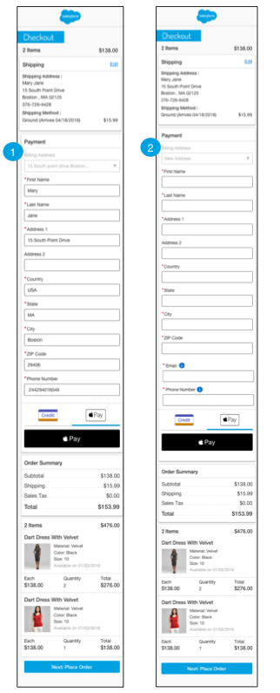 | Checkout - Update | Add New Billing Address  Mobile | Desktop:  1. Clicking Update Address opens the Billing Address form with the corresponding fields auto-filled. The shopper can edit the auto-filled fields but this does not modify the saved address.  2. Clicking Add New opens the Billing Address form with the fields blank.

9.6 Checkout - Add Payment Method  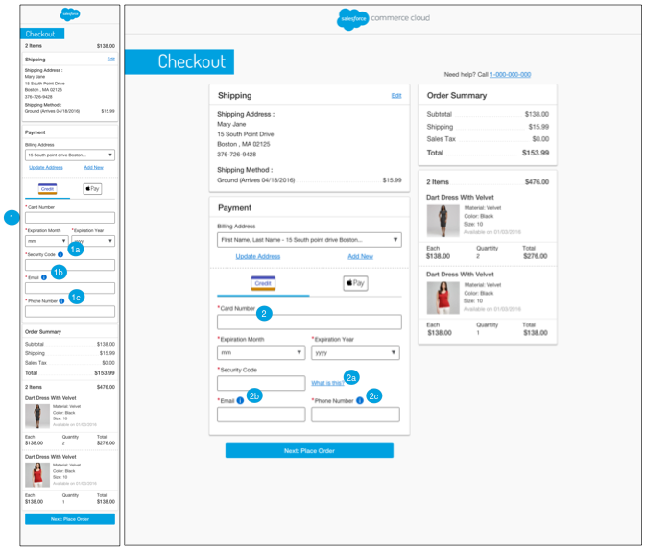 | Checkout - Add Payment Method  Mobile:  - When the shopper enters the credit card number, the form dynamically updates to show the fields associated with the type of credit card.  - Clicking the CVV help icon opens a tooltip. The tooltip text is stored in the ‘creditCard.properties’ file (in the ‘tooltip.security.code’ property).  - Clicking the email help icon opens a tooltip. The tooltip text is stored in the ‘creditCard.properties’ file (in the ‘tooltip.email’ property).  - Clicking the phone help icon opens a tooltip. The tooltip text is stored in the ‘creditCard.properties’ file (in the ‘tooltip.phone.number’ property).  Desktop:  2. When the shopper enters the credit card number, the form dynamically updates to show the fields associated with the type of credit card.  - Hovering over the CVV help icon opens a tooltip. The tooltip text is stored in the ‘creditCard.properties’ file (in the ‘tooltip.security.code’ property).  - Hovering over the email help icon opens a tooltip. The tooltip text is stored in the ‘creditCard.properties’ file (in the ‘tooltip.email’ property).  - Hovering over the phone help icon opens a tooltip. The tooltip text is stored in the ‘creditCard.properties’ file (in the ‘tooltip.phone.number’ property).

10.0 Multi-Ship Checkout

10.1 Multi-Ship Checkout (Registered)
10.1.1 Multi-Ship - Shipping Address / Shipping Method (Registered)  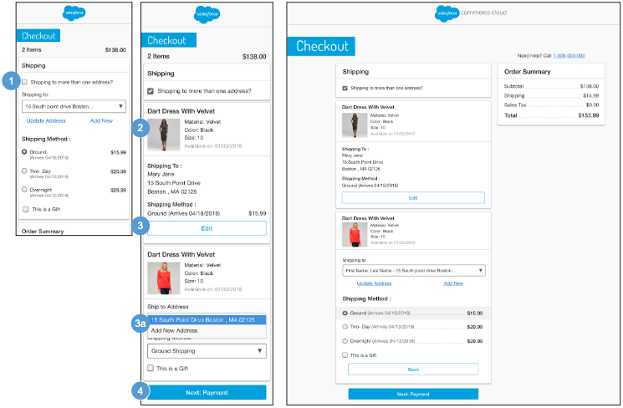 | Multi-Ship - Shipping Address | Shipping Method (Registered)  If a registered shopper has multiple items in their basket, they are given the option to ship the products to multiple addresses on the registered shopper’s Shipping Address | Shipping Method page. The default value is single shipment, which means all items in the basket are shipped to the same address.  Mobile| Desktop:  1. Clicking the Shipping To More Than One Address checkbox lets the shopper elect to ship items to multiple addresses. Once the multi-ship checkbox is selected, the items in the cart are listed individually.  2. The shopper’s default address from their my account address book and the default Shipping Method configured in Business Manager are shown for each line item. The following product attributes are shown:  - Name  - Thumbnail Image  - Selected Variations (i.e., size, color, width)  3. The shopper can edit the Shipping Address and Shipping Method per item.  - Clicking Edit opens the Shipping Address | Shipping Method page with the fields auto-filled. (see Multi-Ship Checkout - Edit Shipping Address | Shipping Method (Registered) for details).  4. Clicking Next: Payment opens the registered shopper’s Multi-Ship Billing Address | Payment Method page after all fields are validated without error. This button is active even if all required fields are not filled in. If the form is not valid, the appropriate error messages are shown.

10.1.2 Multi-Ship - Edit Shipping Address | Shipping Method (Registered)  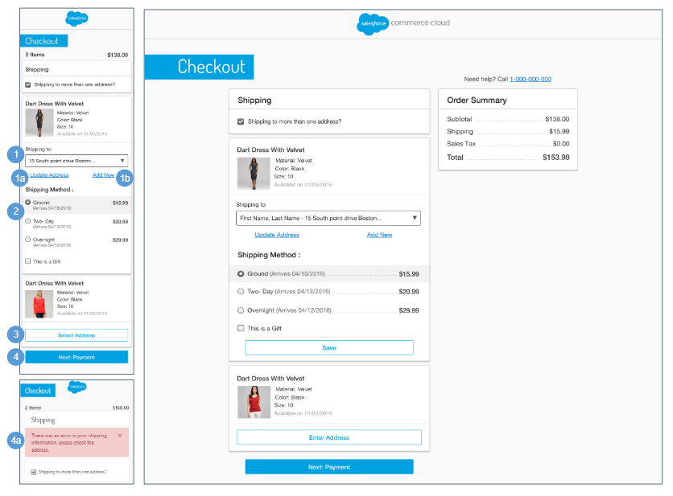 | Multi-Ship - Edit Shipping Address | Shipping Method (Registered)  Mobile | Desktop:  1. Shows stored addresses in a dropdown list for each line item. The shopper’s default address is listed first in the dropdown.  - Clicking Update Address opens the Shipping Address form with fields auto-filled. Updating the address updates all product line items in the same shipment.  - Clicking Add New opens the Shipping Address form with the fields blank. This changes the shipping information only for the selected product line item without affecting other product line items.  If one or more items are from one or more wishlists or gift registries (with multiple items in the cart), the wishlist or gift registry item dropdown is shown with its associated default address.  2. Valid Shipping Methods are shown based on the rules configured in Business Manager. The default method is pre-selected. This list of Shipping Method options is dynamically updated based on the address selected / entered (state, country, PO Box, etc).  3. Clicking Save Address saves the address information for that line item.  4. Clicking Next: Payment opens the registered shopper’s Multi-Ship Billing Address | Payment Method page after all fields are validated without error. This button is active even if all required fields are not filled in.  - If the form is not valid, the appropriate error messages is shown

10.1.3 Multi-Ship - Billing Address | Payment Method (Registered)  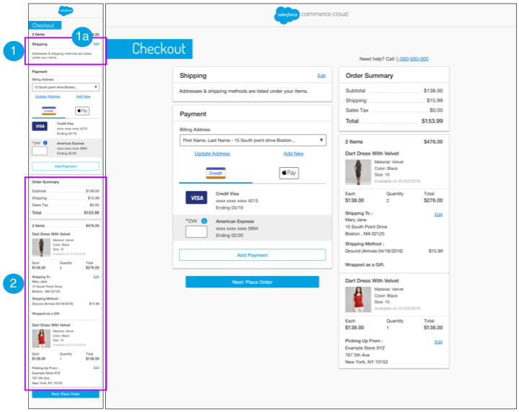 | Multi-Ship - Billing Address | Payment Method (Registered)  The Billing Address | Payment Method page for a multi-ship order has the same functionality as the Billing Address | Payment Method page for a single ship order with the following exceptions (see Checkout - Billing Address | Payment Method (Registered) for details).  Mobile | Desktop:  - Text is stored in the ‘order.properties’ file (in the ‘order.summary.section.text’ property).  - Clicking Edit opens the registered shopper’s Multi-Ship Shipping Address | Shipping Method page (see Multi-Ship Shipping Address | Shipping Method (Registered for details). The updated Shipping Address and Shipping Method data are carried forward throughout the multi-ship checkout process.  2. The Order Summary section is persistent throughout the multi-ship checkout experience.  - Order Subtotal - total of line items in the cart after product promotions are applied. It is the merchandize total price without order level discount. The sum of all order level discounts are shown below as “Order Discount”.  - Shipping / Tax - total shipping and total sales tax. Sales tax calculation is done using the standard B2C Commerce tax functionality, unless a 3rd-party integration is used.  - Total Price - total of the all the lines added or subtracted from the Order Subtotal.  - Total Products - total number of products in the order.  - The following product attributes are shown:  - Product Name  - Thumbnail Image  - Selected Variations (i.e., size, color, width)  - Availability Message  - Individual Price  - Quantity  - Total Product Price  - The following shipping address attributes are shown:  - First Name  - Last Name  - Address  - City, State, Zip Code  - Phone Number  - The following shipping method attributes are shown:  - Shipping Method  - Shipping Cost

10.1.4 Multi-Ship - Place Order (Registered)  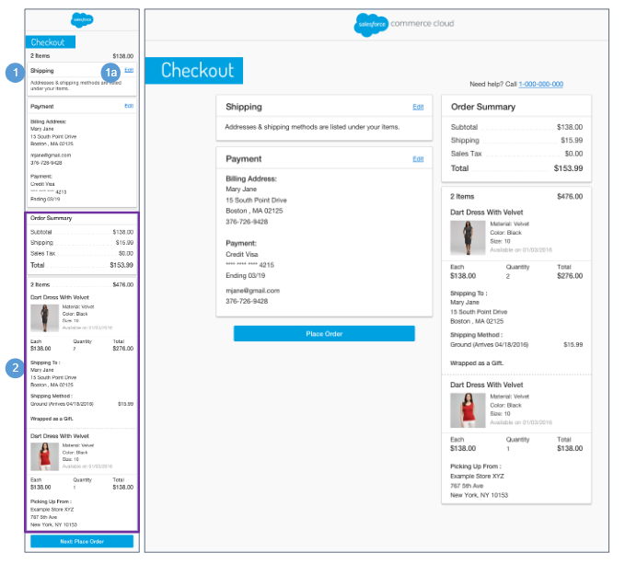 | Multi-Ship - Place Order (Registered)  The Place Order page for a multi-ship order has the same functionality as the Place Order page for a single ship order with the following exceptions (see Checkout - Place Order (Registered) for details).  Mobile | Desktop:  1. Shows UI text that is stored in the ‘order.properties’ file (in the ‘order.summary.section.text’ property).  - Clicking Edit opens the registered shopper’s Multi-Ship Shipping Address | Shipping Method page (see Multi-Ship Shipping Address | Shipping Method (Registered) for details). The updated Shipping Address and Shipping Method data are carried forward throughout the multi-ship checkout process.  2. The Order Summary section is persistent throughout the multi-ship checkout experience.  - Order Subtotal - total of all line items in the cart after product promotions have been applied. It is the merchandize total price without order level discount. The sum of all order level discounts are shown below as “Order Discount”.  - Shipping / Tax - total shipping and total sales tax. Sales tax calculation is done using the standard B2C Commerce tax functionality unless a 3rd-party integration is used.  - Total Price - total of the all the lines added or subtracted from the Order Subtotal.  - Total Products - total number of products in the order.  - The following product attributes are shown:  - Product Name  - Thumbnail Image  - Selected Variations (i.e., size, color, width)  - Availability Message  - Individual Price  - Quantity  - Total Product Price  - The following shipping address attributes are shown:  - First Name  - Last Name  - Address  - City, State, Zip Code  - Phone Number  - The following shipping method attributes are shown:  - Shipping Method  - Shipping Cost

10.1.5 Multi-Ship - Order Receipt (Registered)  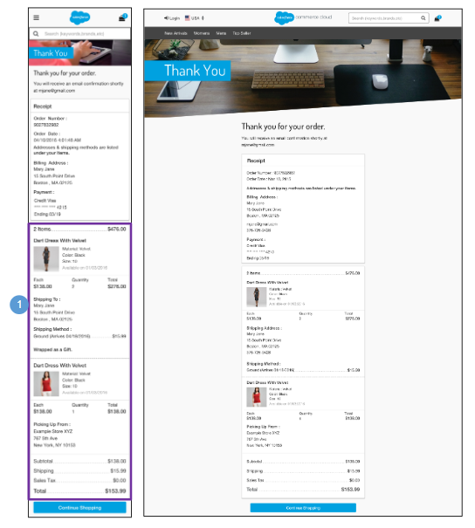 | Multi-Ship - Order Receipt (Registered)  The Order Receipt page for a multi-ship order has the same functionality as the Order Receipt page for a single ship order (see Checkout - Order Receipt (Registered) for details).  Mobile | Desktop:  1. The Order Summary section is persistent throughout the multi-ship checkout experience.  - Order Subtotal - total of all line items in the cart after product promotions have been applied. It is the merchandize total price without order level discount. The sum of all order level discounts are shown below as “Order Discount”.  - Shipping / Tax - total shipping and total sales tax. Sales tax calculation is done using the standard B2C Commerce tax functionality unless a 3rd-party integration is used.  - Total Price - total of the all the lines added or subtracted from the Order Subtotal.  - Total Products - total number of products in the order.  - The following product attributes are shown:  - Product Name  - Thumbnail Image  - Selected Variations (i.e., size, color, width)  - Availability Message  - Individual Price  - Quantity  - Total Product Price  - The following shipping address attributes are shown:  - First Name  - Last Name  - Address  - City, State, Zip Code  - Phone Number  - The following shipping method attributes are shown:  - Shipping Method  - Shipping Cost

10.2 Multi-Ship Checkout (Guest)
10.2.1 Multi-Ship - Shipping Address | Shipping Method (Guest)  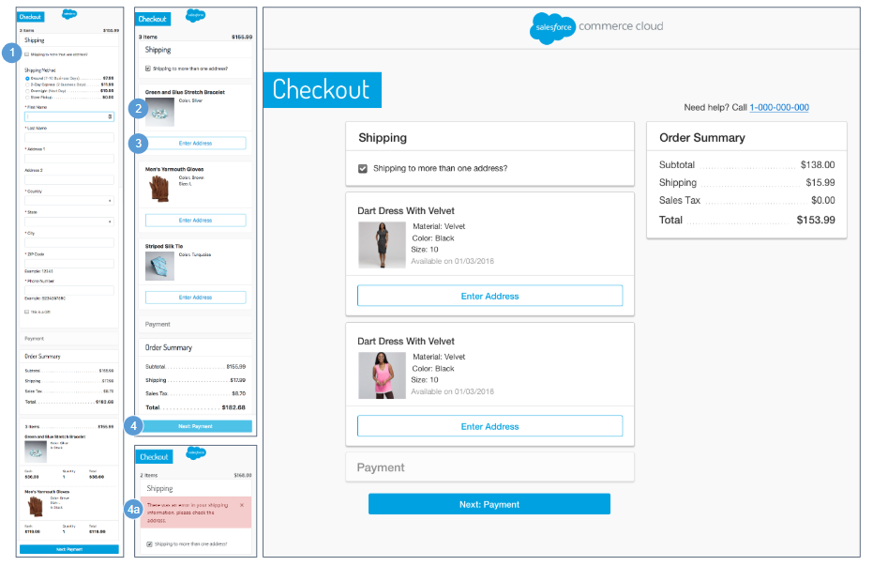 | Multi-Ship - Shipping Address | Shipping Method (Guest)  If the shopper has multiple items in their basket, the shopper is given the option to ship the products to multiple addresses on the guest shopper Shipping Address | Shipping Method page. The default value is single shipment, which means all items in the basket are shipped to the same address.  Mobile | Desktop:  1. Clicking the Shipping To More Than One Address checkbox lets the shopper elect to ship items to multiple addresses. Once the multi-ship checkbox is selected, the items in the cart are listed individually.  2. The following product attributes are shown:  - Name  - Thumbnail Image  - Selected Variations (i.e., size, color, width).  3. The shopper can add the Shipping Address and Shipping Method per item. Clicking Enter Address opens the Shipping Address form with the fields blank. The default Shipping Method is selected.  4. Clicking Next: Payment opens the guest shopper Multi-Ship Billing Address | Payment Method page after all fields are validated without error. This button is active even if all required fields are not filled in.  - If the form is not valid, the appropriate error messages are shown.

10.2.2 Multi-Ship - Billing Address | Payment Method (Guest)  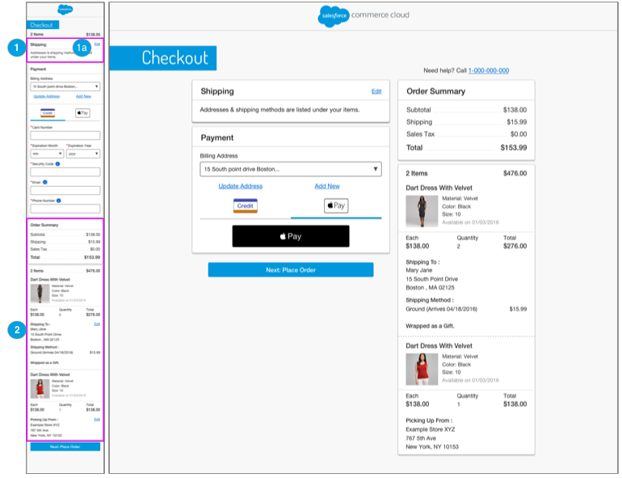 | Multi-Ship - Billing Address | Payment Method (Guest)  The Billing Address | Payment Method page for a multi-ship order has the same functionality as the Billing Address | Payment Method page for a single ship order with the following exceptions (see Checkout - Billing Address | Payment Method (Guest) for details).  Mobile | Desktop:  1. Shows UI Text that is stored in the ‘order.properties’ file (in the ‘order.summary.section.text’ property).  - Clicking Edit opens the guest shopper’s Multi-Ship Shipping Address | Shipping Method page (see Multi-Ship Shipping Address | Shipping Method (Guest) for details). The updated Shipping Address and Shipping Method data are carried forward throughout the multi-ship checkout process.  2. The Order Summary section is persistent throughout the multi-ship checkout experience.  - Order Subtotal - total of all line items in the cart after product promotions have been applied. It is the merchandize total price without order level discount. The sum of all order level discounts are shown below as “Order Discount”.  - Shipping / Tax - total shipping and total sales tax. Sales tax calculation is done using the standard B2C Commerce tax functionality unless a 3rd-party integration is used.  - Total Price - total of the all the lines added or subtracted from the Order Subtotal.  - Total Products - total number of products in the order.  - The following product attributes are shown:  - Product Name  - Thumbnail Image  - Selected Variations (i.e., size, color, width)  - Availability Message  - Individual Price  - Quantity  - Total Product Price  - The following shipping address attributes are shown:  - First Name  - Last Name  - Address  - City, State, Zip Code  - Phone Number  - The following shipping method attributes are shown:  - Shipping Method  - Shipping Cost

10.2.3 Multi-Ship - Place Order (Guest)  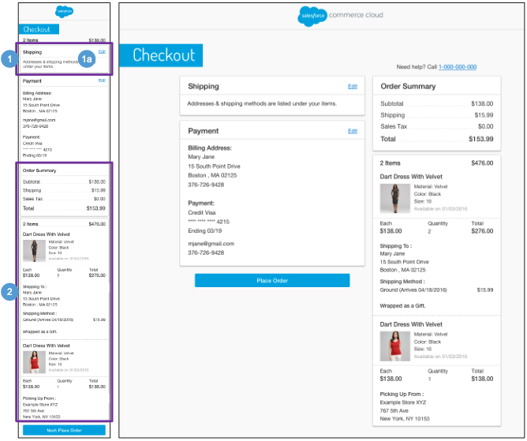 | Multi-Ship - Place Order (Guest)  The Place Order page for a multi-ship order has the same functionality as the Place Order page for a single ship order with the following exceptions (see Checkout - Place Order (Guest) for details).  Mobile | Desktop:  1. Shows UI Text that is stored in the ‘order.properties’ file (in the ‘order.summary.section.text’ property).  - Clicking Edit opens the guest shopper’s Multi-Ship Shipping Address | Shipping Method page (see Multi-Ship Shipping Address | Shipping Method (Guest) for details). The updated Shipping Address and Shipping Method data are carried forward throughout the multi-ship checkout process.  2. The Order Summary section is persistent throughout the multi-ship checkout experience.  - Order Subtotal - total of all line items in the cart after product promotions have been applied. It is the merchandize total price without order level discount. The sum of all order level discounts are shown below as “Order Discount”.  - Shipping / Tax - total shipping and total sales tax. Sales tax calculation is done using the standard B2C Commerce tax functionality, unless a 3rd-party integration is used.  - Total Price - total of the all the lines added or subtracted from the Order Subtotal.  - Total Products - total number of products in the order.  - The following product attributes are shown:  - Product Name  - Thumbnail Image  - Selected Variations (i.e., size, color, width)  - Availability Message  - Individual Price  - Quantity  - Total Product Price  - The following shipping address attributes are shown:  - First Name  - Last Name  - Address  - City, State, Zip Code  - Phone Number  - The following shipping method attributes are shown:  - Shipping Method  - Shipping Cost

10.2.4 Multi-Ship - Order Receipt (Guest)  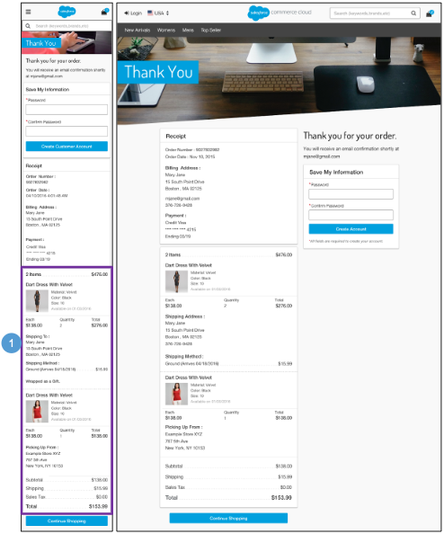 | Multi-Ship - Order Receipt (Guest)  The Order Receipt page for a multi-ship order has the same functionality as the Order Receipt page for a single ship order (see Checkout - Order Receipt (Guest) for details).  Mobile | Desktop:  1. The Order Summary section is persistent throughout the multi-ship checkout experience.  - Order Subtotal - total of all line items in the cart after product promotions have been applied. It is the merchandize total price without order level discount. The sum of all order level discounts are shown below as “Order Discount”.  - Shipping / Tax - total shipping and total sales tax. Sales tax calculation is done using the standard B2C Commerce tax functionality, unless a 3rd-party integration is used.  - Total Price - total of the all the lines added or subtracted from the Order Subtotal.  - Total Products - total number of products in the order.  - The following product attributes are shown:  - Product Name  - Thumbnail Image  - Selected Variations (i.e., size, color, width)  - Availability Message  - Individual Price  - Quantity  - Total Product Price  - The following shipping address attributes are shown:  - First Name  - Last Name  - Address 1  - Address 2  - City, State, Zip Code  - Phone Number  - The following shipping method attributes are shown:  - Shipping Method  - Shipping Cost

11.0 My Account

11.1 My Account - Login  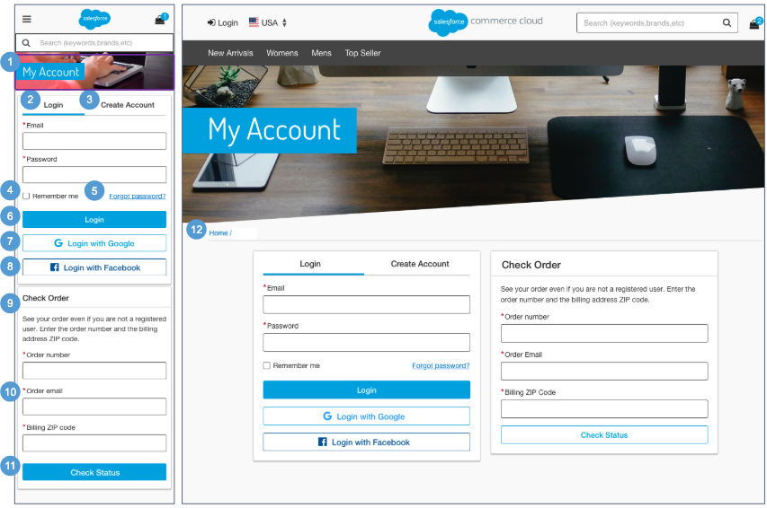  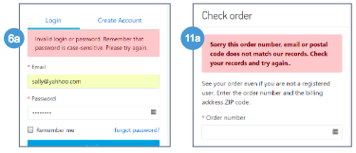 | My Account - Login  Mobile:  1. The account banner image and text is stored in a .properties file. The banner remains persistent through the My Account experience.  2. The shopper must enter their login credentials. Mandatory fields are a valid email address and password.  3. Clicking Create Account opens the Create Account tab (see My Account - Create an Account for details)  4. Clicking Remember Me saves the shopper’s email and password information for future sessions.  5. Clicking Forgot Password opens the password recovery window (see My Account - Forget Password for details).  6. After the shopper logs in, the shopper is taken to the My Account Dashboard page.  - If the shopper enters invalid login information, an error message is shown.  7. The shopper can Login via Google. Requires a 3rd-party integration.  8. The shopper can Login via Facebook. Requires a 3rd-party integration.  9. Shows UI Text that is stored in the ‘login.properties’ file (in the ‘header.form.trackorder.text’ property).  10. To check an order, the shopper must enter an order number, order email address, and billing ZIP code. Both registered and unregistered shoppers can enter their order information in this area.  11. After correctly entering the mandatory fields, the shopper is returned to the Order Details page.  - If the shopper enters an invalid order number and / or billing postcode, an error message is shown.  Desktop:  12. The breadcrumb is: Home. Clicking Home opens the homepage.

11.2 My Account Dashboard  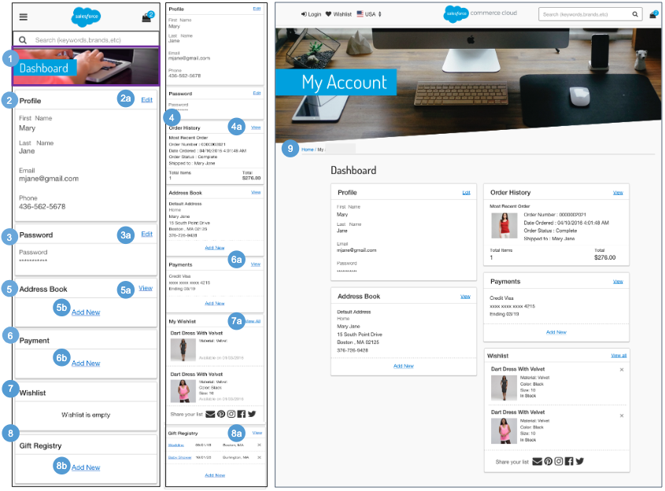 | My Account Dashboard  After the shopper logs into My Account, the dashboard shows information about the shopper’s account.  Mobile:  1. The account banner image and text is stored in a .properties file. The banner remains persistent through the My Account experience.  2. Shows account profile attributes:  - First Name  - Last Name  - Email Address  - Phone Number  - Clicking Edit opens the Edit Profile page (see My Account - Edit Profile for details).  3. Password information is masked.  - Clicking Edit opens the Edit Password page (see My Account - Edit Password for details).  4. The system shows the most recent order. Order history attributes are shown:  - Order Number  - Creation Date  - Order Status  - Shipped To First Name] [Last Name]  - Number of Items  - Order Amount  - Clicking View opens the Order History Landing page (see My Account - Order History Landing for details).  5. Shows the shopper’s default address attributes:  - Nickname  - First Name  - Last Name  - Address  - City, State, Zip / postal code  - Country  - Phone Number  - The View link is shown if at least one stored address exists. Clicking View opens the Payment Method page (see My Account - Payment Method page for details).  - Clicking New opens the Add Address page (see My Account - Add Address for details).  6. Shows the shopper’s default credit card. Payment method attributes are shown::  - Card Type  - Card Number - last four digits masked  - Expiration Date  - The View link is shown if at least one payment method exists. Clicking View opens the Payment Method page (see My Account - Payment Method page for details).  - Clicking Add New opens the Add Payment page (see My Account - Add Payment Method for details).  7. Shows the last two items added to the shopper’s wishlist.. Product attributes are shown:  - Thumbnail Image  - Product Name  - Selected Variation(s) (i.e., size, color)  - Price  - Availability Message  - Clicking View opens the shopper’s Wishlist page (see Wishlist - Registered View for details).  8. Shows a list of Gift Registries created by the registered shopper. Gift registry attributes are shown:  - Event Name - clicking opens the gift registry.  - Event Date  - Event City, State  Clicking X opens the remove gift registry confirmation window. Clicking Cancel closes the modal window, and the shopper remains on the my account dashboard page. Clicking Yes removes the gift registry from the shopper’s account.  - Clicking View opens the manage gift registries page (see Manage Gift Registries for details).  - Clicking Add New opens the Create Gift Registry page (see Create Gift Registry - Event Information for details)  Desktop:  9. Clicking Home in the breadcrumb opens the homepage.

11.3 My Account - Edit Profile  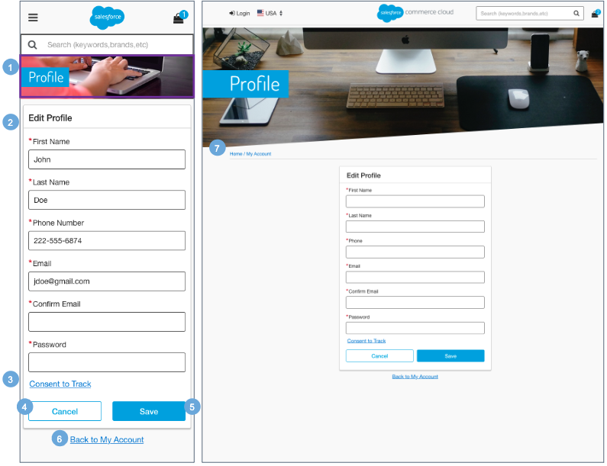 | My Account - Edit Profile  Mobile:  1. The account banner image and text is stored in a .properties file. The banner remains persistent through the My Account experience.  2. A returning shopper's first name, last name, phone number, and email address are pre-filled from stored account information.  To change profile information, the shopper is required to re-enter their email address and enter their current password.  3. Clicking Content to Track sets the ‘setTrackingAllowed’ in the session.  4. Clicking Cancel returns the shopper to the My Account Dashboard page.  5. Clicking Save saves the changes to the shopper's profile.  6. Clicking Back to My Account returns the shopper to the My Account Dashboard page (see My Account Dashboard for details).  Desktop:  7. The breadcrumb is: Home | My Account. Clicking My Account opens the My Account Dashboard page. Clicking Home opens the homepage.

11.4 My Account - Edit Password  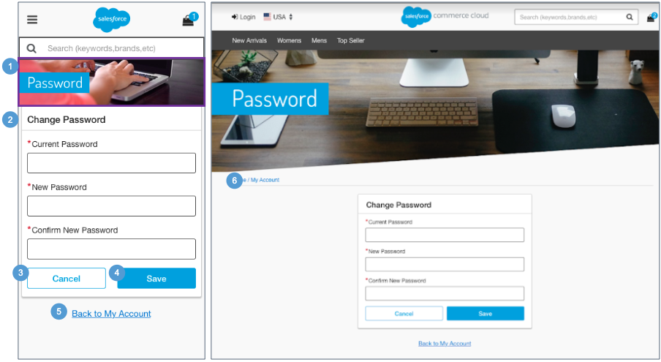 | My Account - Edit Password  Mobile:  1. The account banner image and text is stored in a .properties file. The banner remains persistent through the My Account experience.  2. To change password information, the returning shopper is required to enter their current password and enter a new password twice.  Password constraints are set in the Business Manager. If the provided password does not meet those requirements, an error message is shown informing the shopper that the password does not match the constraints.  The default requirements for storefront passwords, which are managed via customer lists are:  - The minimum password length is 8 characters.  - The minimum number of special characters is one.  - Letters, mixed case letters, and numbers are required.  3. Clicking Cancel returns the shopper to the My Account Dashboard page (see My Account Dashboard for details).  4. Clicking Save saves the password to the shopper's profile.  5. Clicking Back to My Account returns the shopper to the My Account Dashboard page (see My Account Dashboard for details).  Desktop:  6. The breadcrumb is: Home | My Account. Clicking My Account opens the My Account Dashboard. Clicking Home opens the homepage.

11.5 My Account - Address Book  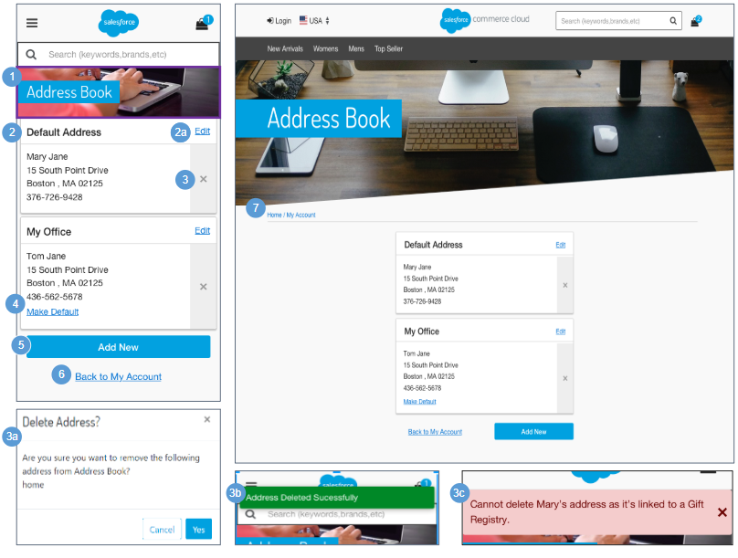 | My Account - Address Book  Mobile:  1. The account banner image and text is stored in a .properties file. The banner remains persistent through the My Account experience.  2. This page opens only if saved address information exists. The default address is shown first. All other addresses saved by the shopper are shown below the default address. The layout contains one address per row with no paging.  - To edit an address, the shopper must be on the Address Book page and must have previously saved at least one address. Clicking Edit opens the Add | Edit Address page with the fields pre-populated (see My Account - Add | Edit Address for details).  3. Clicking X opens the delete address confirmation window.  - Clicking Cancel returns the shopper to the Address Book page. Clicking Yes removes the address from the address book.  - After the shopper deletes an address, the message ‘Address Deleted Successfully’ is shown.  - If the address is associated to a gift registry, the message ‘Cannot delete [First Name] address as it’s linked to a Gift Registry’ is shown.  4. Clicking Make Default makes the associated address the default. There can only be one default address.  5. Clicking Add New opens the Add | Edit Address page with no fields pre-populated (see My Account - Add | Edit Address for details).  6. Clicking Back to My Account returns the shopper to the My Account Dashboard page (see My Account Dashboard for details).  Desktop:  7. The breadcrumb is: Home | My Account. Clicking My Account opens the My Account Dashboard. Clicking Home opens the homepage.

11.5.1 My Account - Add | Edit Address  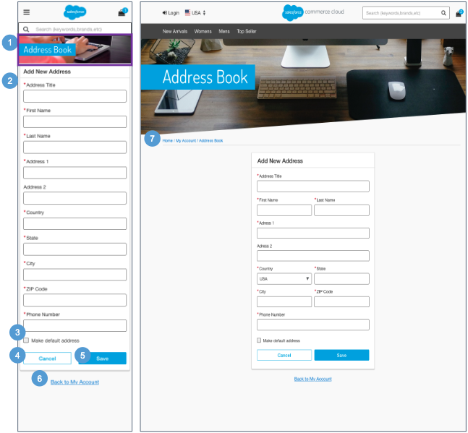 | My Account - Add | Edit Address  Mobile:  1. The account banner image and text is stored in a .properties file. The banner remains persistent through the My Account experience.  2. A returning shopper can add an address. All fields are mandatory except Address 2.  - Address Name - must be unique. A shopper can save two identical addresses as long as address title is different.  - First Name  - Last Name  - Address 1  - Address 2  - Country - dynamically changes the fields that follow depending on the selected country.  - State  - City  - Zip / Post Code  - Phone Number  3. There can be only one default address. Checking ‘Make default address’ sets this address to be the default.  4. Clicking Cancel returns the shopper to the Address Book page.  5. When the shopper clicks Save, all validations occur on the server. An error message is shown if fields are incomplete or invalid.  On saving an address, the shopper is returned to the Address Book page (see My Account - Address Book for details).  6. Clicking Back to My Account returns the shopper to the My Account Dashboard page (see My Account Dashboard for details).  Desktop:  7. The breadcrumb is: Home | My Account | Address Book. Clicking Address Book opens the Address Book page. Clicking My Account opens the My Account Dashboard page. Clicking Home opens the homepage.

11.6 My Account - Payment Method  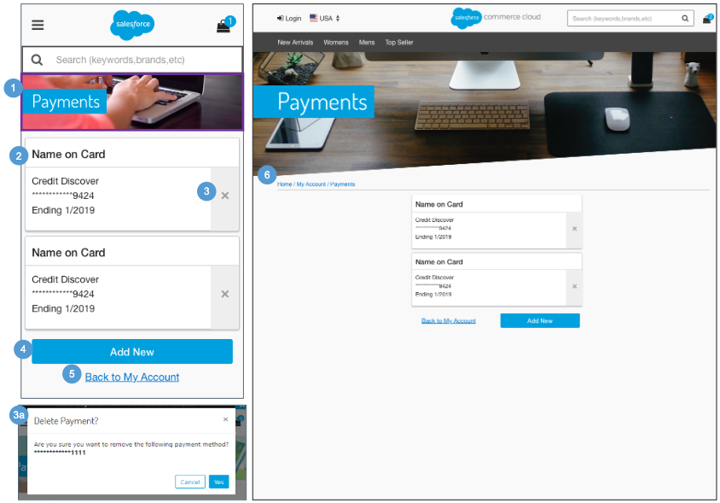 | My Account - Payment Method  This page is shown if at least one saved payment method exists.  The shopper can view an existing payment or add a payment method. They cannot edit an existing payment method; they can only delete an existing payment method.  Mobile:  1. The account banner image and text is stored in a .properties file. The banner remains persistent through the My Account experience.  2. Shows payment method attributes:  - Name on Card  - Card Type  - Card Number - masked except the last 4 digits  - Expiration Date  The default payment method always is shown first. The layout contains one payment methods per row with no paging.  3. Clicking X opens the delete payment confirmation window.  - Clicking Cancel returns the shopper to the Payment Method page. Clicking Yes removes the payment method from the shopper's account.  4. Clicking Add New opens the Add Payment Method page with no fields pre-populated (see My Account - Add Payment Method for details).  5. Clicking Back to My Account returns the shopper to the My Account Dashboard page (see My Account Dashboard for details).  Desktop:  6. The breadcrumb is: Home | My Account | Address Book. Clicking My Account opens the My Account Dashboard page. Clicking Home opens the homepage.

11.6.1 My Account - Add Payment Method  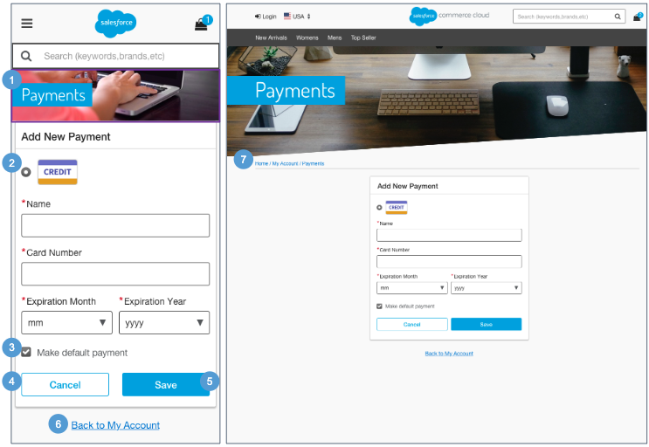 | My Account - Add Payment Method  Mobile:  1. The account banner image and text is stored in a .properties file. The banner remains persistent through the My Account experience.  2. The shopper can add a payment method by selecting the card type and entering valid information into the mandatory fields:  - Name on Card  - Card Number  - Expiration Date  3. There can only be one default payment method. Checking ‘Make default payment’ sets this payment method to be the default.  4. Clicking Cancel returns the shopper to the Payment Method page.  5. When the shopper clicks Save, all validations occur on the server. An error message is shown if fields are incomplete or invalid.  After saving the shopper’s changes, the system returns the shopper to the Payment Method page (see My Account - Payment Method for details).  Once a payment has been added it can only be removed; there is no edit feature. If the shopper wants to edit, the shopper must remove the existing payment and then add a payment with correct information.  6. Clicking Back to My Account returns the shopper to the My Account Dashboard page (see My Account Dashboard for details).  Desktop:  7. The breadcrumb is: Home | My Account | Payments. Clicking Payments opens the Payment Method page. Clicking My Account opens the My Account Dashboard page. Clicking Home opens the homepage.

11.7 My Account - Create an Account  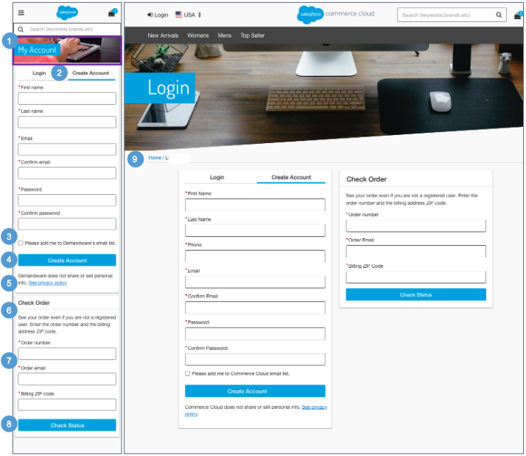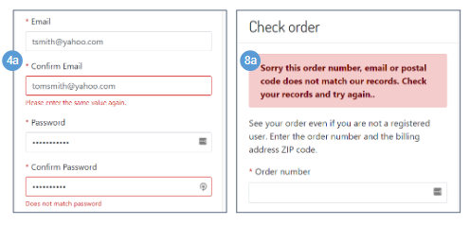 | My Account - Create an Account  Mobile:  1. The account banner image and text is stored in a .properties file. The banner remains persistent through the My Account experience.  2. A new shopper can create an account by filling out the mandatory form fields:  - First Name  - Last Name  - Email Address  - Confirm Email Address  - Password  - Confirm Password  - Phone Number  3. A new shopper can opt in to receive email notifications. The text is stored in a resource bundle. By default, the checkbox is unchecked. This requires a 3rd-party integration.  4. After correctly entering the mandatory fields, the system saves the account information and the shopper is returned to the My Account landing dashboard page.  - If the shopper enters an email and a confirmation email and / or a password and a confirmation password that do not match, an error message is shown.  5. Shows UI text that is stored in a resource bundle. Clicking See Privacy Policy opens the content asset ‘privacy-policy.’  6. To check an order the shopper must enter an order number, order email, and billing ZIP code. Both registered and unregistered shoppers can enter their order information in this area.  7. Help text is stored in the ‘login.properties’ file (in the ‘header.form.trackorder.text’ property).  8. After correctly entering the mandatory fields, the shopper is returned to the order details page.  - If the shopper enters an invalid order number and / or billing postcode, an error message is shown.  Desktop:  9. The breadcrumb is: Home. Clicking Home opens the homepage.

11.8 My Account - Forget Password  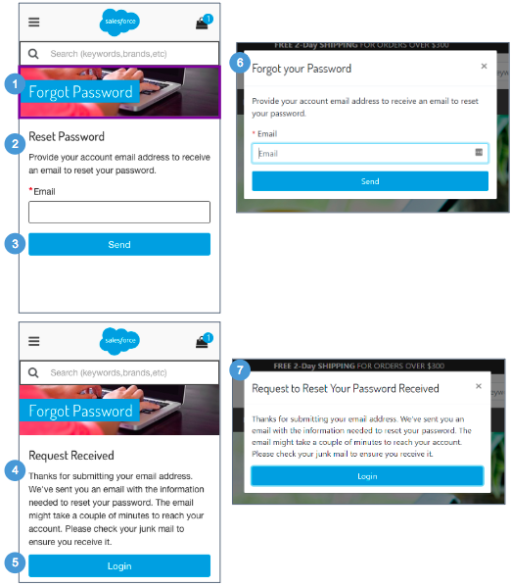  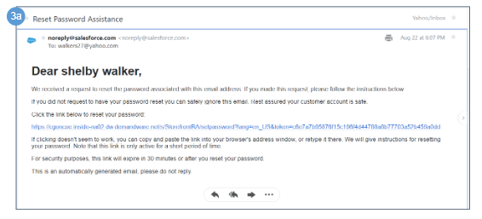 | My Account - Forget Password  The shopper is shown this page after clicking Forget Password.  Mobile:  1. The account banner image and text is stored in a .properties file. The banner remains persistent through the My Account experience.  2. Text is stored in the ‘login.properties’ file (in the ‘msg.forgotpassword’ property). The shopper must enter a valid email address.  3. After clicking Send, the shopper receives the Password Reset Request email.  - Clicking the link takes the shopper to the Change Password page (see My Account - Change Password for details).  4. After sending an email, the system shows the Password Reset Confirmation page. Text is stored in the ‘login.properties’ file (in the ‘msg.requestedpasswordreset’ property).  5. Clicking Login takes the shopper to the My Account Login page (see My Account - Login for details).  Desktop:  6. The reset password message is shown in a modal window.  7. The reset password confirmation message is shown in a modal window.

11.9 My Account - Reset Password  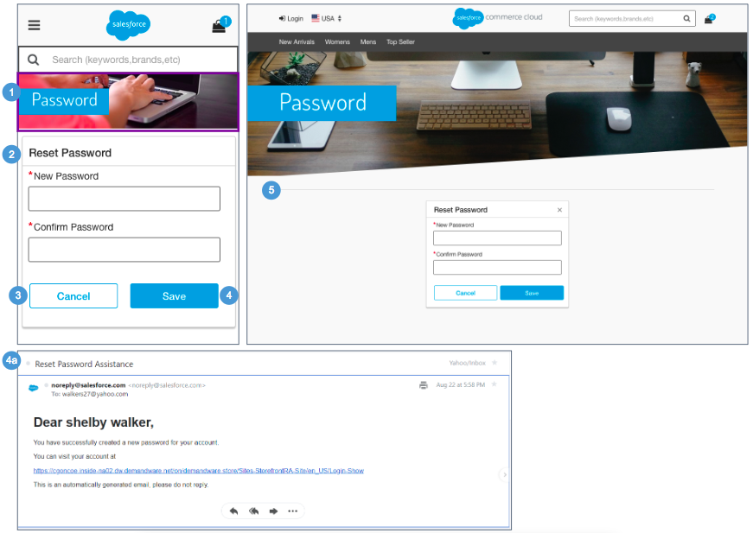 | My Account - Reset Password  The shopper is taken to this page from the Password Reset Request email.  Mobile:  1. The account banner image and text is stored in a .properties file. The banner remains persistent through the My Account experience.  2. To reset their password, the shopper must enter a valid password and confirm the new password.  3. Clicking Cancel opens the My Account Login page (see My Account - Login for details).  4. Clicking Save returns the shopper to the My Account Login page (see My Account - Login for details). The shopper is sent the Password Change email.  - Clicking the link takes the shopper to the My Account Login page (see My Account - Login for details).  Desktop:  5. Note: No breadcrumb is shown on this page.

11.10 My Account - Order History Landing  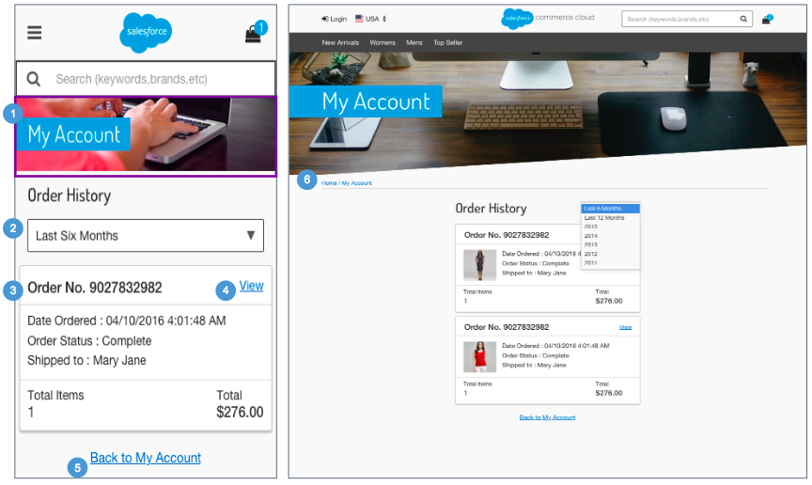 | My Account - Order History Landing  Mobile:  1. The account banner image and text is stored in a .properties file. The banner remains persistent through the My Account experience.  2. The shopper can use the dropdown to filter orders (i.e., last six months, last twelve months, and current year).  3. Shows a subset of order detail attributes:  - Order Number  - Creation Date  - Order Status  - Shipped To Name]  - Total # of Items  - Total Price  Note: Orders are saved in the currency in which they were placed, and are shown in that currency (using the respective currency symbol), regardless of the currency selected.  4. Clicking View opens the Order Detail page which shows the full order details for the order selected (see My Account - Order Detail for details).  5. Clicking Back to My Account returns the shopper to their My Account Dashboard page (see My Account Dashboard for details).  Desktop:  6. The breadcrumb is: Home | My Account. Clicking My Account opens the My Account Dashboard page. Clicking Home opens the homepage.

11.11 My Account - Order History Detail  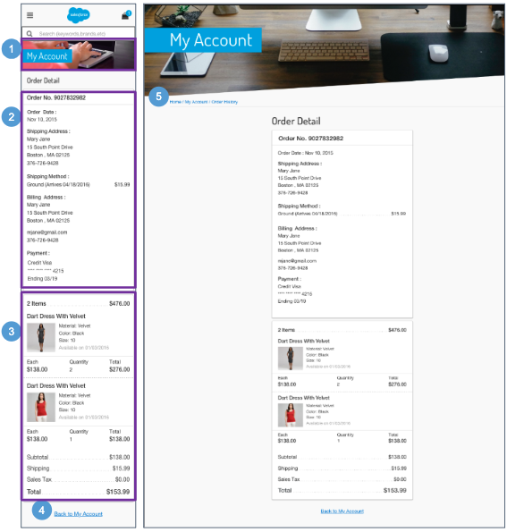 | My Account - Order History Detail  Mobile:  1. The account banner image and text is stored in a .properties file. The banner remains persistent through the My Account experience.  2. The Order History Detail contains order related information:  - Order Number  - Creation Date  - Shipping Address  - First Name  - Last Name  - Address 1  - Address 2  - City, State, Zip Code  - Phone Number  - Shipping Method  - Shipping Method  - Shipping Cost  - Billing Address  - First Name  - Last Name  - Address  - City, State, Zip Code  - Email Address  - Phone Number  - Payment Method  - Credit Card Type  - Credit Card Number - masked except last 4 digits  - Expiration Date  3. The Order Summary section is persistent throughout the checkout experience. Shows Order Subtotal, Shipping Cost, Sales Tax, and Product information (see Checkout - Shipping Address | Shipping Method (Registered) for details)  4. Clicking Back to My Account returns the shopper to their My Account Dashboard page (see My Account Dashboard for details).  Desktop:  5. The breadcrumb is: Home | My Account | Order History. Clicking Order History opens the Order History Landing page. Clicking My Account opens the My Account Dashboard page. Clicking Home opens the homepage.

12.0 Wishlist

12.1 Wishlist - Guest View (Temporary Wishlist)  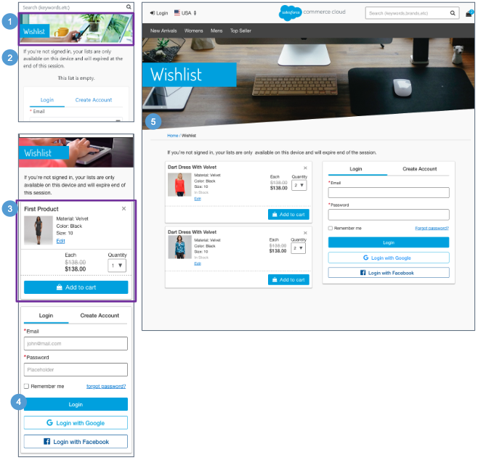 | Wishlist - Guest View (Temporary Wishlist)  Configurations:  - Install the ‘plugin_wishlists’ cartridge.  Mobile:  The guest shopper can navigate to this page from the global navigation hamburger menu.  1. The Wishlist banner image and text is stored in a .properties file. The banner remains persistent through the wishlist experience.  2. Shows UI text stored in a resource bundle.  3. Lists all items the guest shopper added to their wishlist. Clicking (X) removes the product from the wishlist. Clicking Edit opens the product in a modal window (see Edit Wishlist for details). Individual product attributes are shown:  - Product Name  - Thumbnail Image  - Selected Variations (size, color)  - Price  - Quantity  - Add to Cart  4. Logging into an existing account either creates a wishlist for the registered shopper or merges the items into the registered shopper's existing wishlist.  Desktop:  The guest shopper can navigate to this page from the header.  5. The breadcrumb is: Home. Clicking Home opens the homepage.

12.2 Wishlist - Registered View  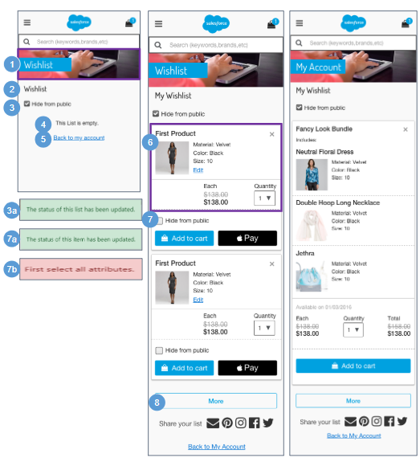  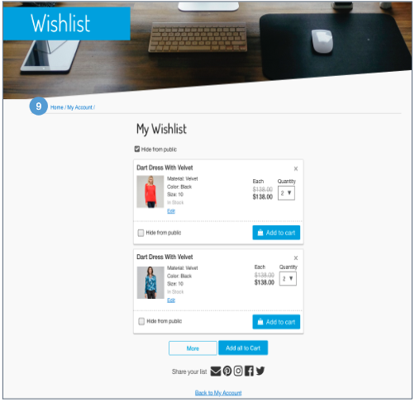 | Wishlist - Registered View  Configurations:  - Install the‘plugin_wishlists’ cartridge.  Mobile:  The registered shopper can navigate to this page from the global navigation hamburger menu and from the shopper’s My Account dashboard page.  1. The Wishlist banner image and text is stored in a .properties file. The banner remains persistent through the wishlist experience.  2. Shows the registered shopper's “[First name] Wishlist”.  3. A wishlist is private (not searchable) by default. Checking ‘Hide from public’ prevents other shoppers from seeing and searching for the wishlist. Unchecking ‘Hide from public’ lets other shoppers search for and see the wishlist.  - An alert message ‘The status of this list has been updated’ is shown when the shopper has changed the wishlist privacy setting (hide / unhide from public).  4. Shows UI text stored in a resource bundle.  5. Returns the shopper to their My Account dashboard page.  6. Lists all items the shopper added to their wishlist. Clicking X removes the product from the wishlist. Clicking Edit opens the product in a modal window (see Edit Wishlist for details). Individual product attributes are shown:  - Product Name  - Thumbnail Image  - Selected Variations (size, color)  - Price  - Quantity  - Add to Cart  7. A wishlist product is private (not searchable) by default. Checking Hide from public prevents other shoppers from seeing this product. Unchecking Hide from public lets other shoppers see the product on the wishlist.  - If the product is a variation, the message ‘The status of this product has been updated’ is shown when the shopper has changed the wishlist privacy setting (hide / unhide from public).  - If the product is a master, the message ‘First select all attributes’ is shown when the shopper has changed the wishlist privacy setting (hide / unhide from public).  8. Clicking More shows additional products in the wishlist.  Desktop:  The registered shopper can navigate to this page from the header and from the My Account Dashboard page.  9. The breadcrumb is: Home | My Account. Clicking My Account opens the My Account Dashboard page. Clicking Home opens the homepage

12.2.1 Edit Wishlist  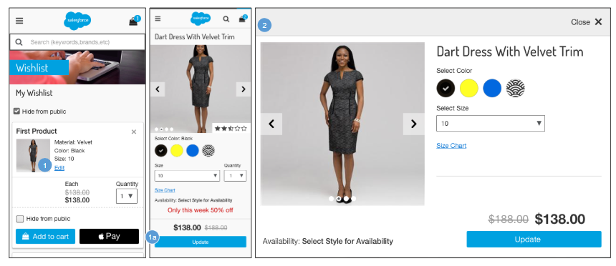 | Edit Wishlist  Configurations:  - Install the ‘plugin_wishlists’ cartridge.  Mobile:  1.Clicking Edit opens a version of the Product Detail page for editing.  - The shopper can edit the product variations (i.e., size, color). Clicking Update closes the modal window and updates the product attributes and price on the Wishlist page.  Desktop:  2. Clicking Edit opens a version of the Product Detail page for editing in a modal window.

12.3 Wishlist - Search  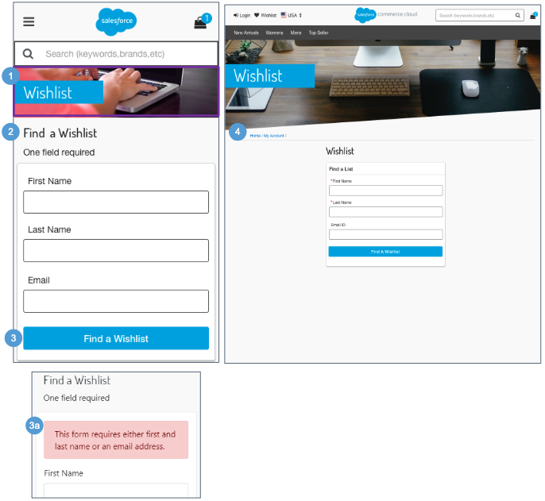 | Wishlist - Search  Configurations:  - Install the ‘plugin_wishlists’ cartridge.  - Configure the footer content asset with a link to the ‘Wishlist-Search’ pipeline / controller.  Mobile:  1. The Wishlist banner image and text is stored in a .properties file. The banner remains persistent through the wishlist experience.  2. Shows UI text stored in a resource bundle. To find a wishlist, the shopper must enter an mail Address or a First Name and Last Name. Both names must be specified if no email address is provided. Text entry is not case-sensitive.  3. Clicking Find a wishlist searches for publicly exposed wishlists using the criteria specified by the shopper (see Wishlist - Search Results for details).  - If no results are found, the message ‘This form requires either first and last name or an email address’ is shown.  Desktop:  4. The breadcrumb is: Home | My Account. Clicking Home opens the homepage.

12.4 Wishlist - Search Results  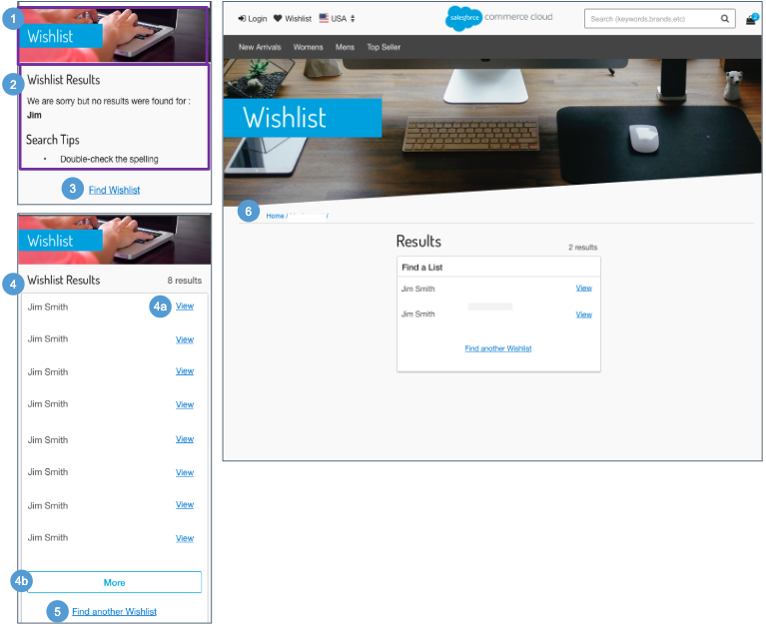 | Wishlist - Search Results  Configurations:  - Install the ‘plugin_wishlists’ cartridge.  Mobile:  1. The Wishlist banner image and text is stored in a .properties file. The banner remains persistent through the wishlist experience.  2. If no results are found, a message is shown indicating that nothing was found.  3. Clicking Find Wishlist opens the Wishlist Search page with the fields blank (see Wishlist - Search for details).  4. Shows publicly exposed wishlists matching the search criteria specified by the shopper. If only one wishlist is found, it is shown. If multiple wishlists match the criteria, results are shown in a list view.  - Clicking View opens the individual wishlist (see Wishlist - Public View for details).  - If more than 8 matches exist, a More button is shown. Clicking More loads 8 more results onto the page.  5. Clicking Find Another Wishlist opens the Wishlist Search page with the fields blank (see Wishlist - Search for details).  Desktop:  6. The breadcrumb is: Home. Clicking Home opens the homepage.

12.5 Wishlist - Public View 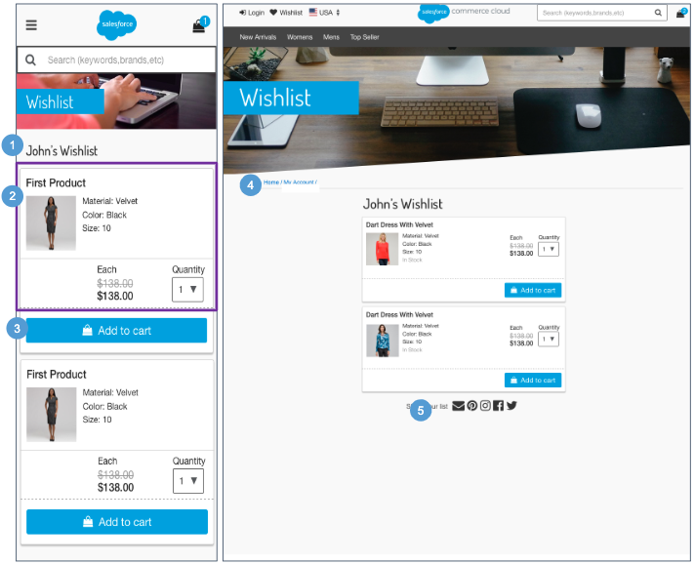 | Wishlist - Public View  Configurations:  - Install the ‘plugin_wishlists’ cartridge.  Mobile:  1. Shows the selected wishlist: ‘[First name] Wishlist.’  2. Shows the selected shopper’s wishlist (i.e., products with Hide from public unchecked). The following product attributes are shown:  - Product Name  - Thumbnail Image  - Selected Variations (size, color)  - Price  - Quantity  3. Add to Cart adds the product to cart, and the system indicates that this is from someone’s wishlist.  Desktop:  4. The breadcrumb is: Home. Clicking Home opens the homepage.  5. Requires an integration with various social media applications.

13.0 Store Locator

13.1 Store Locator - Search  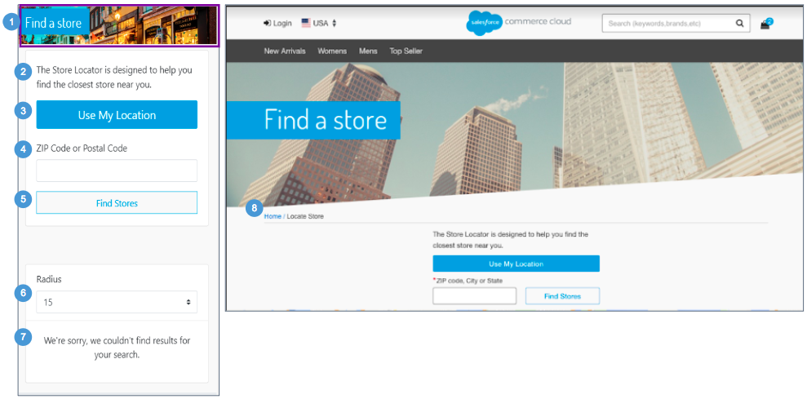 | Store Locator - Search  Clicking Locate Store in the footer opens the Store Locator page.  In order to use the Google Maps functionality, the Google Maps API Key must be configured in the Site Preference ‘google map api key.'  Mobile:  1. The Store Locator banner image and text is stored in a .properties file. The banner remains persistent through the Store Locator experience.  2. This text is stored in the ‘storeLocator.properties’ file (in the ‘msg.find.store’ property).  3. If the shopper first selects Use My Location, clicking Find Stores on the Store Locator page uses the browser's location or the location of the shopper's mobile device to refine the search. The ZIP code, if specified, is ignored.  A list of stores is shown only if the store data is defined in Business Manager.  4. Specifying a ZIP code or postal code refines the store search.  5. Clicking Find Stores shows a list of stores that match the search criteria. The search results are refined by the ZIP code (or postal code) and the radius. The ZIP code field is not validated. A list of stores is shown only if the store data is defined in Business Manager.  Miles can be converted to kilometers via the script method ‘dw.catalog.StoreMgr.searchStoresBy.'  6. Radius dropdown values are stored in UX Studio (15-300 miles), the default is 15 miles. Selecting a radius value refines the search results.  7. Shows UI text that is stored in ‘storeLocator.properties’ file (in the ‘error.no.results’ property).  Desktop:  8. The breadcrumbs no longer exist

13.2 Store Locator - Search Results  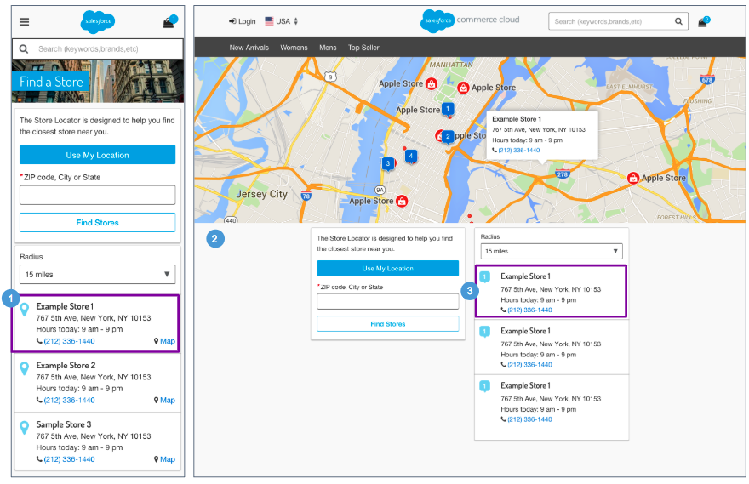 | Store Locator - Search Results  The system returns all valid store locations in list view based on the zip code / postal code or radius from the store locator selection page.  Mobile:  1. Shows store attributes maintained in Business Manager:  - Store Name  - Store Address - Clicking the pin or Map opens Google Maps in a browser window with the store location pinned on the map. Store attributes for latitude and longitude must be configured in Business Manager.  - Store Hours  - Phone Number - Clicking opens a prompt to dial the store's number.  Desktop:  2. No breadcrumb is shown on this page.  3. Shows store attributes maintained in Business Manager:  - Number correspond to the location of the store on the map.  - Store Name  - Store Address - store location pinned on Google Maps. Store attributes for latitude and longitude must be configured in Business Manager.  - Store Hours  - Phone Number - Clicking opens a prompt to dial the store's number.

14.0 Gift Registry

14.1 Gift Registry – Footer  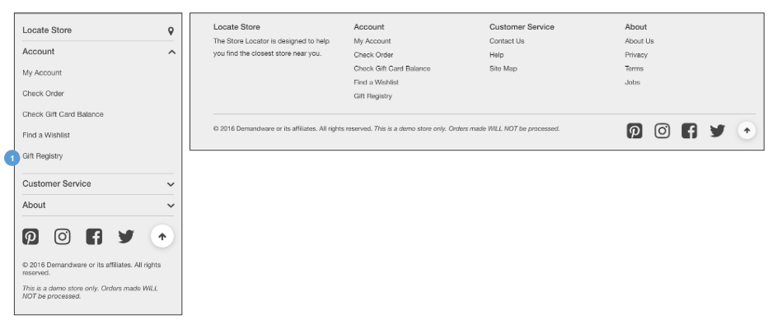 | Gift Registry – Footer  Configurations:  - Install the ‘plugin_giftregistry’ cartridge.  - Configure the footer content asset with a link to the controller route ‘GiftRegistry-Landing.’  Mobile | Desktop:  1. Clicking Gift Registry opens the gift registry landing page (see Gift Registry Landing for details).

14.2 Gift Registry – My Account Dashboard  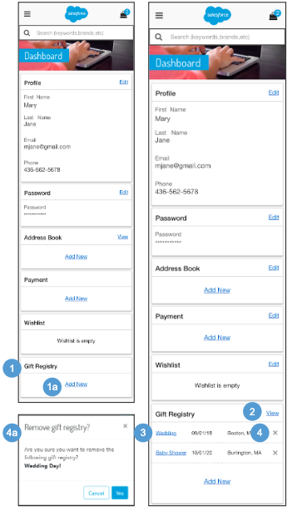  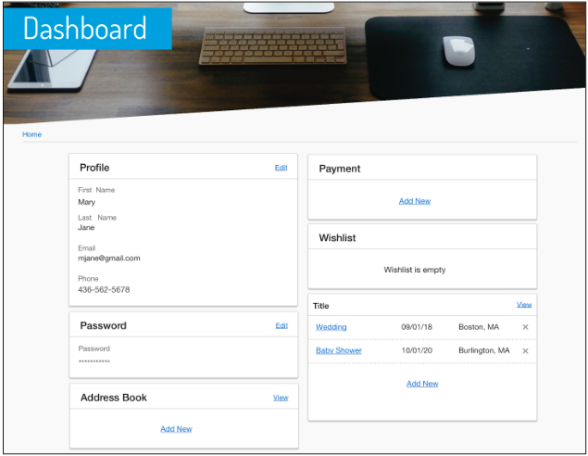 | Gift Registry – My Account Dashboard  A shopper must log in to add items or edit their gift registry.  Configurations:  - Install the ‘plugin_giftregistry’ cartridge.  Mobile | Desktop:  1. If no registries exist, the message ‘This list is empty’ is shown.  - Clicking Add New opens the Create Gift Registry page (see Create Gift Registry - Event Information for details).  2. Clicking View opens the manage gift registries page (see Manage Gift Registries for details).  3. Shows a list of Gift Registries created by the registered shopper. Gift registry attributes are shown:  - Event Name - clicking opens the gift registry  - Event Date  - Event City, State  4. Clicking X opens the remove gift registry confirmation window.  - Clicking Cancel closes the modal window, and the shopper remains on the My Account Dashboard page. Clicking Yes removes the gift registry from the shopper's account.

14.3 Create Registry - Event Information  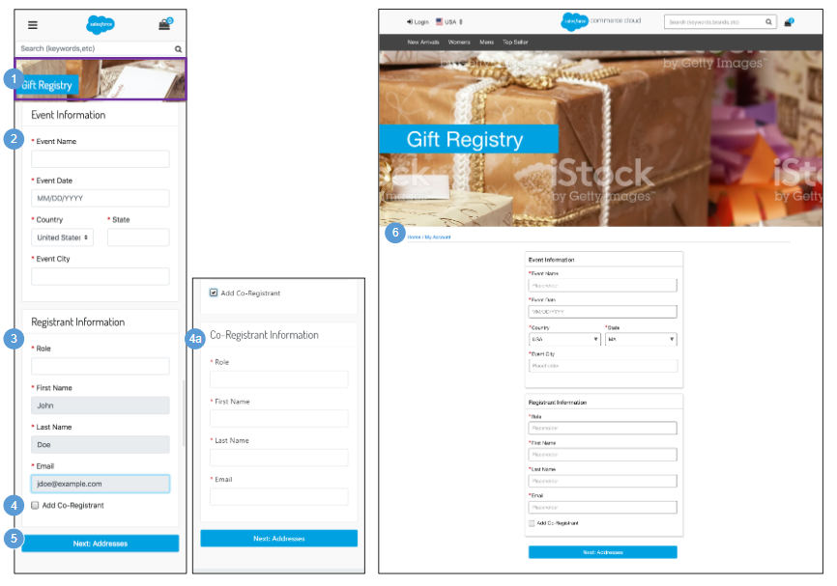 | Create Registry - Event Information  Configurations:  - Install the ‘plugin_giftregistry’ cartridge.  Mobile:  1. The Gift Registry banner image and text is stored in a .properties file. The banner remains persistent throughout the gift registry experience.  2. Shows gift registry event information attributes. All attributes are required.  - Event Name  - Event Date  - Country  - State  - Event City  3. Shows gift registry registrant information attributes. All attributes are required.  - Role  - First Name - read-only, prefilled from account profile information.  - Last Name - read-only, prefilled from account profile information.  - Email - read-only, prefilled from account profile information.  4. Clicking Add Co-Registrant enables the registered shopper to designate a second registrant (for example, a wedding could have the bride and groom as registrant and co-registrant).  - Gift registry co-registrant information attributes are shown. All attributes are required.  - Role  - First Name  - Last Name  - Email  5. Clicking Next: Addresses opens the pre-Event and post-Event Shipping Addresses page (see Create Registry - Address Information for details).  Desktop:  6. The breadcrumb is: Home | My Account. Clicking My Account opens the My Account Dashboard. Clicking Home opens the homepage.

14.4 Create Registry - Address Information  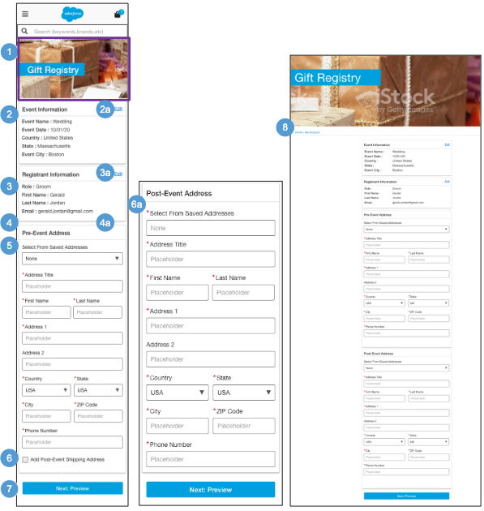 | Create Registry - Address Information  Configurations:  - Install the ‘plugin_giftregistry’ cartridge.  Mobile:  1. The Gift Registry banner image and text is stored in a .properties file. The banner remains persistent throughout the gift registry experience.  2. Shows the gift registry event information.  - Clicking Edit opens the event / registrant information section for editing.  3. Shows the gift registry registrant information.  - Clicking Edit opens the event / registrant information section for editing.  4. Shows the gift registry co-registrant information.  - Clicking Edit opens the event / registrant information section for editing.  5. Gift registry pre-event address attributes are shown. All attributes are required except for Address 2. If the shopper selects a saved address from the dropdown, all fields are prefilled with the stored address information.  - Address Title  - First Name  - Last Name  - Address 1  - Address 2  - Country  - State  - City  - Zip Code  - Phone Number  6. Clicking Add Post-Event Shipping Address enables the gift registry owner to define Shipping Address to use after the event has occurred.  - All attributes are required except for Address 2. If the shopper selects a saved address from the dropdown, all fields are prefilled with the stored address information.  - Address Title  - First Name  - Last Name  - Address 1  - Address 2  - Country  - State  - City  - Zip Code  - Phone Number  7. Clicking Next: Preview opens the Review Registry Information page (see Gift Registry - Review Registry Information for details).  Desktop:  8. The breadcrumb is: Home | My Account. Clicking My Account opens the My Account Dashboard. Clicking Home opens the homepage.

14.5 Create Registry – Review Registry Information  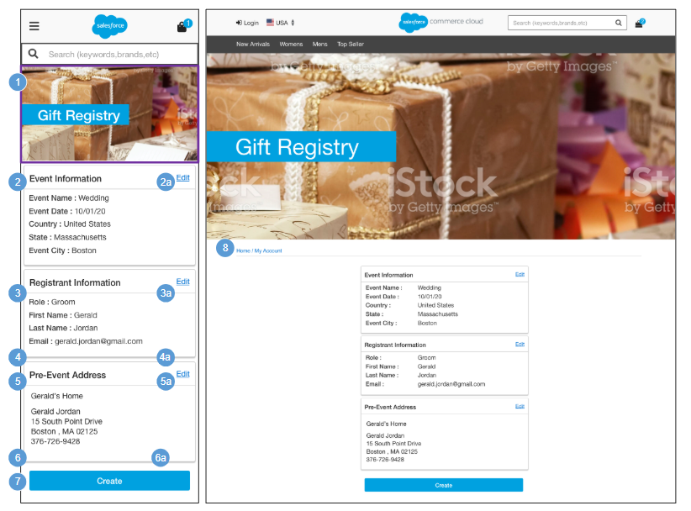 | Create Registry – Review Registry Information  Configurations:  - Install the‘plugin_giftregistry’ cartridge.  Mobile:  1. The Gift Registry banner image and text is stored in a .properties file. The banner remains persistent throughout the gift registry experience.  2. Shows the gift registry event information.  - Clicking Edit opens the event / registrant information section for editing.  3. Shows the gift registry registrant information.  - Clicking Edit opens the event / registrant information section for editing.  4. Shows the gift registry co-registrant information.  - Clicking Edit opens the event / registrant information section for editing.  5. Shows the gift registry pre-event address information.  - Clicking Edit opens the pre-event / post-event address information section for editing.  6. Shows the gift registry post-event address information.  - Clicking Edit opens the pre-event / post-event address information section for editing.  7. Clicking Create opens the Gift Registry page (see Gift Registry - Registered View for details).  Desktop:  8. The breadcrumb is: Home | My Account. Clicking My Account opens the My Account Dashboard. Clicking Home opens the homepage.

14.6 Gift Registry – Add Item to Registry  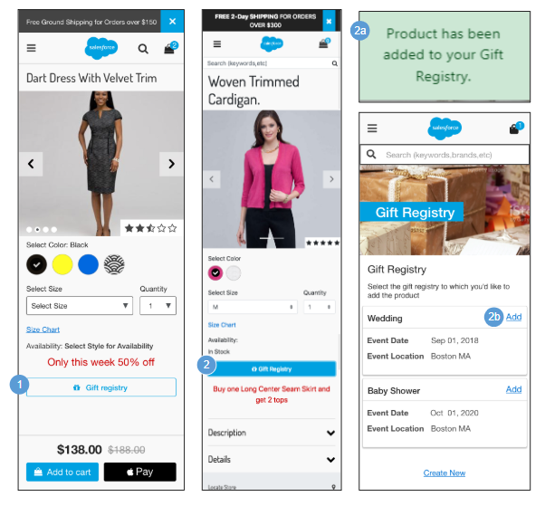 | Gift Registry – Add Item to Registry  A shopper must log in to add items to their gift registry.  Configurations:  - Install the ‘plugin_giftregistry’ cartridge.  Mobile | Desktop:  1. The Gift Registry button is disabled until the shopper selects the required product attributes (i.e., color, size and width).  2. The Gift Registry button is enabled after the shopper selects the required product attributes (i.e., color, size and width). For a guest shopper, clicking Gift Registry opens the my account login page (see My Account - Login for details).  - For a registered shopper with only one gift registry, clicking Gift Registry adds the item to the shopper’s gift registry, and the message ‘Product has been added to your Gift Registry’ is shown.  - For a registered shopper with multiple gift registries, clicking Gift Registry opens the Gift Registry selection page. Clicking Add adds the product to the gift registry. Clicking Create New opens the Create Gift Registry page (see Create Gift Registry - Event information for details).

14.7 Gift Registry – Registered View  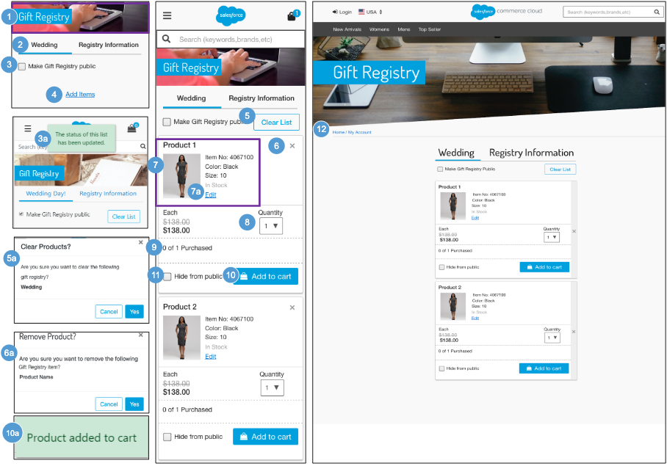 | Gift Registry – Registered View  Shows the view of the gift registry as visible by the registry owner.  Configurations:  - Install the ‘plugin_giftregistry’ cartridge:  Mobile:  1. The Gift Registry banner image and text is stored in a .properties file. The banner remains persistent throughout the gift registry experience.  2. Clicking the name of the gift registry lets the owner modify the items in the registry. Clicking Registry Information lets the owner modify the registry event, registrant, co-registrant, pre- and post-event shipping information.  3. Selecting the Make Gift Registry public checkbox makes the gift registry visible to other shoppers. Deselecting the Make Gift Registry public checkbox hides the gift registry from other shoppers.  - On select and deselect of the Make Gift Registry public checkbox, the message ‘The status of this list has been updated’ is shown.  4. Clicking Add Items opens the homepage.  5. Clicking Clear List opens the clear gift registry list confirmation window.  - Clicking Cancel closes the modal window, and the shopper remains on the Gift Registry page. Clicking Yes removes all items from the gift registry.  6. Clicking X opens the remove gift registry product confirmation window.  - Clicking Cancel closes the modal window, and the shopper remains on the Gift Registry page. Clicking Yes removes the selected item from the gift registry.  7. Shows product attributes (name, thumbnail image, selected variations, individual list and sale price) when applicable.  - Clicking Edit opens the item for editing in a modal window (see Gift Registry - Edit Registry Product for details.).  8. Shows the desired quantity of the specified item. The maximum quantity in the dropdown is dynamic based on the remaining quantity desired.  9. Shows how many items have been purchased, compared to the specified quantity desired.  10. Clicking Add to Cart adds the item to the gift registry owner’s cart. The count of purchased items updates once the order has been placed.  - If the shopper adds the item to the gift registry, the message ‘Product added to Cart’ is shown.  11. Selecting ‘Hide from public’ checkbox hides the gift registry item from other shoppers. Deselecting the ‘Hide from public’ checkbox makes the gift registry item visible to other shoppers. After the shopper selects and deselects the ‘Hide from public’ checkbox, the message ‘The status of this list has been updated’ is shown.  Desktop:  12. The breadcrumb is: Home | My Account. Clicking My Account opens the My Account Dashboard. Clicking Home opens the homepage.

14.7.1 Gift Registry – Edit Registry Product  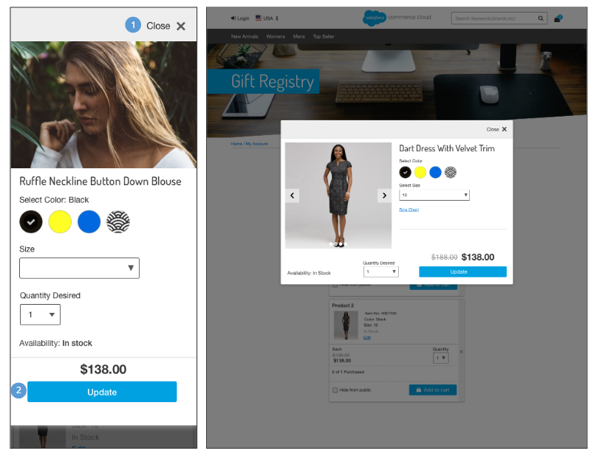 | Gift Registry – Edit Registered Product  Configurations:  - Install the ‘plugin_giftregistry’ cartridge.  Mobile | Desktop:  1. Clicking Close X closes the modal window. No product attribute or quantity changes are saved for the item in the gift registry.  2. Clicking Update saves the product attribute or quantity changes for the item in the gift registry.

14.8 Gift Registry Landing - Search  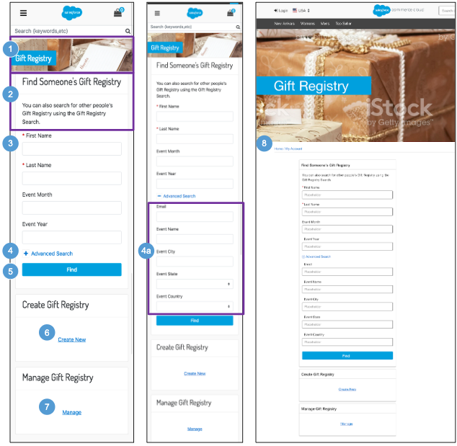 | Gift Registry Landing - Search  Configurations:  - Install the‘plugin_giftregistry’ cartridge.  Mobile:  1. The Gift Registry banner image and text is stored in a .properties file. The banner remains persistent throughout the gift registry experience.  2. Text is stored in the ‘forms.properties’ file (in the ‘header.form.search.gr.text’ property).  3. Shows Gift Registry attribute fields that a shopper can use to perform a basic search. First Name and Last Name are required.  - First Name (Required)  - Last Name (Required)  - Event Month  - Event Year  4. Clicking Advanced Search lets shopper use additional fields to perform a search.  - Shows Gift Registry attribute fields that a shopper can use to perform an advanced search. All fields are optional.  - Email  - Event Name  - Event City  - Event State  - Event Country  5. Clicking Find initiates the search for a gift registry.  6. For a guest shopper, clicking Create New opens the My Account Login page (see My Account - Login for details).  For a registered shopper, clicking Create New opens the Gift Registry - Event Information page (see Gift Registry - Event Information for details).  7. For a guest shopper, clicking Manage opens the my account login page (see My Account - Login for details).  For a registered shopper, clicking Manage opens the Manage Gift Registries page (see Gift Registry - Manage Gift Registries for details).  Desktop:  8. The breadcrumb is: Home | My Account. Clicking My Account opens the My Account Dashboard. Clicking Home opens the homepage.

14.8.1 Gift Registry – Manage Gift Registries  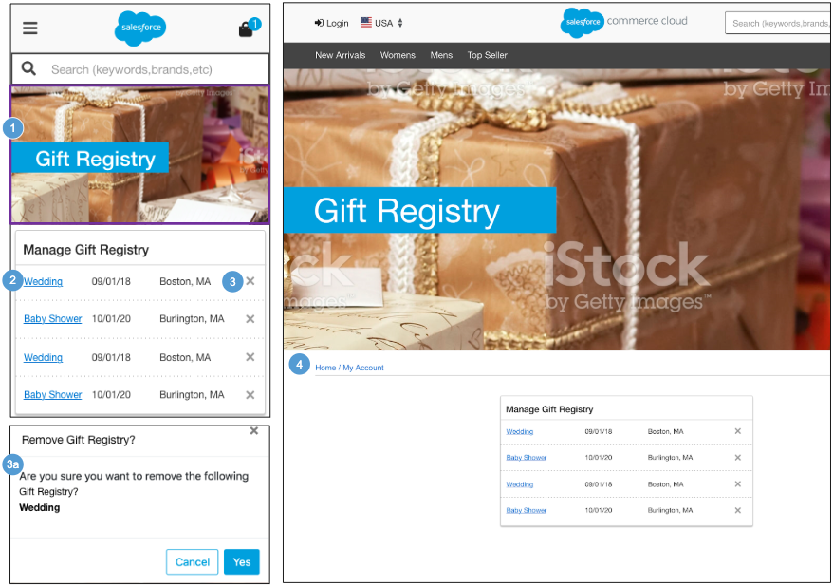 | Gift Registry - Manage Gift Registries  Configurations:  - Install the ‘plugin_giftregistry’ cartridge:  Mobile:  1. The Gift Registry banner image and text is stored in a .properties file. The banner remains persistent throughout the gift registry experience.  2. Shows a list of gift registries created by the registered shopper. Gift registry attributes are shown:  - Event Name - clicking opens the gift registry.  - Event Date  - Event City, State  3. Clicking X opens the remove gift registry confirmation window.  - Clicking Cancel closes the modal, the shopper remains on the Manage Gift Registry page. Clicking Yes removes the gift registry from the owners account.  Desktop:  4. The breadcrumb is: Home | My Account. Clicking My Account opens the My Account Dashboard. Clicking Home opens the homepage.

14.9 Gift Registry – Search Results  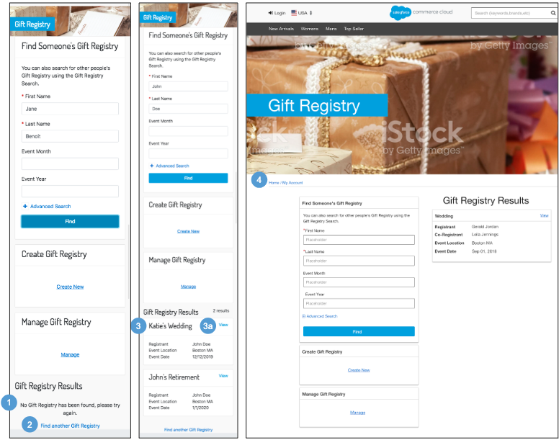 | Gift Registry – Search Results  Gift registry results show after a shopper performs a basic or an advanced search.  Configurations:  - Install the ‘plugin_giftregistry’ cartridge.  Mobile:  1. If no results are found, the message ‘No Gift Registry has been found, please try again’ is shown.  2. Clicking Find another Gift Registry clears the search fields. The shopper can perform a new search.  3. Shows a list of gift registries matching the specified search criteria (x results).  Gift registry attributes are shown:  - Registry Name  - Registrant Name  - Co-Registrant Name  - Event Location  - Event Date  - Clicking View opens the Gift Registry Public View page (see Gift Registry - Public View for details).  Desktop:  4. The breadcrumb is: Home | My Account. Clicking My Account opens the My Account Dashboard. Clicking Home opens the homepage.

14.10 Gift Registry – Public View  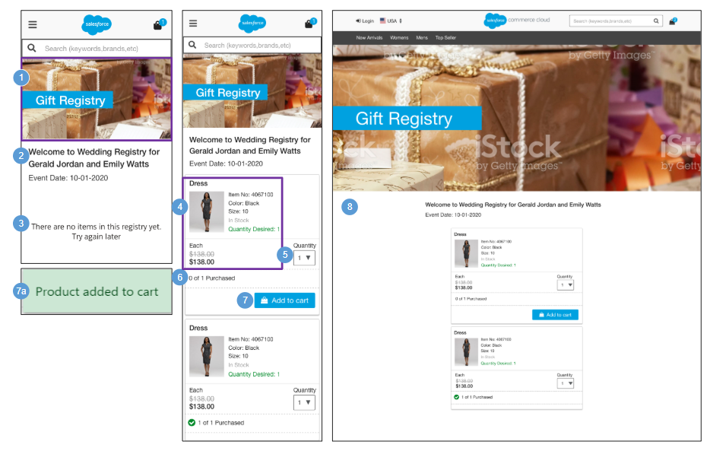 | Gift Registry – Public View  Shows the public view of the gift registry as visible by other shoppers.  Configurations:  - Install the ‘plugin_giftregistry’ cartridge.  Mobile:  1. The Gift Registry banner image and text is stored in a .properties file. The banner remains persistent throughout the gift registry experience.  2. Shows a message about the gift registry: ‘Welcome to [Event Name] Registry for [Registrant Name] [Co-Registrant Name] [Event Date].’  3. Shows a message if the gift registry is empty: ‘There are no items in this registry yet. Try again later.’  4. Shows product attributes:  - Name  - Thumbnail Image  - Selected Variations  - List Price  - Sale Price - when applicable  - Desired Quantity - specified by the gift registry owner  5. The maximum quantity in the dropdown is dynamic, based on the quantity desired by the gift registry owner.  6. Shows how many items have been purchased, compared to the quantity specified by the gift registry owner.  7. Clicking Add to Cart adds the item to the shopper's cart. The count of purchased items updates once the order has been placed.  - After the shopper adds the item to the cart, the message ‘Product added to Cart’ is shown.  Desktop:  8. The breadcrumb is: Home | My Account. Clicking My Account opens the My Account Dashboard. Clicking Home opens the homepage.  .

15.0 Error Pages | Example Error States

15.1 General (500) Error  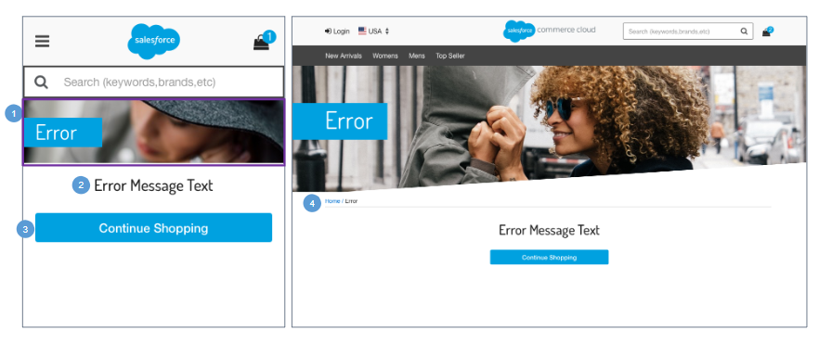 | General (500) Error  This is a server-side error that is shown when something has gone wrong on the website’s server but the server could not be more specific on what the exact problem is.  The problem is not with the shopper's computer or internet connection but instead is a problem with the website’s server. For example, the web server could be overloaded and therefore unable to handle requests properly.  Mobile:  1. The general error banner image is stored in the ‘in_common.scss’ file.  2. The error text is stored in a properties file and is shown when the corresponding error occurs.  3. Clicking Continue Shopping opens the homepage.  Desktop:  4. The breadcrumb is: Home | Error. Clicking Home opens the homepage.

15.2 Missing Page (404) Error  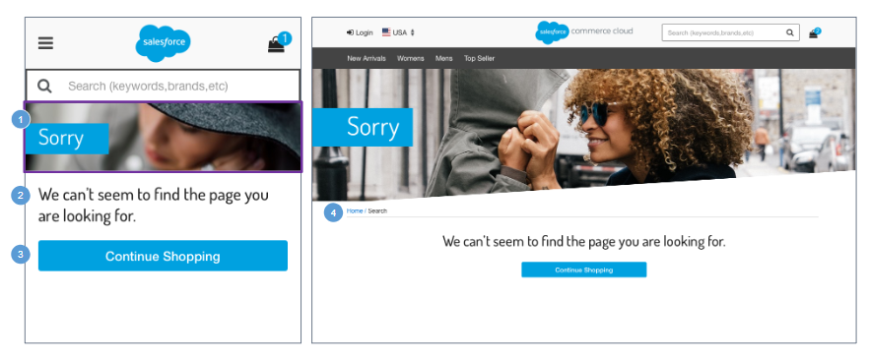 | Missing Page (404) Error  This is a client side error that is shown when the webpage the shopper is trying to reach could not be found on the server. This error indicates that the page has been removed, or indicates that the page was moved but the URL was not changed accordingly, or indicates that the shopper typed in the URL incorrectly.  Mobile:  1. The 404: missing page banner image is stored in a .properties file.  2. Shows UI text stored in the ‘error.properties’ file (in the ‘message.page.not.found’ property).  3. Clicking Continue Shopping opens the homepage.  Desktop:  4. The breadcrumb is: Home | Search. Clicking Home opens the homepage.

15.3 Client Side Validation Error  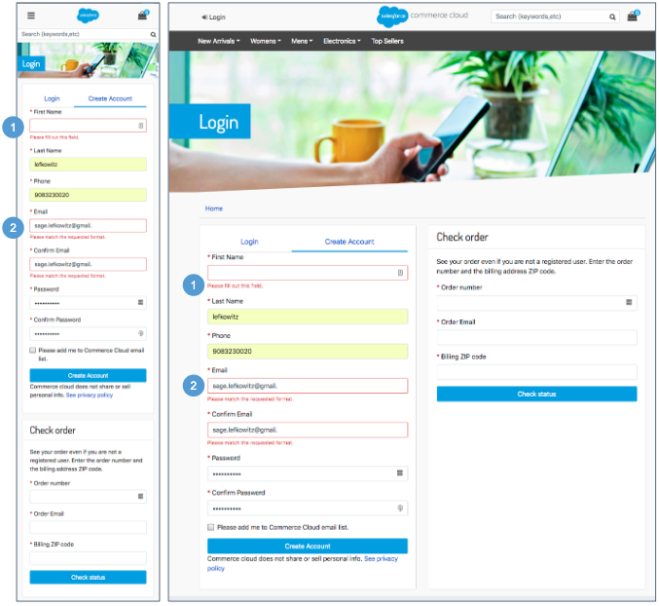 | Client Side Validation Error  Client-side and server-side validation errors are shown in the same manner.  Mobile | Desktop:  1. When the shopper attempts to submit a form without completing the required fields, the message ‘This field is required’ is shown. The form is not submitted to the server until the shopper completes the required fields and resubmits the form.  2. More in-depth field validation is performed upon submit. When the shopper attempts to submit a form with invalid data, the message ‘Please match the requested format’ is shown.

15.4 Server Side Validation Error  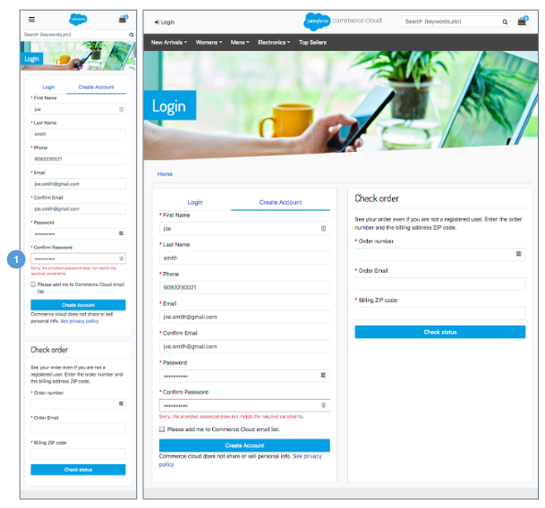 | Server Side Validation Error  Client-side and server-side validation errors are shown in the same manner.  Mobile | Desktop:  1. When the shopper submits a form to the server but the data is invalid, messaging will display below the form field.  For example, ‘Sorry, the provided password does not match the requested constraints’.

15.5 Cart - Coupon Error  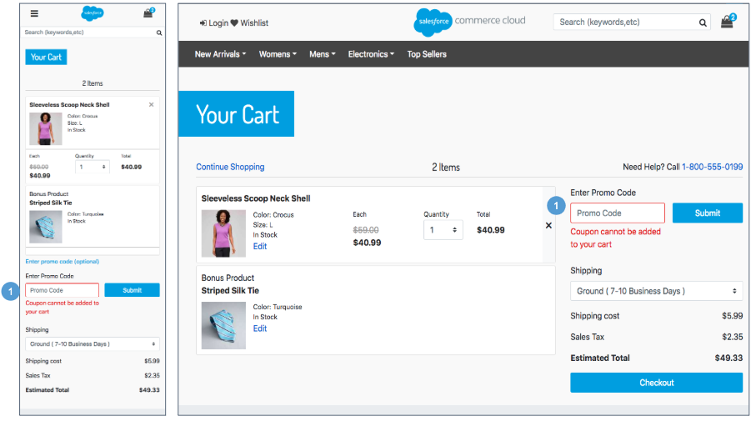  1 | Cart - Coupon Error  Mobile | Desktop:  1. When the shopper enters a coupon code on the cart page that does not exist, the message ‘Coupon cannot be added to your Cart’ is shown.  - When the shopper enters a coupon code on the cart page that is already applied, the message ‘Coupon code is already in your Cart’ is shown.

15.6 Checkout - Login Error  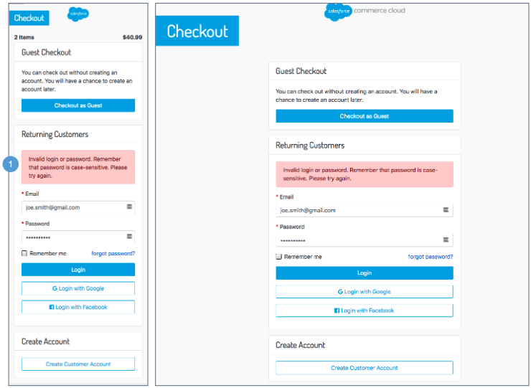 | Checkout - Login Error  Mobile | Desktop:  1. When the shopper enters an invalid email address or password on the Checkout login page, the message ‘Invalid login or password. Remember the password is case-sensitive. Please try again’ is shown.

15.7 Checkout - Credit Card Error  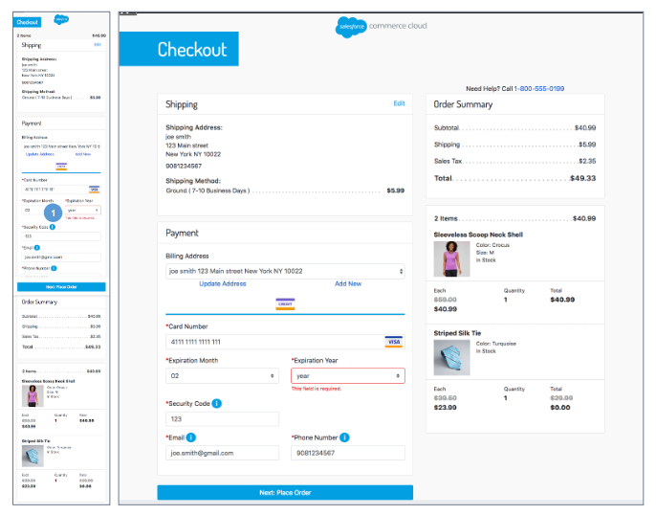 | Checkout - Credit Card Error  Mobile | Desktop:  1. When the shopper attempts to submit a form without completing the required fields, the message ‘This field is required’ is shown. The form is not submitted to the server until the shopper completes the required fields and resubmits the form.  When the shopper attempts to submit an invalid credit card number, the message’Invalid Credit Card Number’ is shown.  When the shopper attempts to submit an expired credit card number, the message ‘This Credit Card has expired’ is shown.

15.8 My Account – Order Tracking Error  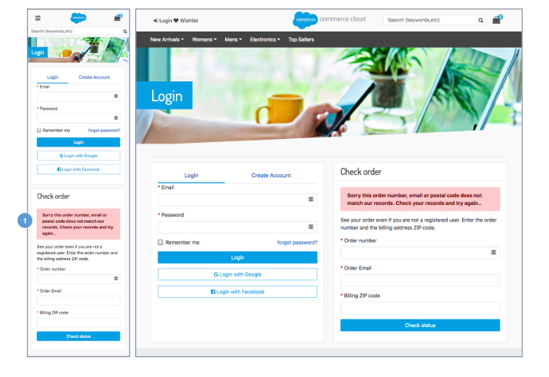 | My Account - Order Tracking Error  Mobile | Desktop:  1. When the shopper attempts to submit an invalid order number and / or billing postcode, the message ‘Sorry, this order number, email or Postal Code does not match our records. Check your records and try again’ is shown.

15.9 My Account - Confirm Email Error  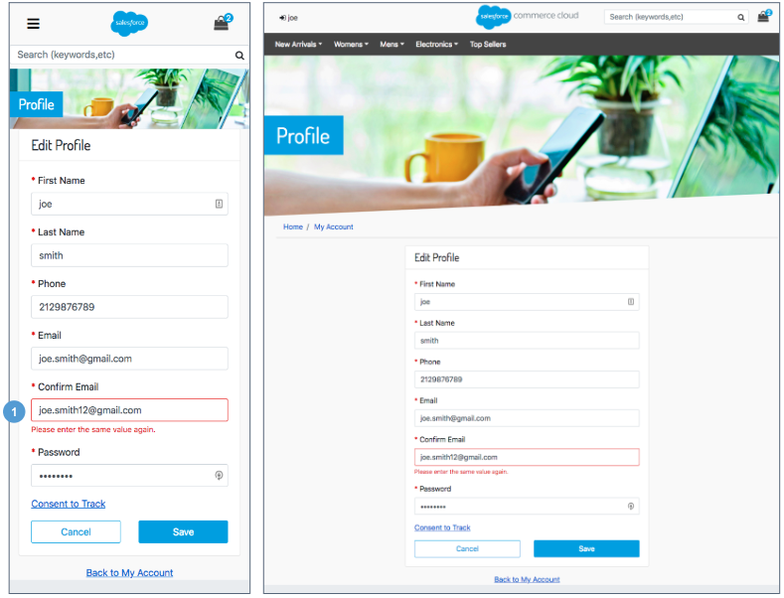 | My Account - Confirm Email Error  Mobile | Desktop:  1. When the shopper enters a confirm email address on any form, the system checks the spelling compared to the original email entered. If there is a difference in values, the message ‘Please enter the same value again’ is shown.

Appendix

Glossary
List all acronyms and unique terminology used throughout this document in alphabetical order.
Type | Description
BM | Business Manager
CSS | Cascading Style Sheets
HTML | Hypertext Markup Language
ISML | Internet Store Markup Language
PDP | Product Detail Page
PLP | Product Listing Page
SaaS | Software as a Service
SAYT | Search As You Type
SFCC | Salesforce Commerce Cloud
SFRA | SFRA

